OUTREACH NOTICE
Up to 8 Total Vacancies to fill for Silviculturists at multiple duty stations across the Idaho Panhandle National Forests

Potential Duty Stations: Idaho Panhandle NF Supervisors Office; Bonners Ferry RD; St. Joe RD; Sandpoint RD; Priest Lake RD; Silver Valley and Coeur d’Alene River RD

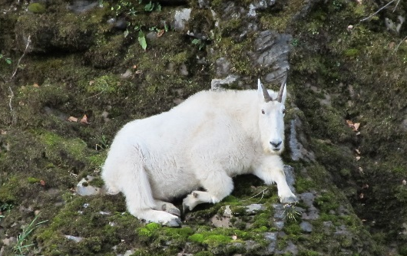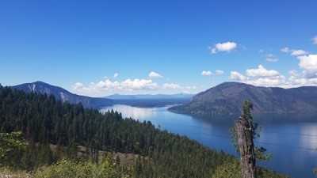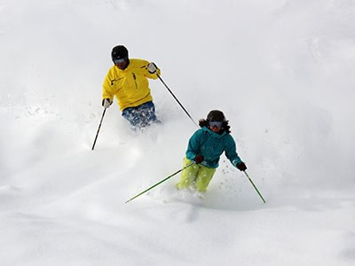
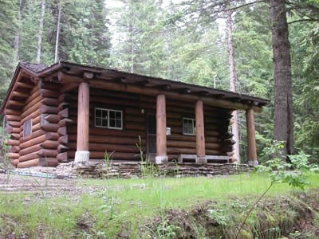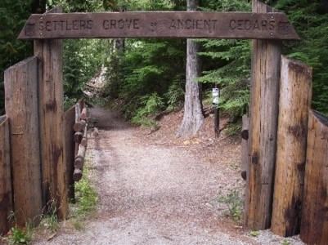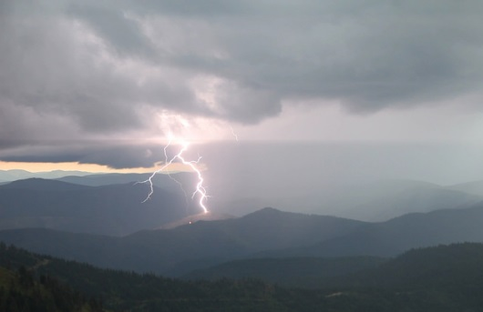

Title, GS-Series-Grade: | Silviculturist GS-460-7/9
District/Unit: | Coeur d’Alene River RD (1)  Silver Valley (Smelterville) (1)  St. Joe RD (2)
Duty Location: | Multiple
Date of Notice: | August 25, 2023

Title, GS-Series-Grade: | Silviculturist GS-460-9/11
District/Unit: | Sandpoint RD (1)  St. Joe RD (1)  Coeur d’Alene River RD (1)
Duty Location: | Multiple
Date of Notice: | August 25, 2023

Title, GS-Series-Grade: | Silviculturist GS-460-12
District/Unit: | Idaho Panhandle NF Supervisor’s Office (1)
Duty Location: | Coeur d’Alene, ID
Date of Notice: | August 25, 2023

The Idaho Panhandle National Forests will be filling up to 8 Permanent Silviculturist Positions across the Supervisor’s Office and multiple ranger districts. Each duty station is also considering details/temp promotions. Actual duty stations will be discussed at the time of offer, but please indicate your preference(s) for duty station, and whether you wish to also be considered for a detail/temp promotion when responding to this outreach. This notification is being circulated to inform prospective applicants of this upcoming opportunity.

Interested applicants, or those desiring further information, should contact the supervisor and area of interest, listed below or submit a response form to the supervisor, which is provided below. Please respond no later than September 8, 2023, so that we can understand the potential applicant pool and make informed decisions on how best to move forward.

Name of Supervisor | Ben Johnson - St. Joe District Ranger
Phone numbers | 208-245-6001
e-mail addresses | benjamin,johnson2@usda.gov
Name of Supervisor | Kevin Knauth, Bonners Ferry RD
Phone numbers | 208-267-6701
e-mail addresses | kevin.knauth@usda.gov
Name of Supervisor | Jessie Berner, Sandpoint RD
Phone numbers | (208) 265-6601
e-mail addresses | jessie.berner@usda.gov
Name of Supervisor | Holly Hampton, Office/Coeur d’Alene River RD
Phone numbers | (208) 769-3001
e-mail addresses | holly.hampton@usda.gov
Name of Supervisor | Michelle Caviness
Phone numbers | 208-765-7211
e-mail addresses | michelle.caviness@usda.gov

The position…………
We are looking for several high-performing individuals to join our team! We have a great deal of restoration and fuels reduction work across all Ranger Districts, but we accomplish this by joining forces as necessary to focus on the highest priority work across a large landscape.
Much of the IPNF’s silviculture program is focused on the restoration of white pine, western larch, ponderosa-pine, and whitebark pine forests. This work is accomplished through a combination of timber harvest, prescribed burning, timber stand improvement, and reforestation. The Forest works closely with multiple collaborative groups and partners in developing projects at a landscape-scale to improve long-term ecosystem sustainability.
Duties Include:
- Planning and implementing the Forest/Unit’s silviculture and TSI programs, including program goals, objectives, priorities, monitoring accomplishments, and budget expenditures.
- Interdisciplinary team member for planning of land management activities including terrestrial and aquatic habitat restoration with timber outputs, water quality restoration, and recreation and land use permits.
- Preparing written and oral reports and making suggestions and recommendations for inclusion in a variety of reports and decision documents.
- Developing silvicultural prescriptions for all vegetation management activities
- Assisting with the FACTs database and annual KV program of work.
- Preparing grants, agreements, partnership documents, contracts, and environmental documents.
A successful candidate for this position will be someone with interest and abilities in leadership, program management, communication, and teamwork.

The Idaho Panhandle National Forests …………
The Idaho Panhandle National Forests http://www.fs.fed.us/ipnf/ comprise about 2.5 million acres of public lands which lie within "the panhandle" of north Idaho and extend into eastern Washington and western Montana.
The Idaho Panhandle National Forests are an aggregation of the Coeur d'Alene and portions of the Kaniksu and St. Joe National Forests. There are eight local points of contact including the Supervisor's Office, six district offices and the Coeur d'Alene Nursery. The Forest is within nine counties in three states: Boundary, Bonner, Benewah, Kootenai, Shoshone, Latah and Clearwater Counties in Idaho; Lincoln County in Montana; and Pend Oreille County in Washington. The Supervisors Office (SO) shares the front reception area with the Bureau of Land Management (BLM). The SO ASA provides administrative support to the SO Office, routine services for both agencies including greeting visitors, answering telephones, and responding to routine inquiries from customers.
The Silver Valley Office (SVO) on the Coeur D’Alene River RD… … …

The Silver Valley is a beautiful area following the South Fork of the Coeur d'Alene River and comprised of several communities along the I-90 corridor. An area rich in mining and logging history, there are a number of local museums and organizations seeking to preserve and interpret this rich legacy. While the office is located in Smelterville, there are numerous communities in the valley including Kingston, Pinehurst, Kellogg, Osburn, Silverton, Mullan and Wallace (also the Shoshone County seat) which are all within a 15-20 minute drive. Approximately 30 miles to the west is Coeur d'Alene, a full service community of approximately 35,000 people, and another 30 miles west of there is Spokane, WA. There are four distinct and wonderful seasons in the Silver Valley. For more information see the Silver Valley Chamber of Commerce website at www.silvervalleychamber.com

The average cost of a modest (1500 SQ FT) three bedroom, two bath home is around $150,000, with slightly larger and nicer homes in the $200,000 - $250,000 plus range. Homes of a similar type rent for $700 to$900 per month.

There is a full range of primary and secondary education facilities in the Silver Valley, including three different school districts. Higher education opportunities abound with North Idaho College (4000 students) in Coeur d’Alene, the University of Idaho 110 miles south in Moscow, Idaho, Washington State University eight miles east of Moscow in Pullman Washington, Gonzaga University and Whitworth University 30 miles east in Spokane Washington, Eastern Washington University 80 miles east in Cheney, Washington, and several smaller institutions in the Spokane area. Adult education classes are offered by several of these entities in the Silver Valley.

Spokane International Airport, 65 miles to the east, serves the area with six national and two regional air carriers. I-90 which passes through the heart of the valley provides efficient travel to Missoula to the east or Coeur d'Alene/Spokane to the west.

As with most areas near a national forest, outdoor recreation opportunities are abundant. The Trail of the Coeur d'Alenes, a 73 mile bike route, traverses a large portion of the valley. There is fishing in the numerous lakes, rivers and streams for a wide variety of game fish; big game and bird hunting; hiking, camping, horseback riding, river floating, motorcycle and ATV riding. There are several golf courses in the area. For the winter recreation enthusiast, there are two downhill ski areas, Silver Mountain in Kellogg (just minutes from the Smelterville Office and a gondola ride to boot!) and Lookout Pass (about thirty minutes to the east), groomed cross-country ski trails and an extensive groomed snowmobile trail. The Old Mission State Park at Cataldo preserves the oldest building in Idaho and the area's rich native American heritage. Communities and clubs provide organized recreation opportunities for children and adults in such activities as football, baseball, softball, basketball, and soccer.
The St. Joe Ranger District … … …
The St. Joe Ranger District is at the southern end of the Idaho Panhandle National Forests and consists of approximately 725,000 acres with backcountry and mixed ownerships. The main district office is in St. Maries, Idaho. We also have another office near Avery, Idaho with temporary government housing in the town of Avery. The St. Joe Ranger District stretches westward from the rugged Idaho/Montana border along the Bitterroot Mountains between the Clearwater Divide and the Coeur d’Alene Divide to the lower St. Maries River Valley. The St. Joe has some of the most productive and biologically diverse forest lands in the Columbia River Basin. It contains plants and animals of the central Rocky Mountains, the boreal forests, and the moist coastal forests. The St. Joe River, headwaters of the Little North Fork of Clearwater River, and the St. Maries River Basins are the dominant watershed.
Unique features of the diverse St. Joe Ranger District include the St. Joe Wild and Scenic River, Emerald Creek Garnet Area, Mallard Larkins Pioneer Area, Marble Creek Historic Area, Route of the Hiawatha Bike Trail, Hobo Cedar Gove Botanical Area, and the Snow Peak Cooperative Wildlife Management Area.
St. Maries, Idaho … … …
St. Maries offers the best of a small town setting with necessary amenities and a host of extras. Located along the scenic St. Joe River, this town of approximately 2,800 boasts an active community spirit and true enjoyment of the outdoors. More information can be found at http://www.stmariesid.com/.

Coeur d'Alene, Idaho is an hour drive from St. Maries. It offers all the amenities of larger western cities. More information can be found at Coeur d'Alene Visitors Bureau :: Home

The major transportation corriders to St. Maries are State Highway 3 and Sate Highway 5. The Spokane International Airport Spokane International Airport is the main hub for air travel (an hour and half drive north and west from St. Maries).
The Priest Lake Ranger District
The Priest Lake Ranger District is located in the small recreational community of Nordman, Idaho approximately 30 miles north of Priest River, ID. Elevations on the District vary from 2000 to over 7,000 feet. Vegetation is extremely diverse - from boreal and coastal conditions to plant species and communities commonly found in the interior Northern Rockies. In an average year there are only a few days where temperatures will drop below zero in the winter or climb above 90 degrees during the summer. Average precipitation is about 32 inches and is equally divided between snow and rain. Average yearly snowfall may exceed 100 inches with 3-4 feet typical at the office in mid-winter.

The District office is only minutes from the banks of Lower Priest Lake, a “Gem of North Idaho”, which is 26 miles long, 4 miles wide, and connected by a scenic, slow moving 2 ½ mile river called the Thorofare to Upper Priest Lake Scenic area. Priest Lake has 26,000 acres of clear water, making this one of the most exceptional lakes in the world. The District also shares management of the 41,335 acre Salmo-Priest Wilderness Area with the Colville National Forest.

In addition to world class lake and water-sports, other recreational opportunities are numerous. Summer activities include camping and picnicking at 13 developed campgrounds and two picnic grounds, hiking of 200 miles of trail system (with many well-marked hiking trails leading to acres of wild huckleberries and mushrooms), horseback riding, and float-trips down Priest River. Hunting is a favorite activity with big-game hunting primarily for deer and elk, but moose permits are also awarded on a limited basis. Bird hunting is mostly for grouse along the roads. In the winter, three cross-country ski trails and 400 miles of snowmobile trails (250 on NFS) are kept groomed with a large number of ungroomed trails available.

There are two small stores supplying groceries for area residents and tourists, one laundromat, two fuel and service stations, an auto repair and service garage, several restaurants, and a hardware store. Several marinas offer sales, services and storage. Most area residents do their major shopping in either Sandpoint, ID (approximately 1.25 hours east), Coeur d’Alene, ID, or Spokane, WA (both approximately two hours south).

Schooling for grades K-6 is at Priest Lake Elementary School in the Lamb Creek area a few miles south of the Ranger District office, with the junior and senior high schools in Priest River, ID. All major services, including medical facilities, are in Priest River, ID, with a community hospital located in Newport, WA (40 miles from Priest Lake).

The Bonners Ferry Ranger District … … …

The District office is located in the community of Bonners Ferry, a full service community nestled along the Kootenai River. Bonners Ferry has a population of 2,473 and is the county seat for Boundary County, population 10,808. Boundary County borders Canada to the north, Washington to the west, Montana to the east, and Bonner County, Idaho to the south.

The community is home to Boundary Community Hospital, numerous medical and dental offices, ambulance service, several pharmacies, residential care, senior services, hospice, a public library, community theatre, county-owned airport, radio station, weekly newspaper, elementary, middle, and high school, city swimming pool, historical museum, several grocery stores, restaurants, and motels.

Along with excellent hunting and fishing, Bonners Ferry and surrounding areas offer unlimited outdoor recreational opportunities such as hiking, mountain biking/cycling, rock hounding, camping, dramatic scenery, golfing, history, winter sports such as cross country and back country skiing or snowmobiling. Schweitzer Mountain Ski Resort is located 38 miles south of Bonners Ferry in Sandpoint Idaho.

The Bonners Ferry Ranger District is home to a multitude of big game species including white-tailed deer, mule deer, black bear, elk, moose, mountain goat, big horned sheep, cougar, lynx and bobcat. The area is also home to two very special species; the woodland caribou and the grizzly bear. The Selkirk Mountains are the last home in the Continental United States of the endangered woodland caribou. The grizzly bear also finds refuge in the high peaks there, as well as other areas of the district.
There are a multitude of bird species for the bird watcher including osprey, hawk, eagle, pileated woodpecker and many varieties of owl. The principal upland game birds are blue grouse, Franklin grouse and ruffed grouse, duck, and geese. There are 271 miles of streams and 297 acres of lakes in the district, furnishing habitat for considerable fish and waterfowl, including rainbow and brook trout, sturgeon, whitefish, bass and salmon.

Sandpoint, Idaho is located 32 miles south of Bonners Ferry. Coeur d’Alene, Idaho is the closest urban area (1.5 hours to the south), Spokane, WA (2.0 hours to the south), Kalispell, MT (2.5 hours to the southeast), and Missoula, MT (4.0 hours to the southeast).

The Sandpoint Ranger District … … …

The Sandpoint Ranger District is located on the North Zone of the Idaho Panhandle National Forests (IPNF), which also includes the Bonners Ferry and Priest Lake Ranger Districts. The work will be spread over the three Ranger Districts based on priorities. The North Zone rangers will collectively approve a program of work to ensure the highest priority work is accomplished. The North Zone is home to three US Fish and Wildlife Service Listed Terrestrial Species (Canada lynx, grizzly bear, and woodland caribou) as well as one Proposed Terrestrial Species (North American wolverine).

Sandpoint is a vibrant community, rich in arts and culture. The population of the city is 7,365 (2010 census). As the county seat, Sandpoint also services much of Bonner County, population 40,877 (2010 census). A wide range of people make up the Sandpoint community; many are native residents – 30 percent were born in Idaho – but most were born elsewhere, relocating after experiencing Sandpoint’s friendly atmosphere and beautiful setting. This influx accounts for the area’s rapid population growth. The County’s population increased 35 percent between 1990 and 2010.

Surrounded by heavily forested mountains and nestled on the shore of the state’s largest lake, Lake Pend Oreille, Sandpoint is known for its exceptional natural beauty. The town itself is attractive with many buildings of architectural distinction, several nice parks including City Beach and bustling events that reflect the vigor of the community.

The Sandpoint area is rich in natural resources and outdoor recreation opportunities. About 40 percent of northern Idaho is National Forest land, along with 65 percent of the shoreline of Lake Pend Oreille. As a result, camping, hiking, biking and other outdoor activities are popular in the area.

The weather in Sandpoint changes dramatically throughout the year, creating four distinct seasons. Summer temperatures, such as in July, reach average highs in the 80s and lows in the 40s. On occasion, the mercury spikes to 100, making it an ideal time to take advantage of the lake. Fall is a popular time for camping and sports activities; temperatures are cooler with long Indian summers, and the autumn leaves and beautiful weather make it the preferred season for many residents. Winter in Sandpoint revolves largely around Schweitzer Mountain Resort, which boasts an average annual snowfall of 300 inches. Winter temperatures, in January for example, average 26.3 degrees. The spring thaw brings warm weather and rushing creeks, making it a popular time for sports such as hiking and whitewater rafting. The rapid weather shift also offers the unique chance to ski in the morning in the mountains and golf in the valleys in the afternoon.

The area has several high schools, middle schools and elementary schools. Sandpoint High School, the largest high school in the area, serves around 1,400 students and is a focal point for the community, hosting sporting events, concerts and plays.

The area has numerous churches and religious organizations, with more than 30 in Sandpoint alone. In addition, Sandpoint has a modern library, numerous historical sites within the city limits, a modern hospital with newly expand health care options and many small vendor shops downtown.

OUTREACH NOTICE RESPONSE FORM
Idaho Panhandle National Forest and Districts
Please respond by September 8, 2023

Position Title/Series/Grade: | Silviculturist – GS-460 7/9, 9/11, 12.
Location: | *Multiple Duty Locations (Interested Outreach Responders reply to your interest area and above listed Supervisor)

Personal Information

Name: |  |  | Date:
Address:

E-Mail Address:

Phone: | Office
 | Cell:

Current Title/Series/Grade:

Highest Position Held:
Title/Series/Grade:
Location:

Are you currently a Federal Employee? | Yes: |  |  | No:

IF YES:
Type of Appoint you are currently under:
(e.g., Career, Career-Conditional, Excepted)
Current Agency and location:
IF NO:
Are you currently a temporary employee? | Yes: |  |  | No:

Briefly describe your interest and duty station preferences(s):

