OUTREACH NOTICE

IDAHO PANHANDLE NATIONAL FORESTS

Coeur d’ Alene River Ranger District
Coeur d’Alene, ID
Forestry Technicians (Recreation) GS-0462-5/6 PSE 18/8

Reply Due by 9/19/2023

Outreach for Permanent Position

Are you looking for that next challenging but yet rewarding job? The Idaho Panhandle National Forests is seeking outreach for a skilled, motivated, and talented candidate to fill a GS-5/6 Forestry Technician (Recreation) position on the Coeur d’Alene River Ranger District. The purpose of this outreach is to inform prospective applicants of this upcoming opportunity and to determine interest in the permanent positions as well as grade level eligibility and hiring authorities of potential applicants.

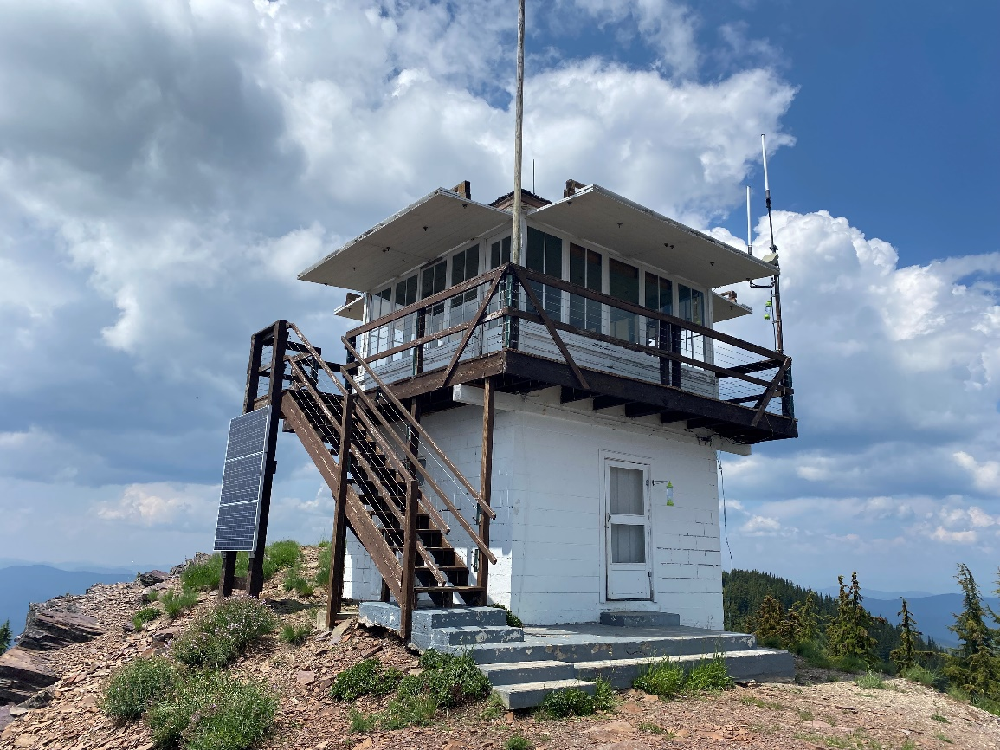

Outreach Response

If you have questions about the position, please reach out to Jed Friedman, District Recreation Staff Officer via jedediah.friedman@usda.gov or 208-670-1193.

If you are interested in this position, please submit the outreach form (Last Page) via email to jedediah.friedman@usda.gov with a copy of your resume by September 19th, 2023.

Introduction

The Idaho Panhandle National Forests (IPNF) has adopted a Sustainable Recreation Strategy that positions the Forest through a leveraged organization, to take advantage of unique funding opportunities to deliver a sustainable recreation program. Part of the IPNF’s Sustainable Recreation Strategy is to take advantage of grant resources unique to Idaho to support our recreation and trails program. In addition, we will manage our partners and volunteers under a “Center of Excellence” concept. This model will provide increased capacity and allow us to appropriately respond to our communities, partners, stakeholders, and the needs of the public. Applicants must be willing to work across resource and district boundaries, be part of a dynamic and challenging Forest and provide innovative solutions. This includes participation in the Forest’s Recreation working group and Program of Work discussions.
Please refer to the Forest web site at https://www.fs.usda.gov/detail/ipnf/recreation/ for more information
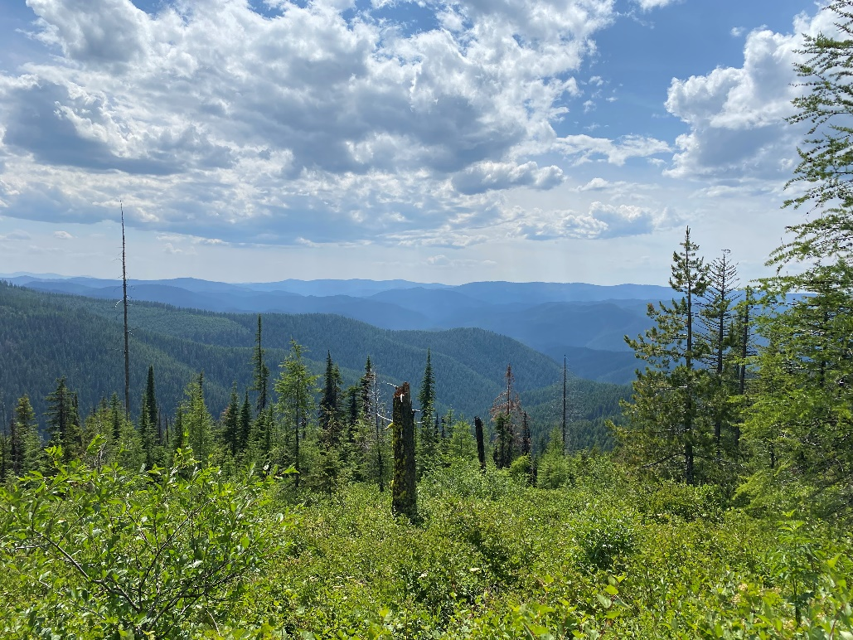

Forestry Technician (GS 0462-5/6) Position:
We are looking for several high-performing individuals to join our team! We have diverse programs on our Forest. These positions will cover a range of work in developed recreation, dispersed recreation, river rangers, and trails as well as winter program.
Recreation Duties:
- Performing regular cleaning and maintenance of developed recreation facilities, such as campsites, interpretive sites, rental cabins and lookout building, picnic areas, toilets and boat launch facilities.
- Perform maintenance, trash collection, and education/enforcement of dispersed recreation sites
- Provide recommendations for site improvements.
- Opening recreation sites, including landscape maintenance, cleaning and stocking and opening water systems.
- Closing of recreation sites including winterizing water systems and securing facilities.
- Collection of drinking water samples for testing.
- Performing recreation facility condition surveys.
- Serving as work lead for temporary employees, interns and youth crews.
- Perform brushing around rec sites, utilizing chainsaws, line trimmers, and handtools.
- Engage with Forest visitors, providing information about the local area.
- Follows safety protocols and contributes to an inclusive work environment.
- May require working alone regularly in remote locations.
- Must be eligible to attain a government driver’s license.
- Desire to make a difference on our District, in our communities, and HAVE FUN!

About the Idaho Panhandle National Forests
The IPNF is comprised of 2.5 million acres of public lands which lie within "the panhandle" of north Idaho and extend into eastern Washington and western Montana. The Forests are an aggregation of the Coeur d'Alene and portions of the Kaniksu and St. Joe National Forests. There are eight local points of contact including the Supervisor's Office, six district offices and the Coeur d'Alene Nursery. The Forest is within nine counties in three states: Boundary, Bonner, Benewah, Kootenai, Shoshone, Latah and Clearwater Counties in Idaho; Lincoln County in Montana; and Pend Oreille County in Washington.
The IPNF is known for its water-based recreation and substantial road and trail infrastructure. A newly signed Forest Plan creates opportunities for the IPNF to accomplish Landscape Scale Restoration Projects across the northern part of the State. Reforestation, Restoration, and Recreation are integrated in planning and implementation as we continue to evolve with our urban and rural communities.
Please refer to the Forest web site at http://www.fs.fed.us/ipnf/ for more information

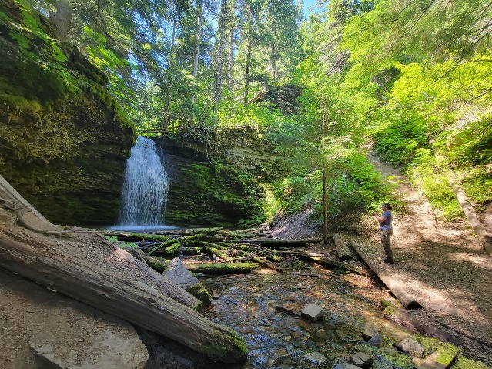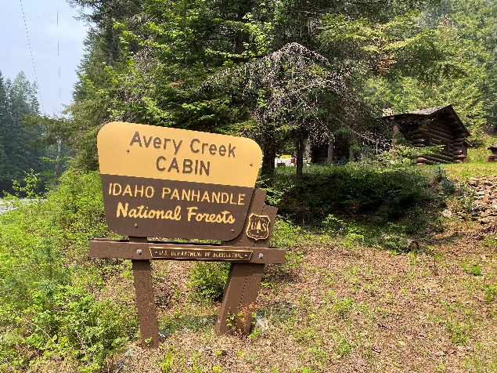

About the Communities:

Coeur d’ Alene

The Idaho Panhandle National Forests’ Supervisors Office is located in Coeur d'Alene, Idaho, a full-service community of close to 50,000 people. Approximately 185,000 people live in Kootenai County. Located on the northern shore of Lake Coeur d'Alene, the city is 100 miles south of the Canadian border, 33 miles east of Spokane, Washington, and an hour’s drive from the Montana state line. There are four distinct seasons, with summer average highs and lows of 82 degrees and 51 degrees; and average winter temperatures from 38 degrees and 26 degrees, with consistent amounts of snowfall. Higher education opportunities are available. North Idaho College (NIC) is located in Coeur d'Alene, Idaho, and 30 miles to the west of Coeur d'Alene, in Spokane, Washington, several colleges provide higher education opportunities. Moscow, Idaho is 80 miles south of Coeur d'Alene, and is the home of the University of Idaho. Washington State University is located just eight miles west of Moscow in Pullman, Washington, and Gonzaga University is located 33 miles away in Spokane. NIC, U of I, and other universities offer adult education classes in Coeur d’Alene and Post Falls.

There are several high schools within 5 miles of the office. There are many grade schools, middle schools and opportunities for private schooling exist in the area as well as in Spokane. Community day care and caregivers in private homes are readily available Health care services include a full service hospital, physicians, dentist, chiropractors, optometrists, physical therapist, and mental health services at the Kootenai Medical Center. . There is a modern library with excellent reference and checkout books, and access to other libraries for patron-requested books. A local museum and historical society chronicle the area's history. Spokane International Airport is located just 40 miles west of Coeur d'Alene.

Forestry Technician (Recreation) GS-462-5/6
Coeur d’Alene, Idaho Panhandle National Forests
USDA Forest Service, R1-Northern Region

Interested candidates should respond to this outreach with the following form filled out and a brief resume by September 19, 2023.

Name:
Phone:
Email:

If Federal Employee, Type of Appointment:
Permanent |  | Temporary |  | Student/  Intern |  | Contractor |  | Other
Current Position Title: |  |  |  |  | Series/Grade:

Please Mark each Position Interested In: 18/8
GS-0462-5, Forestry Technician (Recreation)
GS-0462-6, Forestry Technician (Recreation)

Are you eligible to be hired under any of the following special authorities?
☐ Schedule A (persons with disabilities)
☐ Veterans Recruitment Act (ARA)
☐ Veterans with 30% Compensable Disability
☐ Veterans Employment Opportunities Act (VEOA) of 1998
☐ Former Peace Corps Volunteer
☐ Pathways Program (Students, Interns and Recent Graduates)
☐ Public Land Corps (PLC)
☐ Land Management Workforce Flexibility Act (Temporary/Term Land Management Agency Employees)
☐ Other: <please elaborate>

