United States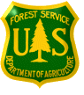Forest Service
Outreach Notice for GS-11/12/13 - 0807
Landscape Architect / Planner
Region 1
Multiple Locations: Regional Office, Bitterroot, Custer Gallatin
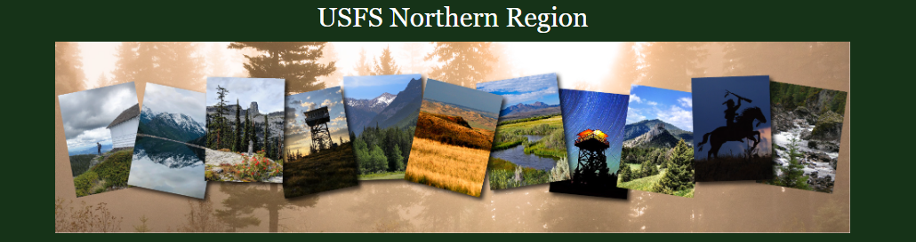

Region 1 will soon be advertising and filling (5) Landscape Architect/Planner positions, GS 0807 - 11/12/13 including supervisory positions in multiple duty locations. Duty location can be negotiable after selection, but please rank the locations in the Outreach response form to demonstrate interest level.

- Regional Office – 3 positions within Region 1
- Bitterroot National Forest – 1 position, Hamilton, MT
- Custer Gallatin National Forest – 1 positions, Bozeman, MT or Billings, MT
TO EXPRESS INTEREST IN THE POSITION:

Please fill out the attached outreach response form and send to Jeff Dulka, R1 Acting Deputy Director of Engineering Jeffrey.w.dulka@usda.gov by close of business, October 3, 2022, it is preferred to receive the response within the first two weeks of issuance. The vacancy announcement for this position will be posted on the U.S. Government’s official website for employment, www.usajobs.gov. The announcement will be posted at a later, yet undetermined date. Once the announcement is posted, all who responded to the outreach notice will be contacted by email to let you know what the vacancy announcement number will be for this position. Applicants must have all required documentation to be considered for this position.

THE POSITION
These positions will support work across the Region/District/Forest by providing a variety of complex and recurring tasks as they pertain to landscape architecture, recreation planning and designs for contract package preparation, project and program management, construction management, data management, and correspondence with stakeholders.

GAOA Landscape Architect
Recreation Planner
Landscape Architect

Duties for the position(s) include:

- Assists in performing surveys and studies of existing developed recreation facilities and their present use and demand.
- Assists in recommending potential sites or areas for additional recreation use and planned development with suggested priorities for development.
- Assist in designing, planning, and monitoring new construction of wilderness trails, parking areas, trailhead facilities, campgrounds, picnic areas, parking areas and access roads in consultation with other resource personnel.
- Gathers relevant information and project cost for recreation facilities, maintenance, and operation.
- Support for ADA, technical reviews and NEPA
- Assists in developing environmental documents including impact of statements concerning proposed recreational sites, wilderness, trails, special use on other resources.
- Assists in developing and maintaining the District’s Marketing Plan.
- Oversees the preparation and maintenance of the unit sign and poster plan by sketching designs for interpretative signs for completion by the Regional sign design specialist.
- Assists in graphic presentations as assigned.
- Participates in the development, administration, and execution of annual work plans for recreation resources in compliance with agency guidelines and direction.
- Assists with implementing recreation plan objectives and inspection of the full range of recreation uses administration of special authorization for recreation events and concessionaire operations.
- Processes special use applications including on-the-ground investigations of site suitability, preparation of associated environmental assessment reports, and special use permits in final form for the supervisor's review.
- Uses applicable databases to maintain unit information in order to monitor recreation resources program activities.
- Communicates program information to the public regarding the agencies management practices, rules, and regulations.
- Works with Federal and local law enforcement agencies to ensure compliance with federal laws, reporting all known violations of law or regulations.
- Performs other duties as assigned.

THE NORTHERN REGION AND GRASSLANDS
The Northern Region area encompasses 25 million acres and is spread over 5 states. Included are 12 national forests located within the perimeter of northeastern Washington, northern Idaho, and Montana; and the national grasslands in North Dakota and northwestern South Dakota. As a place for individuals and families to enjoy the outdoors, the Northern Region's public lands offer hiking, camping, fishing, hunting, skiing, kayaking, and countless other adventures. These very special areas protected from development offer the ability to escape the crowds of the city and encounter nature at its best – to experience the solitude and challenges of wildlands.

Forest and Region websites
- Region 1 - https://www.fs.usda.gov/r1
- Beaverhead-Deerlodge National Forest – https://www.fs.usda.gov/bdnf
- Bitterroot National Forest - https://usdagcc.sharepoint.com/sites/fs-r01-bnf/SitePages/Home.aspx
- Custer Gallatin National Forest - https://www.fs.usda.gov/custergallatin
- Dakota Prairie Grasslands - https://www.fs.usda.gov/dpg
- Flathead National Forest - https://www.fs.usda.gov/flathead
- Helena-Lewis and Clark National Forest - https://www.fs.usda.gov/hlcnf/
- Idaho Panhandle National Forest - https://www.fs.usda.gov/ipnf
- Kootenai National Forest - https://www.fs.usda.gov/kootenai
- Lolo National Forest - https://www.fs.usda.gov/lolo
- Nez Perce-Clearwater National Forest - https://www.fs.usda.gov/nezperceclearwater

FOR MORE INFORMATION/CONTACT
_________________________________________________________________________________________________________
Contact Jeff Dulka by email: Jeffrey.w.dulka@usda.gov . Depending on the outreach response, referral lists will be considered in both the Merit and Demo categories. All interested applicants should submit the attached outreach survey form so they can be notified of the vacancy announcement number and closing date when it becomes available.

- Regional Office
  - Corrine Kegel, corrine.kegel@usda.gov
  - Jennie O’Connor Card, Jennifer.card@usda.gov Ph: 406-589-7060
- Bitterroot National Forest
  - Amber Richardson, amber.richardson@usda.gov
- Custer Gallatin National Forest
  - Lauren Oswald, lauren.oswald@usda.gov
  - Parks Frady, Jefferson.Frady@usda.gov

OUTREACH RESPONSE FORM
GS-11/12/13 – 0807
Email to Jeff Dulka, Jeffrey.w.dulka@usda.gov
Respond by October 3, 2022
(It is preferred if the response is received within the first 2 weeks of notification)
NAME:
E-MAIL:
MAILING ADDRESS:
PHONE:

Agency: | USFS | BLM | Other
Type of Appointment: | Permanent | Temporary | Term |  | VRA | PWD |  | Other
Current Title/Series/Grade:

Current Location (Region/Forest/District):

Briefly explain your interest in this position and/or attach a resume:

*Please click link below to indicate location preference:
https://forms.office.com/Pages/ResponsePage.aspx?id=5zZb7e4BvE6GfuA8-g1Gl4Z-AlajnZxMibYM0QxG5SxUQUdIMFlLSUQxOUNSSExWOU4zNkpNSjg4SC4u

USDA Non-Discrimination Statement Revised 6/8/2005
“The U.S. Department of Agriculture (USDA) prohibits discrimination in all its programs and activities on the basis of race, color, national origin, age, disability, and where applicable, sex, marital status, familial status, parental status, religion, sexual orientation, genetic information, political beliefs, reprisal, or because all or part of an individual’s income is derived from any public assistance program. (Not all prohibited bases apply to all programs.) Persons with disabilities who require alternative means for communication of program information (Braille, large print, audiotape, etc.) should contact USDA’s TARGET Center at (202)720-2600 (voice and TDD). To file a complaint of discrimination, write to USDA, Director, Office of Civil Rights, 1400 Independence Avenue, S.W., Washington, DC 20250-9410, or call (800) 795-3272 (voice) or (202) 720-6382 (TDD). USDA is an equal opportunity provider and employer.”

