United States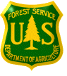Forest Service
Outreach Notice for GS-7/9/11/12/13 - 0810
Civil Engineer
Region 1
Multiple Locations: Regional Office, Bitterroot, Nez Perce/Clearwater – White Bird ID, Flathead, Custer Gallatin, Kootenai, Helena Lewis & Clark, Lolo, Beaverhead Deer Lodge, Idaho Panhandle
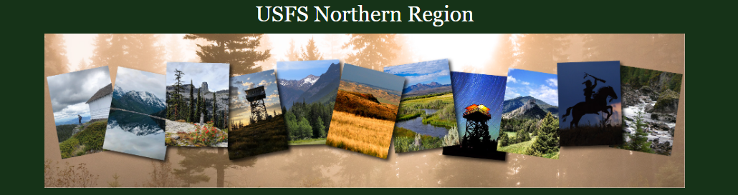

Region 1 will soon be advertising and filling (42) Civil Engineering positions, GS 0810 - 7/9/11/12/13 including supervisory positions in multiple duty locations. Duty location can be negotiable after selection, but please rank the locations in the Outreach response form to demonstrate interest level.

- Regional Office – 14 positions within Region 1
- Beaverhead Deer Lodge National Forest- 1 position total, Dillon, MT or Butte, MT
- Bitterroot National Forest – 1 position, Hamilton, MT
- Idaho Panhandle National Forest – 4 positions, Coeur d'Alene, ID, Priest River, ID, Bonners Ferry, ID, Sandpoint, ID, Smelterville, ID, St. Maries, ID, Avery, ID
- Custer Gallatin National Forest – 3 positions, Bozeman, MT or Billings, MT
- Kootenai, National Forest – 9 positions, Libby, MT, Trout, MT, Troy, MT, or Eureka, MT
- Helena Lewis & Clark National Forest – 3 positions, Great Falls, MT or Helena, MT
- Lolo National Forest – 4 positions, Missoula, MT
- Nez Perce – Clearwater National Forest – 2 positions, Grangeville, ID Kamiah, ID Kooskia, ID or Potlatch, ID
- Dakota Prairie Grassland – 1 position, Bismarck, ND
TO EXPRESS INTEREST IN THE POSITION:

Please fill out the attached outreach response form and send to Jeff Dulka, R1 Acting Deputy Director of Engineering Jeffrey.w.dulka@usda.gov by close of business, October 3, 2022. The vacancy announcement for this position will be posted on the U.S. Government’s official website for employment, www.usajobs.gov. The announcement will be posted at a later, yet undetermined date. Once the announcement is posted, all who responded to the outreach notice will be contacted by email to let you know what the vacancy announcement number will be for this position. Applicants must have all required documentation to be considered for this position.

THE POSITION
These positions will support work across the District/Forest by providing a variety of complex and recurring tasks as they pertain to civil engineering for designs, contract package preparation, project management, construction management, data management, and correspondence with stakeholders.

Position(s) include:

Assistant Bridge Program Manager
Ecosystem Planning
Transportation Planner
Facilities Engineer
Transportation Engineer
Geotech Program Manager, Dam, Tunnels, Pavement
GAOA Program Manager

Serves as a civil engineer on a Forest Service unit performing a variety of duties requiring professional civil engineering expertise. Develops and modifies civil engineering plans and specifications for new construction or to improve utility, quality, appropriateness, and appearance of construction. Prepares original designs and preliminary and final layouts. Such projects may include road design, small bridges, retaining walls, major drainage structures, erosion control features, buildings, towers, equipment shops and yards, small dams and reservoirs, and recreation sites, or other comparable structures. Evaluates design objectives, identifies economic and efficient procedures. Develops design, coordinating with other engineers to ensure that all technical areas are covered. Prepares or supervises preparation of special design specifications, cost estimates, and complete design package.

THE NORTHERN REGION AND GRASSLANDS
The Northern Region area encompasses 25 million acres and is spread over 5 states. Included are 12 national forests located within the perimeter of northeastern Washington, northern Idaho, and Montana; and the national grasslands in North Dakota and northwestern South Dakota. As a place for individuals and families to enjoy the outdoors, the Northern Region's public lands offer hiking, camping, fishing, hunting, skiing, kayaking, and countless other adventures. These very special areas protected from development offer the ability to escape the crowds of the city and encounter nature at its best – to experience the solitude and challenges of wildlands.

Forest and Region websites
- Region 1 - https://www.fs.usda.gov/r1
- Beaverhead-Deerlodge National Forest – https://www.fs.usda.gov/bdnf
- Bitterroot National Forest - https://usdagcc.sharepoint.com/sites/fs-r01-bnf/SitePages/Home.aspx
- Custer Gallatin National Forest - https://www.fs.usda.gov/custergallatin
- Dakota Prairie Grasslands - https://www.fs.usda.gov/dpg
- Flathead National Forest - https://www.fs.usda.gov/flathead
- Helena-Lewis and Clark National Forest - https://www.fs.usda.gov/hlcnf/
- Idaho Panhandle National Forest - https://www.fs.usda.gov/ipnf
- Kootenai National Forest - https://www.fs.usda.gov/kootenai
- Lolo National Forest - https://www.fs.usda.gov/lolo
- Nez Perce-Clearwater National Forest - https://www.fs.usda.gov/nezperceclearwater

FOR MORE INFORMATION/CONTACT
_________________________________________________________________________________________________________
Contact Jeff Dulka by email: Jeffrey.w.dulka@usda.gov . Depending on the outreach response, referral lists will be considered in both the Merit and Demo categories. All interested applicants should submit the attached outreach survey form so they can be notified of the vacancy announcement number and closing date when it becomes available.

- Regional Office
  - Corrine Kegel, corrine.kegel@usda.gov
  - Teresa Morales, teresa.d.morales@usda.gov
  - Mark Sodaro, mark.sodaro@usda.gov
  - Annora Nelson, annora.nelson@usda.gov
- Beaverhead-Deerlodge National Forest
  - Morgan Sandall, morgan.sandall@usda.gov Ph: 406-683-3926
- Bitterroot National Forest
  - Amber Richardson, amber.richardson@usda.gov
- Custer Gallatin National Forest
  - Lauren Oswald, lauren.oswald@usda.gov
  - Parks Frady, Jefferson.Frady@usda.gov
- Dakota Prairie Grasslands
  - Curtis Grudniewski, curtis.grudniewski@usda.gov
- Flathead National Forest
  - Jennifer Brady, Jennifer.brady@usda.gov Ph: 406-758-5210
- Helena-Lewis and Clark National Forest
  - Catherine Pinegar, catherine.pinegar@usda.gov
- Idaho Panhandle National Forest
  - Sean Christen, sean.christen@usda.gov
  - James Gebhardt, james.gebhardt@usda.gov
- Kootenai National Forest
  - Kenneth Wickward, Kenneth.wickward@usda.gov
- Lolo National Forest
  - Amber Richardson, amber.richardson@usda.gov
- Nez Perce-Clearwater National Forest
  - Quentin Smith, quentin.smith@usda.gov

OUTREACH RESPONSE FORM
GS-7/9/11/12/13 0810
Email to Jeff Dulka, Jeffrey.w.dulka@usda.gov
Respond by October 3, 2022
(It is preferred if the response is received within the first 2 weeks of notification)
NAME:
E-MAIL:
MAILING ADDRESS:
PHONE:

Agency: | USFS | BLM | Other
Type of Appointment: | Permanent | Temporary | Term |  | VRA | PWD |  | Other
Current Title/Series/Grade:

Current Location (Region/Forest/District):

Briefly explain your interest in this position and/or attach a resume:

USDA Non-Discrimination Statement Revised 6/8/2005
“The U.S. Department of Agriculture (USDA) prohibits discrimination in all its programs and activities on the basis of race, color, national origin, age, disability, and where applicable, sex, marital status, familial status, parental status, religion, sexual orientation, genetic information, political beliefs, reprisal, or because all or part of an individual’s income is derived from any public assistance program. (Not all prohibited bases apply to all programs.) Persons with disabilities who require alternative means for communication of program information (Braille, large print, audiotape, etc.) should contact USDA’s TARGET Center at (202)720-2600 (voice and TDD). To file a complaint of discrimination, write to USDA, Director, Office of Civil Rights, 1400 Independence Avenue, S.W., Washington, DC 20250-9410, or call (800) 795-3272 (voice) or (202) 720-6382 (TDD). USDA is an equal opportunity provider and employer.”

