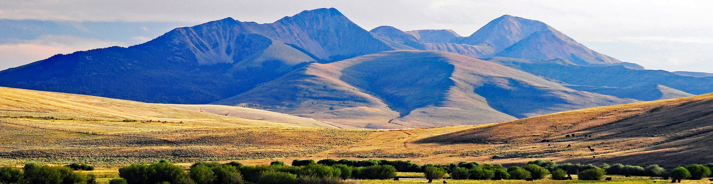
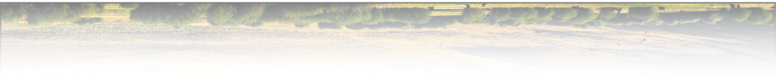
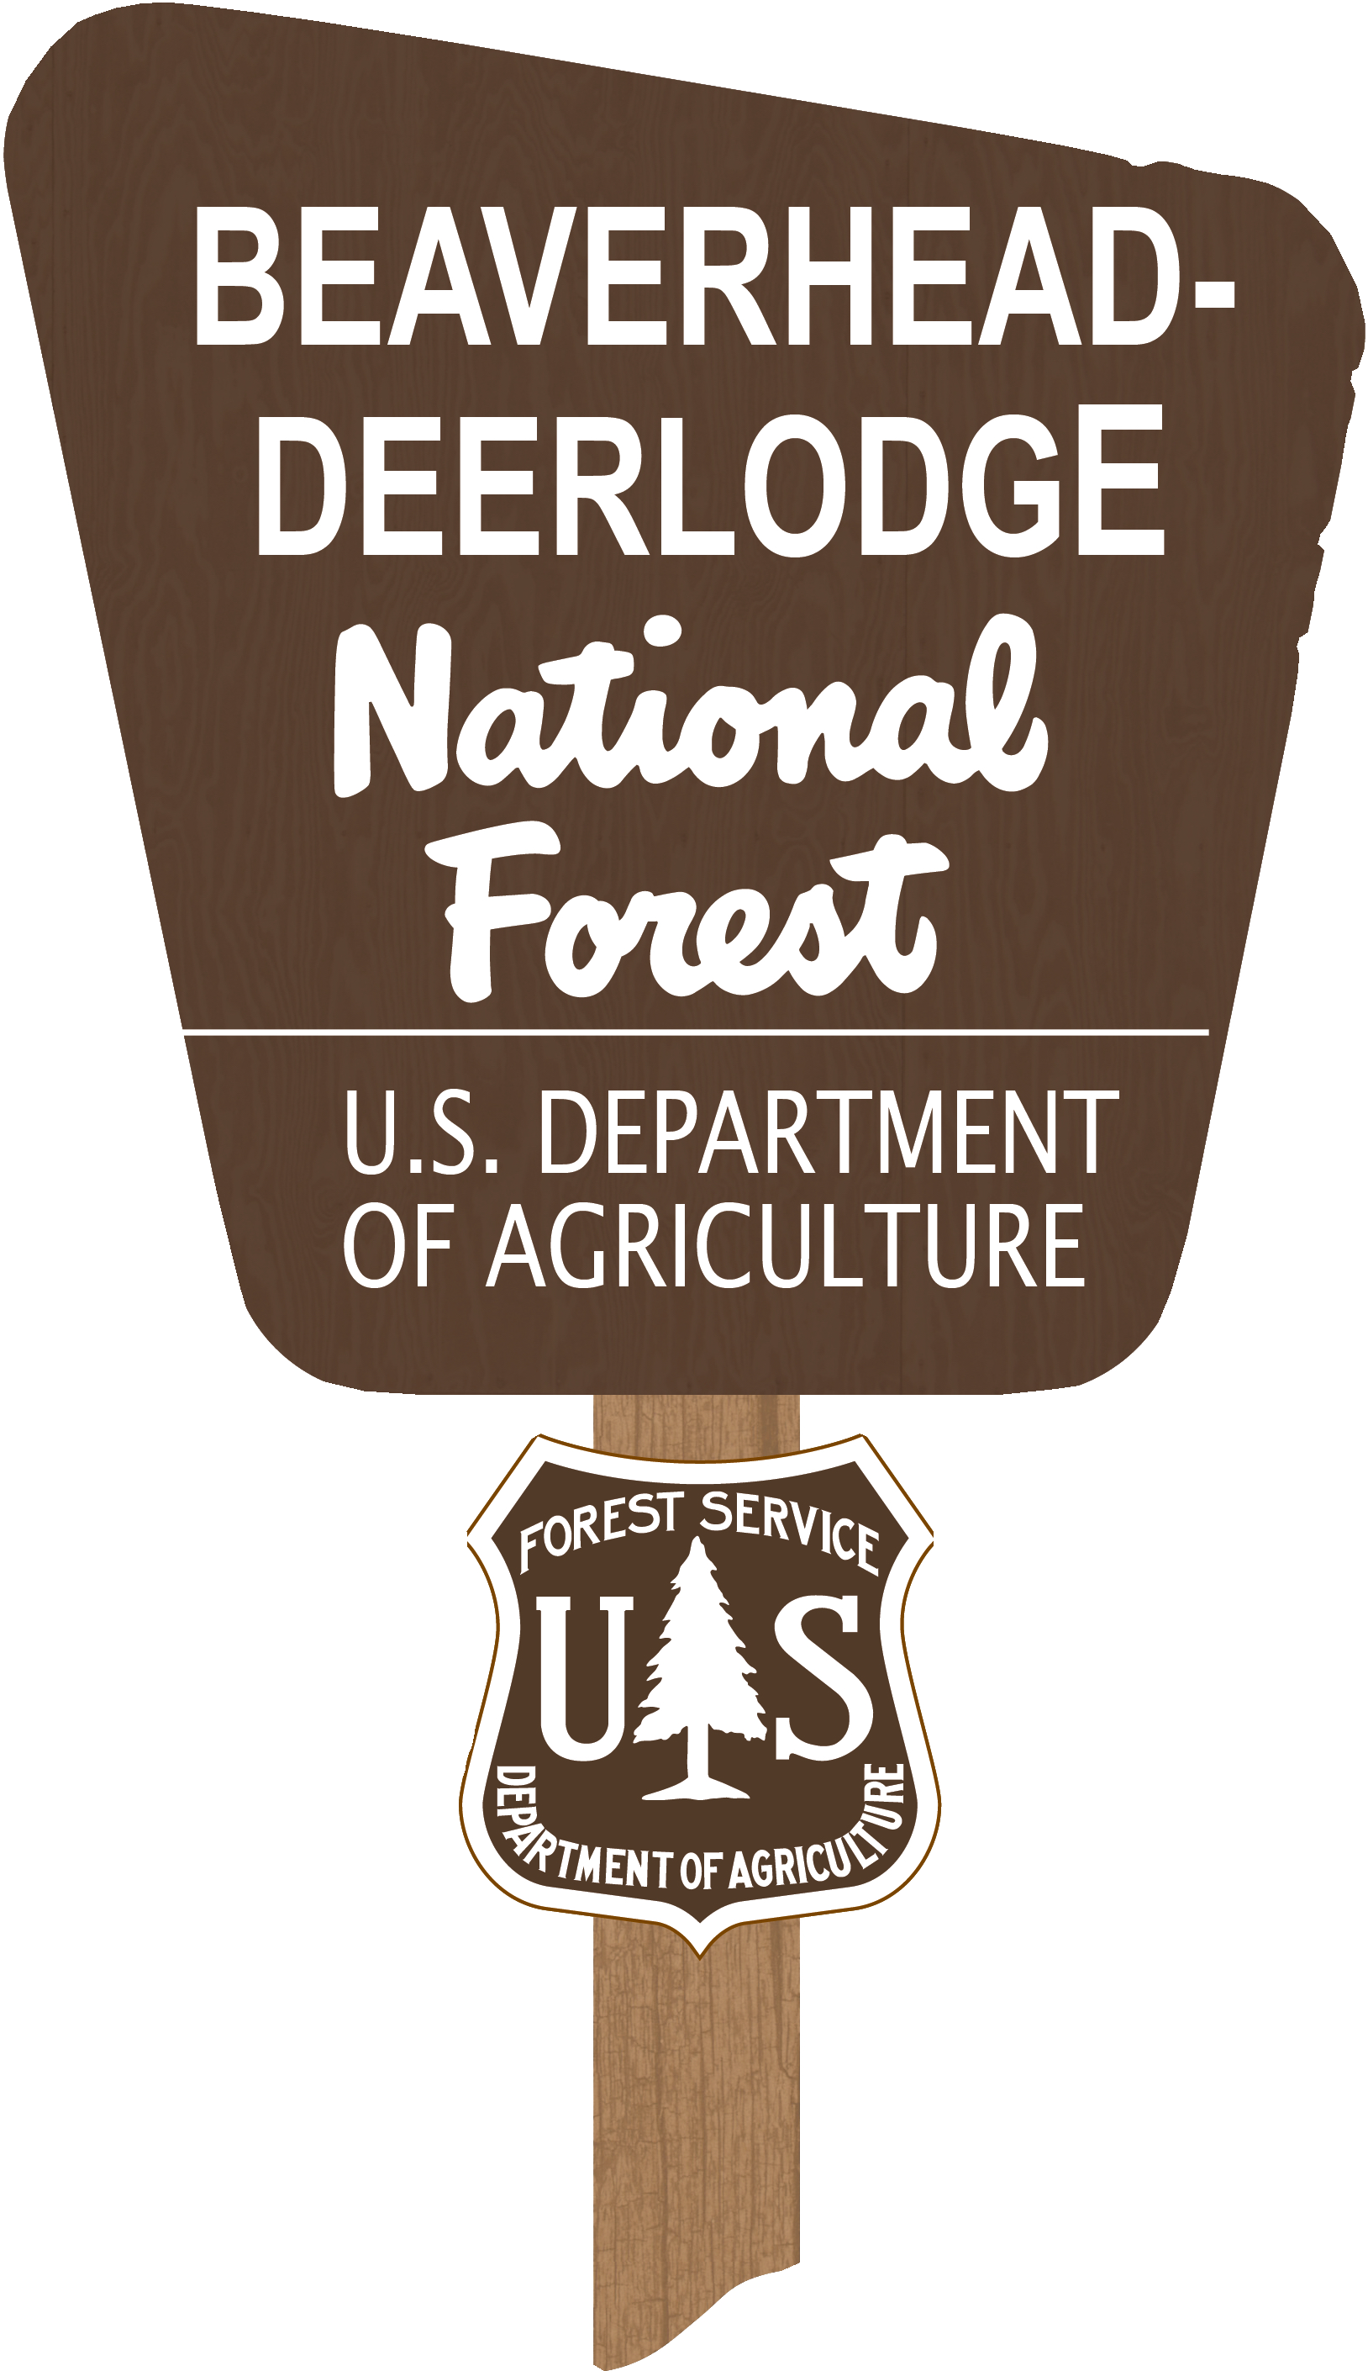
Public Affairs Specialist

BDNF Outreach Notice

The Beaverhead-Deerlodge National Forest is seeking candidates for a permanent Public Affairs Position with a duty station in Dillon, MT.

About the positions:
The Public Affairs Specialist (GS-1035-09/11) will serve as the Forest’s Public Affairs Officer Assistant, with an emphasis on creative media, innovative visual production, strong writing skills, enthusiasm, and teamwork as an advocate for the people, the land and the work happening on the Beaverhead- Deerlodge National Forest (BDNF).

Primary duties:
- Supports the public affairs program, in alignment with the Forest Service vision and purpose, in preparing for, and communicating effectively on a variety of complex issues.
- Evaluates communications issues and opportunities; analyzes public reaction; and recommends
methods of minimizing misconceptions and improving understanding policies.
- Identifies, develops, and manages content for our website, social media, and other distribution channels for internal and external communication.
- Produces written news and feature stories, photo features, and video stories.
- Designs layouts, infographics, and other visualizations.
- Content production is focused on communicating critical issues; explaining Forest Service policies, programs, and activities; informing Forest Service users and customers; and establishing two-way communication with the public including the news media and elected officials.
- Components of the public affairs program include community and media relations, information
strategies, partnership and collaboration coordination, serving as a liaison with local organizations, federal/state/local government officials, special interest groups, and the public.

The single biggest reason to come work for the BDNF is to be part of our team. We have a Partnership Coordinator, Public Information Officer and Public Affairs Officer that combined, comprise one of the strongest, most supportive, innovative, passionate and skilled teams in the region. The team is very driven and cohesive, and we strive to create and keep one of the best working environments you will find .

Outreach Notice
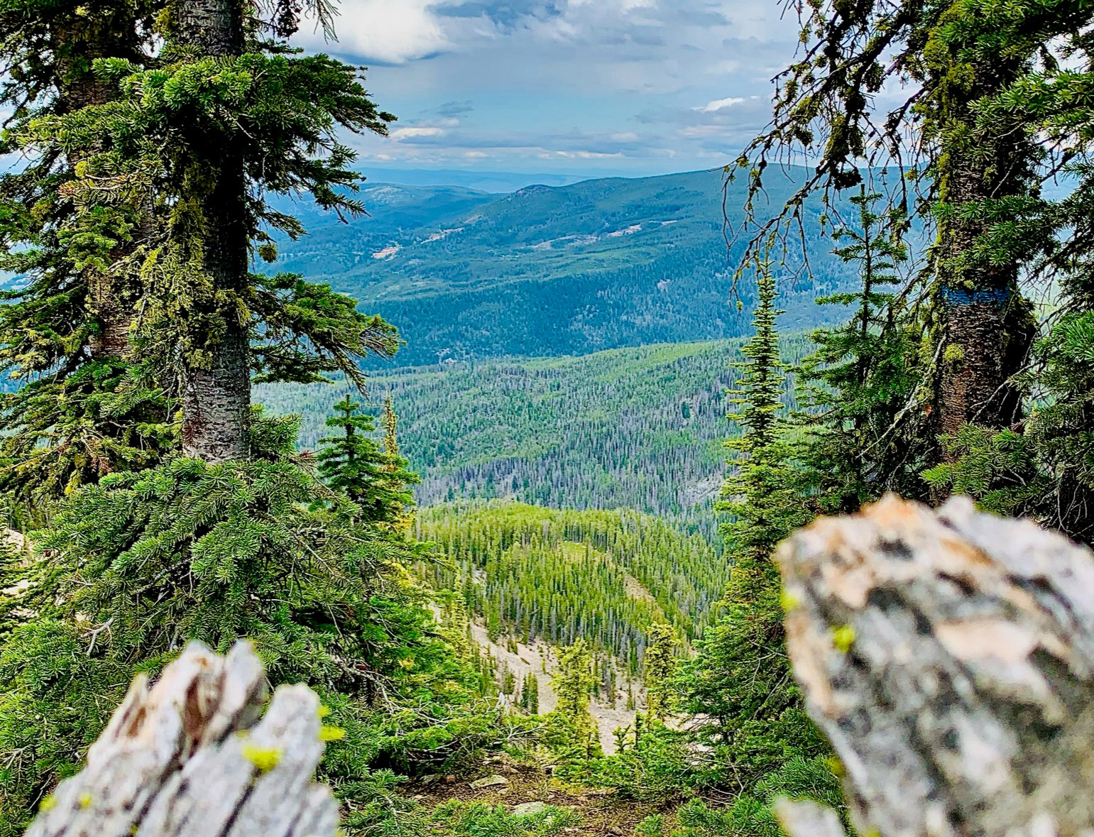
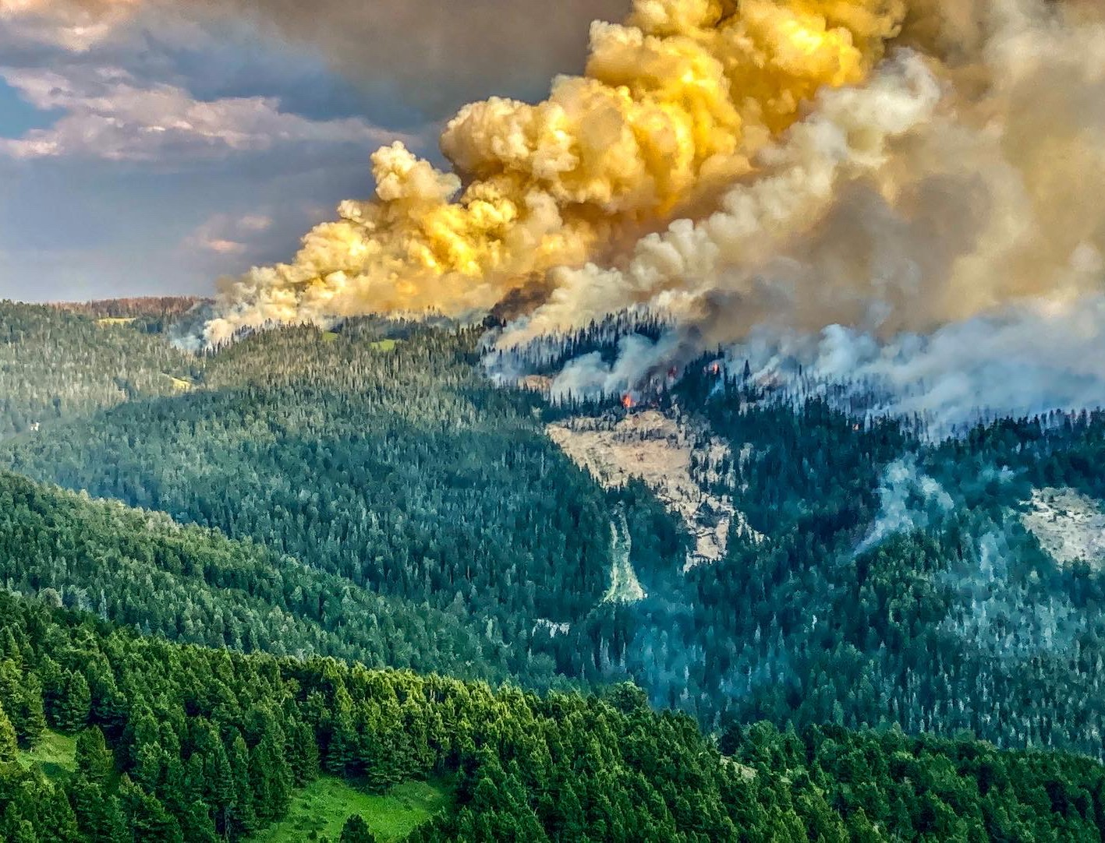
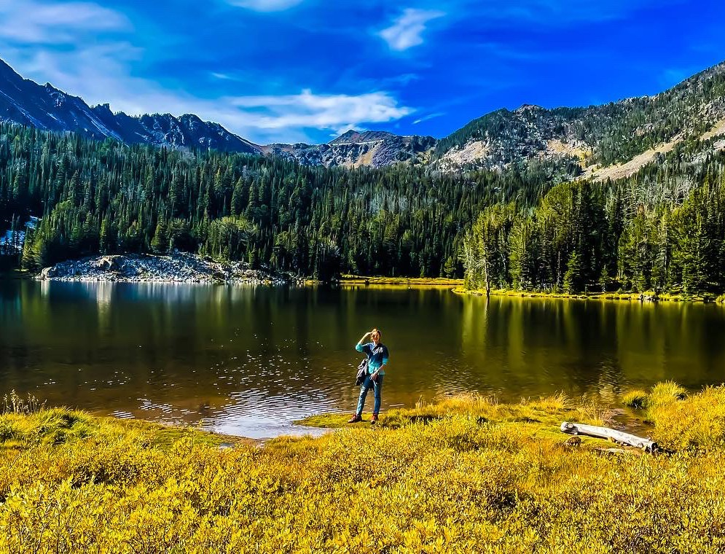

Our Forest

The largest of the national forests in Montana, the BDNF covers 3.39 million acres and lies in eight southwest Montana counties. The Forest has one of the most diverse land bases in Montana and is unique in that it connects three of the most intact large ecosystems in the lower forty-eight states. The Forest provides timber, minerals, and grazing lands. It also offers breath-taking scenery for a wide variety of recreational pursuits. The Forest has incredible mountain ranges, mountain lakes, great fishing rivers and streams, and wildlife abounds.

The Beaverhead-Deerlodge National Forest is comprised of 5 ranger districts: Butte, Dillon, Pintler, Madison, and Wisdom.

Duty Station in Dillon, MT
Dillon is centered in the stunning beauty of southwest Montana and is surrounded on three sides by the Continental Divide. The Forest is famous for outdoor recreation with hundreds of miles of hiking and snowmobile trails, digging for crystals, panning for gold, ghost towns and some of the West's best fisheries…the Madison, Beaverhead, and Big Hole rivers. It's all right here where the Old West began in Dillon and southwestern Montana.

Dillon is the county seat and major trading area for over 13,000 people in Beaverhead and western Madison counties. Along with the Beaverhead-Deerlodge National Forest Supervisor’s Office, Dillon is home to the University of Montana Western and the national franchise office of Great Harvest Bread Company, and a Patagonia outlet store. Dillon also forms the center of Montana's largest cattle and hay producing areas and is one of Montana's top agricultural centers and provides a full-service community. The total population of Beaverhead County is 9,500, and there are nearly 9,000 people in the adjacent Madison County.

Southwest Montana and the B-D are known for outstanding elk hunting and blue-ribbon trout streams. The southern portion of the forest lies within the Greater Yellowstone Ecosystem. Check the Forest website at: https://www.fs.usda.gov/bdnf

Please contact Catherine McRae if you are interested in this position at Catherine.mcrae@usda.gov

