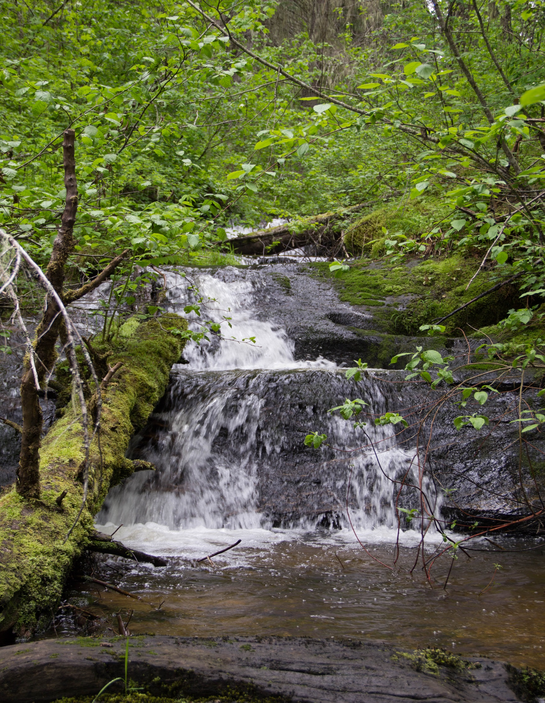
History, Wildlands and Wild Experiences!
Nez Perce-Clearwater NFs

120-DAY DETAIL / TEMPORARY PROMOTION /SINGLE VACANCY
Public Affairs Specialist
GS-1035-11/12

OUTREACH NOTICE

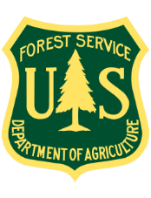

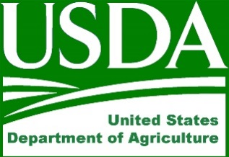

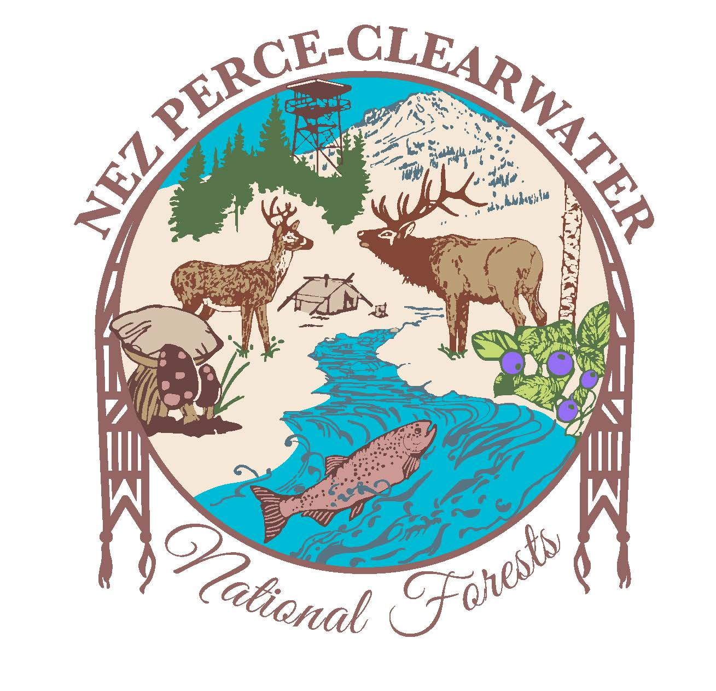
OUTREACH NOTICE

Public Affairs Specialist
120-day Detail/Temporary Promotion Opportunity
GS-1035-11/12 Public Affairs Specialist

Supervisors Office
Nez Perce-Clearwater National Forest

KAMIAH, IDAHO

REPLY DUE BY: October 28, 2021

The USDA Forest Service, Northern Region, is outreaching for a NTE 120-day detail/temp promotion/Single Vacancy, GS-1035-11/12 Public Affairs Specialist for the Nez Perce-Clearwater National Forest.

This notification is being circulated to inform prospective and interested applicants of this upcoming opportunity. This outreach will be updated when the position is advertised in USA Jobs. For more information and/or to respond to this outreach, complete the Outreach Response Form below, include your Resume and respond by January 18, 2022 to:

Martin Mitzkus, Deputy Forest Supervisor, at martin.mitzkus@usda.gov

The Position Duties Include:
Serves as the Supervisory Public Affairs Officer at a Forest Service Unit that: Supervise a Unit public and governmental services team; is Unit Staff officer and a member of the Unit’s Leadership Team; and is a principal staff advisor to the unit Supervisor and other Staff Officers.

The incumbent has responsibilities to the Unit Supervisor for planning, coordinating and directing public relations, govermental relations, informational services, recreational visitor services and enviromental educational programs and or issues for all natural resource program areas on the Unit. This includes but is not limted to community relations; media operations and facilitations; multi media content producer; information strategies; government relations; marketing strategies; recreation visitors and users; special interests groups; educational instuitutes; the public; etc. Organizes, coordinates and implements effective employee and public meetings, workshops, field trips, or other forums designed to foster employee and public participation.

What we are looking for in a Candidate:
The Forest is looking for an enthusiastic, self-motivated individual to meet the challenges of this position. To be successful in this job you must be a self-starter and have a demonstrated track record of leading people in an ever-changing environment. You must be willing to take on challenges and provide innovative solutions to complex problems. Successful candidates must have excellent communication skills and be able to work collaboratively with employees and external partners.
ABOUT THE NEZ PERCE-CLEARWATER NATIONAL FORESTS

The Nez Perce-Clearwater National Forests are about:
- Promoting and protecting our history, wildlands, and wild experiences;
- Connecting with our communities;
- Building and restoring resiliency in our diverse landscapes, workforce and relationships.
The Nez Perce-Clearwater NFs is a complex fire forest with diverse ecosystems that range from dry ponderosa pine to coastal disjunct communities. Wildfire is the primary driving force in the forested ecosystems. Last year, approximately 190,000 acres burned on the Forests along with many acres on state and private land.
The four-million-acre forest extends from the Selway-Bitterroot Continental Divide to Hells Canyon. Approximately one third of the Forest is wilderness, another third is roadless designated under the Idaho Roadless Rule, and the final third is referred to as the “Front Country” where the majority of timber harvest and roaded recreation occurs.
There are six Ranger Districts with approximately 325 permanent employees and over 225 seasonal employees during the summer field season. The Forests host the Grangeville Smokejumper, Grangeville Air Center and Grangeville Dispatch Center.
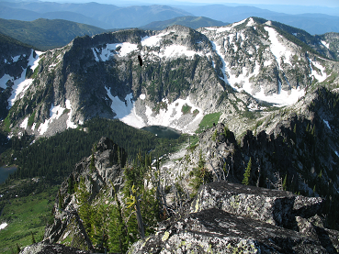
There is an active collaborative group with strong regional and national relationships. The Clearwater Basin Collaborative represents all interests and have been instrumental in garnering support for restoration projects, including projects under the Collaborative Forest Landscape Restoration Program. There is one CFLRP area on the Forest - Clear Creek.
The Forest also has multiple partnerships that are critical for accomplishing our work including: Selway-Bitterroot Foundation, Rocky Mountain Elk Foundation, Nez Perce Tribe, and multiple recreation groups amongst others.
The current Forest priorities are:
- Integrated Landscape Restoration focusing on working with Clearwater Basin Collaborative, Nez Perce Tribe and others to accomplish landscape-scale restoration to improve watershed function, habitat for wildlife, timber resiliency, recreational opportunities, and reduce hazardous fuels, as well as providing local employment.
- Forest Plan Revision under the 2012 Planning Rule. The Forest is an early adopter of the Planning Rule and the resulting Forest Plan will be viewed by many as an example. The Forest Plan and accompanying environmental impact statement will be completed within two years.
- Wildland Fire Preparedness including training and preparedness to manage wildland fire incidents on the Forest and across the country.
- Great American Outdoors Act a national program to improve the experience of National Forest visitors by reducing deferred maintenance in the campgrounds and other recreational facilities and trails.
More information about the Nez Perce-Clearwater NFs is available at: http://www.fs.usda.gov/nezperceclearwater
Contact:
For more information about the position please contact Martin Mitzkus (Deputy Forest Supervisor) at martin.mitzkus@usda.gov. If interested in the 120-day temporary promotion, please submit the response form below and a resume clearly outlining your Safety experience by January 18, 2022.
For information about salary, or job series, visit the US Office of Personnel Management website.
USDA-Forest Service is an equal opportunity employer and provider.

Nez Perce-Clearwater NF
Public Affairs Specialist, GS-1035-11/12
OUTREACH RESPONSE FORM
Duty Station: Kamiah, Idaho (detail/temp promotion can be remote/virtual)
Respond by: January 18, 2022
If you are interested in this position, please complete this outreach interest form and email the form and a resume to Martin Mitzkus, martin.mitzkus@usda.gov.
PERSONAL INFORMATION:
Name:
E-Mail:
Address:
Work Phone: |  |  |  |  | Alternate Phone:
Please Indicate if you are interested in: up to 120 Day Detail/Temp. Promotion
Single Vacancy
Agency Employed with: USFS Other (Please list):
Type of appointment currently under (please check one):
Permanent Temporary Term Other (Please list):
Current Title:
Current Series/Grade:
Current Region/Forest/District/Unit:
If you are not a current permanent (career or career conditional) employee, are you eligible to be hired under any of the following special authorities:
Persons with Disabilities  Veterans Recruitment Appointment  Disabled Veteran w/30% Compensable Disability  Veteran Employment Opportunities Act of 1998 |  |  |  |  |  | Former Peace Corp Volunteer  Pathways Program  Other (explain):

Please attach a copy of your resume and describe why you will be a quality candidate for this position and attach to your response to this outreach.

