OUTREACH NOTICE
National Environmental Policy Act (NEPA)
Interdisciplinary Team Leaders
Northern Region – Multiple Vacancies

Title, GS-Series-Grade: | Environmental Specialists (GS-0028-11)  NEPA Planner (GS-0101/0401-11)
Duty Station: | Multiple positions, various locations  across USFS Region 1
Respond by: | May 30th, 2022

Looking for you if you are interested in working in our NEPA program in Region 1. We have a lot of work and so many interesting resource issues. If you are looking for challenge, a place to showcase your project management and organizational skills – please respond to this outreach.
Please send the outreach form and direct any questions to Julie Schaefers (julie.schaefers@usda.gov). This outreach is not a vacancy announcement.
We seek an individual who has:
- Excellent interpersonal skills and is a team player, a team leader, and enjoys the collaborative process.
- Strong writing, document review, and organizational and project management skills.
- Record management and document publication experience.
- Knowledge and experience in NEPA and NFMA.
- Knowledge about and passion for telling our natural resource management story.

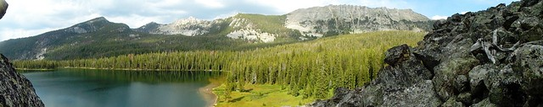

Expectations for our ID Team Leaders
- Provide guidance for environmental analyses to comply with NEPA and NFMA with a focus on process management, document preparation, and review.
- Prepared to lead interdisciplinary teams, carry out routine environmental studies and evaluations to determine the impacts of various actions or events, such as forest planning projects, on the environment.
- Track progress of NEPA documents and support accomplishing timelines set for team members by facilitating meetings, tasks, program of work, and problem identification and resolution.
- Review routine environmental studies and evaluation linking a variety of resources, such as social, cultural, and economic values, land, air, water, timber, recreation, wildlife, and fisheries. Analyze and review these environmental impacts and provide input regarding alternatives for managing natural resources.
- As the project lead, ensures the design criteria or mitigation specified in NEPA decision are incorporated in the implementing tool. Review comments received from other federal, state, public agencies, tribes, etc. to determine how to catalog and work with team and others to outreach and or respond to concerns in accordance with environmental laws, regulations, and policies.
- Organize records for Objection Panel review and converts to administrative record for potential litigation.
- Assist specialists with writing and developing environmental analysis reports, and review data collected by specialists for the project record and preparation of environmental documents. Provide management advice regarding appropriate procedures in the use of analytical tools and information systems and that NEPA and NFMA regulations are followed. Gather and review subject matter documents and include the required information in the NEPA analysis, or other documents.
- Serve as the Forest EndNote Librarian and assists specialists who need to install and use EndNote for NEPA analysis and reference management.
- Provides input for building interdisciplinary approaches and developing policies, procedures and techniques to solve problems that require adaptations or extensions of existing rules.
- This is a non-supervisory position.
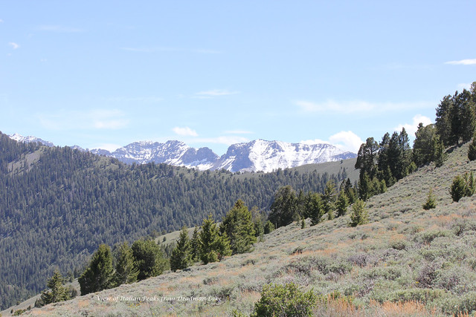
Locations
This position would be telework eligible, Remote work within a 4-hour drive to a selected Forest Service office may be considered, consistent with agency policy.
Possible locations include Butte, Dillon, Hamilton, Philipsburg, Stevensville, Troutcreek in Montana, and Orofino in Idaho. Other duty stations within the region may be selected.

Travel
This position would require occasional travel to meetings and trainings around the region.

Beaverhead-Deerlodge National Forest
The largest of the national forests in Montana, the BDNF covers 3.35 million acres and lies in eight southwest Montana counties. The Forest has one of the most diverse land bases in Montana. It is unique in that is connects three of the most intact large ecosystems in the lower forty-eight states. The Forest provides timber, minerals, and grazing lands. It also offers breath-taking scenery for a wide variety of recreational pursuits. The Forest has incredible mountain ranges, mountain lakes, great fishing rivers and streams, and wildlife abounds.
Climate in southwest Montana is graced with four seasons, generally experiencing cold, snowy winters and relatively warm summers, though temperature changes from day to night can vary greatly. Temperatures range from an average high in August of 80 degrees to an average low in January of 10 degrees. Below-zero temperatures in the winter are common. More information about the Beaverhead-Deerlodge National Forest can be found at: www.fs.fed.us/r1/bdnf/.
For more information about the position, contact Betsy Herrmann at elizabeth.herrmann@usda.gov

Bitterroot National Forest
The Bitterroot National Forest is in western Montana and the central mountains of eastern Idaho. The eastern side of the Forest runs from the Bitterroot Valley floor to the crest of the Sapphire Mountains. The 1.6 million acre Forest includes three ranger districts and hosts approximately 530,000 visitors a year. Half of the Forest is in designated Wilderness. Special features in include Selway Bitterroot, Frank Church River of No Return, and the Anaconda Pintler Wilderness and the Selway Wild and Scenic River. More information about the Bitterroot National Forest can be found at www.fs.usda.gov/bitterroot/
For more information about the position, contact Nell Highfill at danelle.highfill@usda.gov

Kootenai National Forest
More information about the Kootenai National Forest can be found at www.fs.usda.gov/kootenia/
For more information about the position, contact Michael Feiger at michael.feiger@usda.gov

Nez Perce-Clearwater National Forest
From the dry, rugged canyons of the Salmon River to the moist cedar forests of the Selway drainage to the rolling uplands of the Palouse, the Nez Perce-Clearwater National Forests offers something for everyone. This vast, diverse area is managed to provide a variety of goods and services including breathtaking scenery, wilderness, wildlife, fisheries, timber harvest, livestock grazing, mining, pristine water quality and a wide array of recreation opportunities. The Nez Perce-Clearwater National Forests is best known for its wild character. Nearly half of the forest is designated Wilderness. They also sport three rivers popular with thrill-seeking floaters—the Selway, the Lochsa and the Salmon. More information about the Nez Perce-Clearwater National Forest can be found at www.fs.usda.gov/nezperceclearwater/
For more information about the position, contact Zo Anderson at zoanne.anderson@usda.gov
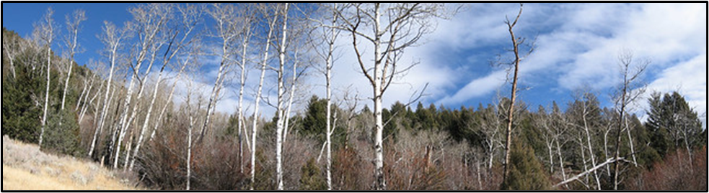

Outreach Response

For Permanent Full-Time Appointment

Reply by May 30th, 2022 to Julie.schaefers@usda.gov

Position Identification
Position Title: | NEPA Planner (Interdisciplinary Team Leader)
Series/Grade: | GS-0101/0401-11 or GS-0028-11
Duty Station | Possible locations include Butte, Dillon, Hamilton, Philipsburg, Stevensville, Troutcreek in Montana, and Orofino in Idaho. Other duty stations within the region may be selected.
Applicant Information
Name: |  |  | E-Mail Address:
Mailing Address:
Phone:
Do you have a preferred location?
Are you a current federal employee? Yes: No:
Current Agency if applicable:
Current Region/Forest/District if applicable:
Current Title, Series and Grade if applicable:
Type of Appointment: |  | Permanent Temporary Term VRA  PWD Other Not Current Employee

If you are NOT a current permanent (career or career conditional) employee, are you eligible to be hired under any of the following authorities:
Reinstatement  Veterans Recruitment Act  Disabled Veteran with 30% Compensable Disability  Veteran’s Employment Opportunities Act of 1998 |  |  |  | Person with Disabilities  Former Peace Corps Volunteer  Pathways (Recent Graduates/Students/PMF)  Other
Qualifications / Additional Remarks
Briefly describe why you would be a quality candidate for this position.
And if you qualify or prefer the 0101/0401 or 0028 series.
###
USDA is an equal opportunity provider, employer, and lender.

