OUTREACH NOTICE
Northern Region – Multiple Vacancies

Title, GS-Series-Grade: | NEPA Planner (Assistant ID Team Leader)  GS-0101/0401-9
Duty Station: | Multiple positions, various locations  across USFS Region 1
Respond by: | May 30th, 2022

We will be filling multiple permanent GS-9 NEPA Planner (Assistant Interdisciplinary Team Leader) positions across Region 1 of the Forest Service, including National Forests in Montana and Idaho.
Possibly duty stations will include: Dillon, Philipsburg, Ennis, Wisdom, Butte, Missoula, Superior, Hungry Horse, Bigfork, Montana and Kamiah, Idaho. Other duty stations within Region 1 may also be considered. Remote work within 4 hours of a Region 1 Forest Service office or Telework may also be an option, consistent with agency policy.
Please send the outreach form and direct any questions to Julie Schaefers (julie.schaefers@usda.gov). This outreach is not a vacancy announcement.
Duties of this position include National Environmental Policy Act (NEPA) document production, assistance with interdisciplinary team leadership, project record management, and clear and consistent writing. The person is responsible for providing high quality written communications including 508 compliant documents and other online publications for work involving natural resources planning and environmental law compliance, including NEPA and the National Forest Management Act (NFMA).
Are you someone who thrives in a fast-paced & challenging workplace? Are you committed to building efficiencies and innovative solutions? Do you enjoy working with people and developing relationships built on great customer service?
We seek an individual who has:
- Excellent interpersonal skills, is a team player, and enjoys the collaborative process.
- Strong writing, document review, and organizational skills, including technical proficiency in word processing and content analysis, and project management.
- Knowledge about and passion for telling our natural resource management story.

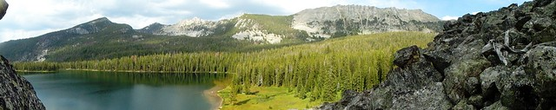

Expectations for our Assistant ID Team Leader
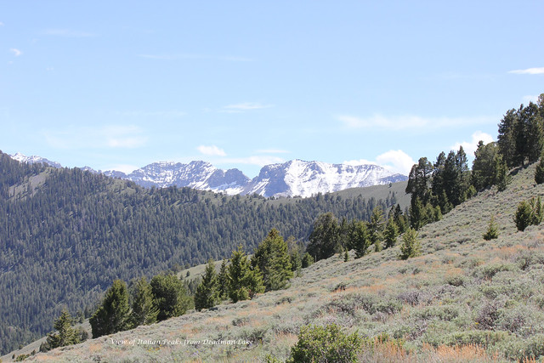
- Provides support of environmental analyses to comply with NEPA and NFMA with a focus on process management, document preparation, and review.
- May lead interdisciplinary teams carrying out routine environmental studies and evaluations to determine the impacts of various actions or events, such as forest planning projects, on the environment.
- Tracks progress of NEPA documents and supports accomplishing timelines set for team members by facilitating problem identification and resolution.
- Reviews routine environmental studies and evaluations linking a variety of resources, such as social, cultural, and economic values, land, air, water, timber, recreation, wildlife, fisheries, and/or special management areas. Analyzes and reviews environmental impacts on social, economic, environmental, and other resources and provides input regarding alternatives for managing natural resources.
- Works with the project leads to ensures the design criteria or mitigation specified in NEPA decision is incorporated in the implementing tool. Reviews comments received from other federal, state, public agencies, tribes, etc. to determine how to catalog and works with the ID Team Leader to respond to concerns in accordance with environmental laws, regulations, and policies.
- Organizes records for Objection Panel review and converts to administrative record for potential litigation.
- Assists specialists writing and developing environmental analysis reports, and reviews data collected by specialists for the project record and preparation of environmental documents. Assists with providing management advice regarding appropriate procedures in the use of analytical tools and information systems and that NEPA and NFMA regulations are followed. Gathers and reviews subject matter documents and includes the required information in the NEPA, or other, source document.
- Serves as the Forest EndNote Librarian and assists specialists who need to install and use EndNote for NEPA analysis and reference management.
- Provides input for building interdisciplinary approaches and developing policies, procedures and techniques to solve problems that require adaptations or extensions of existing rules.

Other
This position would require occasional travel to meetings and trainings around the region.
This is a non-supervisory position.

Beaverhead-Deerlodge National Forest
The largest of the national forests in Montana, the BDNF covers 3.35 million acres and lies in eight southwest Montana counties. The Forest has one of the most diverse land bases in Montana. It is unique in that is connects three of the most intact large ecosystems in the lower forty-eight states. The Forest provides timber, minerals, and grazing lands. It also offers breath-taking scenery for a wide variety of recreational pursuits. The Forest has incredible mountain ranges, mountain lakes, great fishing rivers and streams, and wildlife abounds.
Climate in southwest Montana is graced with four seasons, generally experiencing cold, snowy winters and relatively warm summers, though temperature changes from day to night can vary greatly. Temperatures range from an average high in August of 80 degrees to an average low in January of 10 degrees. Below-zero temperatures in the winter are common.
If you would like more information on the Beaverhead-Deerlodge NF, check out our webpage: http://www.fs.usda.gov/bdnf. For additional information about Southwest Montana, visit http://www.beaverheadchamber.org/

Lolo National Forest:
The 2.3 million Lolo National Forest (NF) in west central Montana is one of ten national forests in Montana. Created in 1906, the Lolo NF now includes former national forests originally named the Cabinet, Hell Gate, Missoula, and Selway National Forests. It’s located west of the continental divide and influenced by both continental and maritime climates. These climates provide for a wide range of environmental gradients producing a forest of high diversity. Diverse ecosystems range from wet, western red cedar bottoms to high alpine peaks, and forests of alpine larch and white bark pine.
These diverse ecosystems are home for 17 conifer and 5 hardwood tree species, over 300 bird species, at least 20 fish species, over 60 mammal species and an estimated 1,500 plant species, including 250 non-native plant species. Within the Lolo NF, are record-sized trees, the Montana Champion ponderosa pine located in the Fish Creek drainage and a national co-champion western larch near Seeley Lake.
Elevation ranges from less than 2,400 ft. on the Clark Fork River below Thompson Falls to many peaks over 7,000 ft. and topping out at over 9,000 ft. at Lolo Peak near the town of Lolo and Ptarmigan Point near Seeley Lake. The highest point is Scapegoat Mountain within the Scapegoat Wilderness. More information about the Lolo National Forest can be found at: www.fs.fed.us/r1/lolo/.

Flathead National Forest
The Flathead includes 2,400,000 acres in the Northern Continental Divide Ecosystem. The spectacular glacial mountains feature majestic peaks, lush forests, snowfields, lakes and alpine. Waters of the Forest flow from numerous mountain streams into the Swan, Stillwater, and 3-forks of the Flathead River downstream into Flathead Lake, the largest freshwater lake west of the Great Lakes. These offer a mix of white-water and quiet water in rocky and forested canyons with outstanding mountain views and provide habitat for native bull trout and westslope cutthroat trout.
World-class wild lands include the remote Bob Marshall, Great Bear, and Mission Wilderness areas (aka Bob Marshall Wilderness Complex), nationally designated Wild & Scenic Rivers, and the adjacent Glacier National Park. These areas are habitat for grizzly bear, wolves, mountain goats, Canada lynx, wolverine, and large elk herds. As stewards of portions of both the BMWC and Northern Continental Divide Ecosystem, the Forest has a responsibility to help sustain this incredible landscape for future generations.
More information about the Flathead National Forest may be found here: https://www.fs.usda.gov/flathead. Information about Flathead County may be found here: https://flathead.mt.gov/about_flathead_county/index.php.

Nez Perce-Clearwater National Forest
From the dry, rugged canyons of the Salmon River to the moist cedar forests of the Selway drainage to the rolling uplands of the Palouse, the Nez Perce-Clearwater National Forests offers something for everyone. This vast, diverse area is managed to provide a variety of goods and services including breathtaking scenery, wilderness, wildlife, fisheries, timber harvest, livestock grazing, mining, pristine water quality and a wide array of recreation opportunities. The Nez Perce-Clearwater National Forests is best known for its wild character. Nearly half of the forest is designated Wilderness. They also sport three rivers popular with thrill-seeking floaters—the Selway, the Lochsa and the Salmon. More information about the Nez Perce-Clearwater National Forest can be found at www.fs.usda.gov/nezperceclearwater/
For more information about the position, contact Zo Anderson at zoanne.anderson@usda.gov

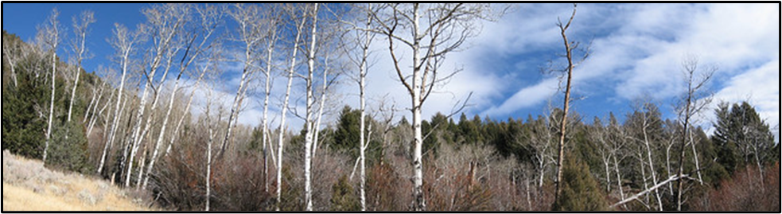
###
USDA is an equal opportunity provider, employer, and lender.

Outreach Response

For Permanent Full-Time Appointment

Reply by May 30th, 2022 to Julie.schaefers@usda.gov

Position Identification
Position Title: | NEPA Planner (Assistant Interdisciplinary Team Leader)
Series/Grade: | GS-0101/0401-9
Duty Station | Multiple locations across USFS Region 1 including: : Dillon, Philipsburg, Ennis, Wisdom, Butte, Missoula, Superior, Hungry Horse, Bigfork, Montana and Kamiah, Idaho. Other duty stations in Region 1 may also be considered.
Applicant Information
Name: |  |  | E-Mail Address:
Mailing Address:
Phone:
Are you a current federal employee? Yes: No:
Current Agency if applicable:
Current Region/Forest/District if applicable:
Current Title, Series and Grade if applicable:
What is your preferred Duty Station?
Type of Appointment: |  | Permanent Temporary Term VRA  PWD Other Not Current Employee

If you are NOT a current permanent (career or career conditional) employee, are you eligible to be hired under any of the following authorities:
Reinstatement  Veterans Recruitment Act  Disabled Veteran with 30% Compensable Disability  Veteran’s Employment Opportunities Act of 1998 |  |  |  | Person with Disabilities  Former Peace Corps Volunteer  Pathways (Recent Graduates/Student/PMF)  Other
Qualifications / Additional Remarks
Briefly describe why you would be a quality candidate for this position and whether you are interested in the detail and/or the permanent appointment.

