United States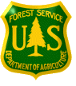Forest Service
Outreach Notice for GS-0303-4/5
Administrative Clerk
Region 1
Helena – Lewis and Clark National Forest
Judith Musselshell Ranger District, Harlowton, MT

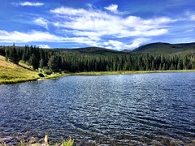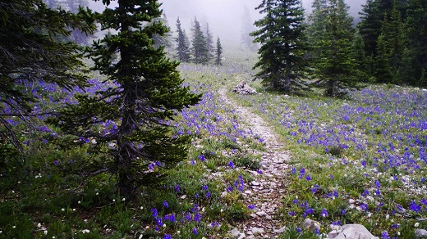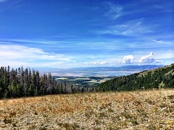

The Helena – Lewis and Clark NF will soon be advertising and filling a Administrative Clerk, GS-0303-4/5 at the Harlowton, MT Office.

TO EXPRESS INTEREST IN THE POSITION:

Please fill out the attached outreach response form and send to Jason Oltrogge, District Ranger, at jason.oltrogge@usda.gov by close of business, May 13, 2022. The vacancy announcement for this position will be posted on the U.S. Government’s official website for employment, www.usajobs.gov. The announcement will be posted at a later, yet undetermined date. Once the announcement is posted, all who responded to the outreach notice will be contacted by email to let you know what the vacancy announcement number will be for this position. Applicants must have all required documentation to be considered for this position

THE POSITION
This position is non-supervisory and performs duties which typically include the following:

Greets visitors and responds to phone and written inquiries, which often requires an explanation in general terms of functions of the Agency to distinguish among and between functions related to the subject of the inquiry. Uses good host techniques in all contacts.

Evaluates inquiries in order to provide the most useful and appropriate information or to suggest other productive sources of specific information applicable to the nature and subject of inquiry. Resolves inconsistencies in available information and if necessary.

Arranges displays of informational and natural materials in the reception area. Varies or changes displays to coincide with seasonal changes, and special public information programs. Uses imagination and good taste to achieve desirable results.

Uses word processing software and printing equipment to create, copy, edit, store, retrieve, and print a variety of standardized documents using a glossary of prerecorded formats, form letters, standard paragraphs, and mailing lists. May use database or spreadsheet software to enter, revise, sort, or calculate, and retrieve data for standard reports.

Serves as Collection Officer to sell such items as National Forest maps, Christmas tree permits, 2400-4’s (Forest Product Sale Permits), and Golden Age Passports in accordance with manual and handbook requirements. Is held accountable for the funds collected. Maintains accountability records as required.

THE ORGANIZATION
The Helena - Lewis and Clark National Forest is located in west central Montana and manages more than 2,700,000 acres. It straddles the Continental Divide and encompasses headwaters of both the Missouri and Columbia River systems. Elevations range from about 3,500 feet to over 9,000 feet. Precipitation varies from 10 to 60 inches across the forest. The forest offers a diversity of environments ranging from open, rolling sage and grassland, to dense timbered mountain slope, to alpine meadows and parks. The Forest has a rich cultural history – mining claims both large and small scale operations; unique front and backcountry recreational opportunities – Wilderness areas, nationally recognized trails and river corridors, and ski resorts. The Helena-Lewis & Clark has two Supervisor’s Offices and six Ranger Districts with 300 employees and offices located at: Helena, Great Falls, Choteau, Augusta, Stanford, Harlowton, Neihart, White Sulphur Springs, Townsend, Helena and Lincoln.

COMMUNITY INFORMATION

The town of Harlowton (population approximately 1000) sits at an elevation of 4309 feet in a picturesque rangeland setting between the Big Snowy, Crazy, and Little Belt Mountains. Harlowton is positioned in the central/south central part of Montana. Within two hours driving time or less one can be in four of the largest cities in Montana, Billings to the east which is Montana’s largest community and the closest at 100 miles, to the south is Bozeman which is the home of Montana State University, to the west is Helena which is the state Capitol of Montana and to the north and furthest is Great Falls which houses the Lewis and Clark Supervisors Office. Harlowton, is an "old railroad town". With the closing of the Milwaukee Railroad, it is now predominately an agricultural community. However, new industries such as the Judith Gap, Shawmut and Martinsdale wind farms are picking up steam in the area. Some private rental units are available.
Community services include Bair Memorial Clinic, Wheatland Memorial Hospital and Nursing Home 24 hour emergency room services, Wheatland County Ambulance, a local pharmacy and emergency helicopter services from Billings and Great Falls to serve medical needs. A dentist on a part time basis also serves the community. There is a small community airport, two motels, four restaurants, a large City Park that includes camping, rodeo grounds, golf course and youth fishing, Citizens Bank and Trust Co., one grocery store, two gas stations with convenience stores, one casino, two hardware stores and several small businesses providing a variety of goods and services. Two public schools, Hillcrest Elementary have K-6 and Harlowton High School handles 7-12. The community also has a municipal swimming pool that opens in the summer.
Other services are readily available at the larger cities of Great Falls (2 hour drive) or Billings (1 ½ hour drive).
Commercial airline service is available in Great Falls, Helena, Bozeman, Billings and Lewistown. Amtrak stations are located in Shelby, Havre and Malta.

Additional links:

Helena-Lewis and Clark National Forest: https://www.fs.usda.gov/hlcnf/

WEBSITES

Helena Area Chamber of Commerce: https://helenachamber.com/
City of Helena: https://www.cityof.com/mt/helena/local/government

Great Falls Area Chamber of Commerce: https://www.greatfallschamber.org/
City of Great Falls: https://greatfallsmt.net/

FOR MORE INFORMATION/CONTACT
_________________________________________________________________________________________________________
Contact Jason Oltrogge 406-566-2292 or by email: Jason.oltrogge@usda.gov. Depending on the outreach response, referral lists will be considered in both the Merit and Demo categories. All interested applicants should submit the attached outreach survey form so they can be notified of the vacancy announcement number and closing date when it becomes available.

OUTREACH RESPONSE FORM
Helena – Lewis and Clark National Forest
Administrative Clerk, GS-0303-4/5
Email to Jason Oltrogge at Jason.oltrogge@usda.gov
Respond by May 13, 2022
NAME:
E-MAIL:
MAILING ADDRESS:
PHONE:

Agency: | USFS | BLM | Other
Type of Appointment: | Permanent | Temporary | Term |  | VRA | PWD |  | Other
Current Title/Series/Grade:

Current Location (Region/Forest/District):

Briefly explain your interest in this position and/or attach a resume:

USDA Non-Discrimination Statement Revised 6/8/2005
“The U.S. Department of Agriculture (USDA) prohibits discrimination in all its programs and activities on the basis of race, color, national origin, age, disability, and where applicable, sex, marital status, familial status, parental status, religion, sexual orientation, genetic information, political beliefs, reprisal, or because all or part of an individual’s income is derived from any public assistance program. (Not all prohibited bases apply to all programs.) Persons with disabilities who require alternative means for communication of program information (Braille, large print, audiotape, etc.) should contact USDA’s TARGET Center at (202)720-2600 (voice and TDD). To file a complaint of discrimination, write to USDA, Director, Office of Civil Rights, 1400 Independence Avenue, S.W., Washington, DC 20250-9410, or call (800) 795-3272 (voice) or (202) 720-6382 (TDD). USDA is an equal opportunity provider and employer.”

