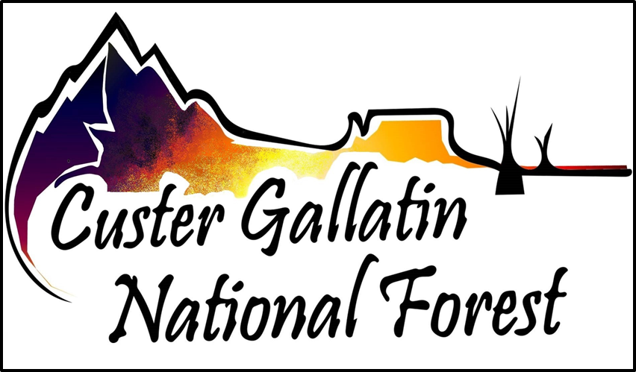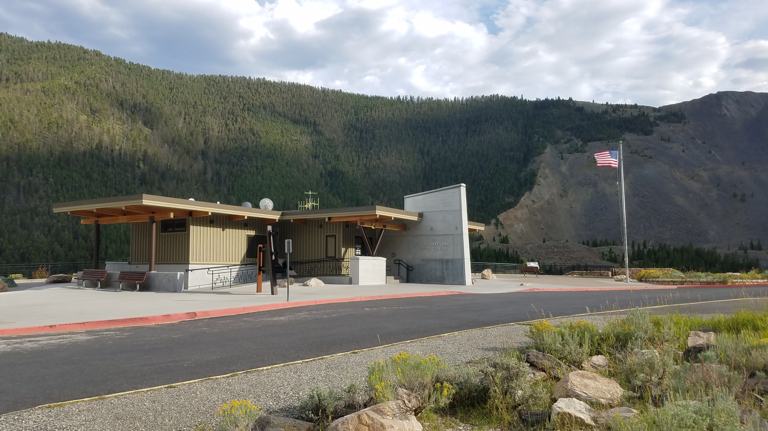

OUTREACH NOTICE:

Earthquake Lake Visitor Center Manager
Custer Gallatin National Forest
Hebgen Lake Ranger District
GS-1001-07

The Hebgen Lake Ranger District of the Custer Gallatin National Forest is seeking to permanently fill a position as the Earthquake Lake Visitor Center manager. This notification is being circulated to inform prospective applicants of the upcoming opportunity.

This position may be filled permanently through use of direct hire authorities or advertised competitively. The hiring manager is considering use of direct hire authorities available to:
- Resource Assistants
- Veterans
- Those with Schedule A disabilities, and
- Current federal employees through lateral reassignments

Interested candidates must respond for direct hire consideration.

Position Overview

This position monitors the daily functions of the interpretation program and to provide resource interpretation, education, and visitor services information. Major duties of the position include:
- Coordinates and directs the daily operations of the interpretation program. Develops environmental and interpretive education programs and materials.
- Works with outside partners on a formal and informal basis to advance the goals of interpretive services program of the Forest Service.
- Provides liaison with community organizations and interest groups to stimulate interest in and utilization of Forest Service facilities.
- Contacts and arranges for presenter who are knowledgeable in the requested program topic.
- Researches, develops, revises and updates educational materials including pamphlets, guides, fact sheets, brochures and interpretive displays.
- Serves as unit collection officer and is responsible for accounting, balancing, reconciling and accurate record keeping of funds.

A successful candidate will have strong partnership, leadership, communication, and collaborative skills.

Government housing is NOT currently available.

For more information about the positions, please contact:
Brian Thompson brian.r.thompson@usda.gov or (406) 823-6961

About the Earthquake Lake Visitor Center

On August 17, 1959, near midnight, an earthquake near the Madison River triggered a massive landslide. The slide moved at 100 mph and in less than 1 minute, over 80 million tons of rock crashed into the narrow canyon, blocking the Madison River and forming Earthquake Lake. This earth-changing event, known as the Hebgen Lake Earthquake, measured 7.5 on the Richter scale. At the time it was the second largest earthquake to occur in the lower 48 states in the 20th century. Twenty-eight people lost their lives in the event.

In 1967, the Forest Service’s Earthquake Lake Visitor Center opened its doors for the first season of operation. Today, the center provides interpretive services for approximately 50,000 visitors annually. The natural attractions and the easily-seen effects of the strongest earthquake in the Rocky Mountains has made this area one of the outstanding scenic and geological study areas in the west. The VC is operated in partnership with a non-profit partner, Yellowstone Forever. Through the partnership with Yellowstone Forever, there is a bookstore operated at the VC, with a portion of net proceeds being re-invested directly into the center.

Located approximately 25 miles northwest of the Hebgen Lake Ranger Station, the center provides a panoramic view of the mountain that fell and the lake that was formed. This facility hosts interpretive displays on earthquakes, plate tectonics, and a working seismograph. In the observatory, scheduled movies and talks, explain the story of the 1959 Hebgen Lake Earthquake. There are restrooms, outside interpretive signs and a walking path to the Memorial Boulder.

About the Custer Gallatin Forest National Forest

Encompassing more than 3.1 million acres and stretching across seven ranger districts from Camp Crook, South Dakota, to West Yellowstone, Montana, the Custer Gallatin National Forest is known as one of the most ecologically diverse landscapes in the region.

The Custer Gallatin is home to some of the tallest peaks in the Northern Rockies, which rise from subalpine meadows interspersed with hanging valleys and lakes. The Custer Gallatin is nationally known for its superb recreational opportunities and outdoor pursuits. The Forest has significant partnerships with our neighboring Forests, Yellowstone National Park, the Bureau of Indian Affairs, the Montana Department of Fish, Wildlife, & Parks, the academic community, and a wide variety of non-governmental organizations. As Gateway to Yellowstone National Park, the Absaroka-Beartooth Wilderness and the Lee Metcalf Wilderness, the Forest features many adventures among rugged mountains, including the tallest Peak in Montana to remote Buttes and Bluffs of southeastern Montana and northwestern South Dakota.

Go to http://www.fs.usda.gov/custergallatin for more specific information about the Custer Gallatin.

About the Community

West Yellowstone is located 90 miles south of Bozeman, Montana and 75 miles north of Rexburg, Idaho and serves as the west entrance to Yellowstone National Park. The community is a mountain basin at nearly 6,700 feet above sea level with a winter population of 1,200 residents and a summer population of 2,500 – 3,000 residents. The town hosts roughly 10,000 tourists every day during the summer. Housing is very limited and expensive, with a median home listing price of $662,000. Island Park, ID is within commuting distance, but housing is also limited and expensive.

During summer, town is alive with people walking the streets and buses, trailers, and cars constantly rattling through. Winter is welcomed in with the annual cross-county ski fall festival on the world-renowned Rendezvous ski trails. Town fully swings into “winter gear” as Yellowstone National Park re-opens for winter in mid-December. Town “rests” during the shoulder seasons of mid-November to mid-December and mid-March to mid-April.

Formerly known as the “snowmobile capitol of the world,” West Yellowstone is a tourism & recreation-based economy. Coupled with a variety of dispersed recreation opportunities and an extensive network of outfitter guide businesses (rafting, hiking, snowmobiling, biking, Nordic and backcountry skiing, hunting, eco-tourism, fishing, pack stock trips, sea kayaking, etc) in the area, the visitor services industry is critical to the livelihood of West Yellowstone and surrounding area residents.

The climate is often cool/cold. West Yellowstone often posts the coldest temperature in the State of Montana or lower 48 states for any given day. Snow accumulation begins in late October and can last until mid-May with a peak accumulation of 4 to 5 feet of snow by the end of March not being uncommon.

Medical facilities consist of a medical clinic which is staffed by a physician assistant and is open year-round (though not daily outside of peak summer season). Ambulance services are staffed year-round by paid Emergency Medical Technicians and a volunteer search-and-rescue unit. The closest hospitals are in Bozeman, MT, (90 miles north) and Ennis, MT, (75 miles northwest). There are two small grocery stores in West Yellowstone, with larger shopping venues found in Bozeman, MT and Idaho Falls, ID.

For more information:
West Yellowstone Chamber of Commerce and Visitor Information Center

Town of West Yellowstone

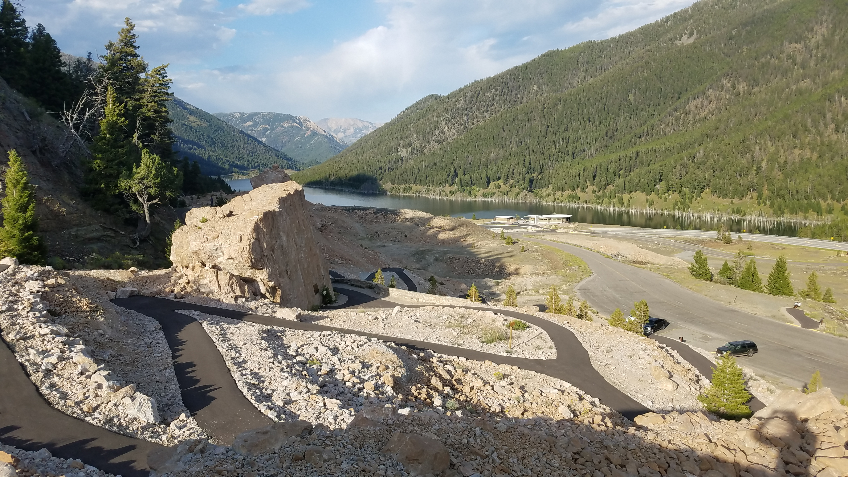
CUSTER GALLATIN NATIONAL FOREST OUTREACH NOTICE
Visitor Information Assistant GS-1001-07
West Yellowstone, Montana
Respond by May 13, 2022

Name: Click or tap here to enter text.
Email Address: Click or tap here to enter text.
Mailing Address: Click or tap here to enter text.
Telephone Number: Click or tap here to enter text.
Agency Employed With: Click or tap here to enter text.
Type of Appointment: Choose an item.
Current Region / Forest / District: Click or tap here to enter text.
Current Grade and Series: Click or tap here to enter text.
Current Position Title: Click or tap here to enter text.
How did you find this outreach notice? Click or tap here to enter text.
If you are not a current permanent (Career or Career Conditional) employee, are you eligible to be hired under any of the following Special Authorities:
☐ Person with Disabilities (Schedule A)
☐ Veterans Readjustment (VRA)
☐ Disabled Veterans w/30% Compensable Disability
☐ Veterans Employment Opportunities Act of 1998 (VEOA)
☐ Former Peace Corps Volunteer
☐ Student Career Experience Program
☐ Other
If you are interested in this position, please respond with this outreach response form to brian.r.thompson@usda.gov by May 13, 2022. If you have questions or want more information, you may contact Brian Thompson at (406) 823-6961.

