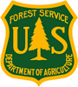
Outreach Notice

___________________________________________________________________
USDA Forest Service
Northern Region
Nez Perce-Clearwater National Forests

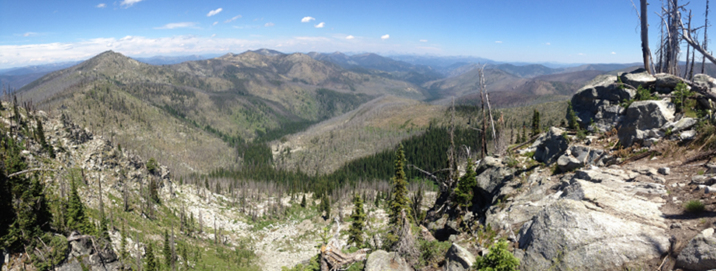

Forest Recreation Special Uses-Agreement Specialist
Up to 120 Temporary Promotion, detail, permanent-full-time.

GS-0301-9/11
Supervisor’s Office

Nez Perce-Clearwater National Forest

Kamiah, ID
Sept 24, 2023
Responses after Sept 10th will continue to be accepted until detail filled and to better understand interest in the permanent position.

OUTREACH NOTICE

The USDA Forest Service, Northern Region, is outreaching for a 120 Day Detail Opportunity for a GS-0301-GS 9/11 Forest Specialist to oversee Forest Recreation Special Uses-Agreement program work on the Nez Perce-Clearwater National Forests.

Interested applicants may respond to this outreach by close of business Sunday, Sept 24th , 2023
Direct inquiries and expressions of interest to Quentin Smith, Recreation, Engineering, Lands, Minerals Staff Officer, at 208-400-0976, or by email at quentin.smith@usda.gov.

page 2

Northern Region Nez Perce-Clearwater National Forests

Forest Recreation SPECIAL USES-AGREEMENT SPECIALIST

120 Day Detail Position
NATIONAL FORESTS
ABOUT THE POSTIION
This position is located on the Nez Perce-Clearwater National Forests, Supervisor’s Office, in Kamiah, ID. The incumbent serves as the Forest Specialist for the Recreation Special Uses and Recreation focused Grants and Agreements program work on the Forest. The position is supervised by the Forest’s Recreation, Wilderness, Trails, Rivers, and Outfitter/Guide Program Manager. In this capacity, the incumbent works with the ranger districts to support issuance of Recreation Special Use permits including recreation event permits, two resort permits and approximately 30 outfitter/guide permits, and over 40 partnership agreements to support an array of partners supporting the Forests’ winter and summer recreation programs.

Incumbent supports Recreation Special Use Permit operations by
- Reviewing proposals for permit requests
- Coordinating any NEPA needed for permit issuance.
- Working collaboratively to draft and issue permits.
- Completing billing and SUDS entries and accomplishments
- Overseeing the Forest’s two permitted resort operations including working collaboratively to draft facility development and maintenance plans and complete annual inspections and billings.

Incumbent supports outfitter operations on the districts by
- Providing filed inspection services for permitted operations and camps (stock experience is desired but not required)
- Drafting and participating in annual performance evaluations
- Completing billing and SUDS reporting requirements for managing permits to standard
- Collaborating with the Idaho Outfitters and Guides Licensing Board (IOGLB) and Idaho Department of Fish and Game (IDFG) regarding outfitter operations,
- Working collaboratively with IOGLB, IDFG and the Idaho Outfitters and Guides Association (IOGA) to host the Forest’s annual outfitter meeting.

Incumbent supports Recreation program agreements and grants by
- collaboratively working with interested partners to develop proposals, including partner match opportunities,
- collaboratively working with partners to draft operating and financial plans for agreements and grant awards, the Forest recreation program currently managers over 40 challenge cost share agreements and numerous state grants
- supports the Forest and Districts recreation programs of work by annually seeking out and drafting grant proposals.

The Forest’s recreation program is guided by a recreation strategy that includes collaborative and partner input and functions using a team approach, in a boundaryless manner across three zones that encompass six combined ranger districts. The Forests three zone recreation program staffs are intricately involved in program planning, oversight, and delivery.

The Nez Perce Clearwater Forest’s backcountry offers has some of the most extraordinary recreational opportunities offered on any National Forest in the nation. With the aid of dedicated partners who provide relevant perspective and ingenuity we realize our program management must stay dynamic to meet the persistent challenges of changing visitor expectations, evolving recreation technology, changing budget allocations and capacity.

The program manager provides oversight for:
- A National Historic Landmark (Lolo Trail NHL)
- 5 Wild and Scenic Rivers (Middlefork Clearwater including the Lochsa and Selway Rivers, Salmon River, Rapid River)
- 3 Wilderness areas (Selway-Bitterroot, Gospel Hump, Frank Church River of No Return; 1.4 million acres)
- 2 Recommended Wilderness Areas (Hoodoo, also known as the Great Burn, Mallard Larkins)
- 34 Idaho Roadless Areas,
- Historic Road Corridors including (McGruder Corridor, Elk City Wagon Road, Lolo Motorway)
- 2 National Historic Trails (Lewis & Clark and Nee-Me-Poo (Nez Perce) NHTs)
- 6 National Recreation Trails including segments of the Idaho Centennial Trail
- 20 unique geographic areas that encompass the Forests’ 5200 miles of NFS trail, 198 developed sites and 1465 dispersed sites, and
  - winter sports areas including Latah, Clearwater and Idaho County Groomed snowmobile areas, Palouse Nordic Park N Ski area, and Lolo Pass snowmobile and Nordic Ski areas

ABOUT THE NEZ PERCE – CLEARWATER NATIONAL FORESTS

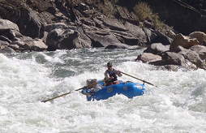
The Nez Perce-Clearwater National Forests are about:
- Promoting and protecting our history, wildlands, and wild experiences.
- Connecting with our communities.
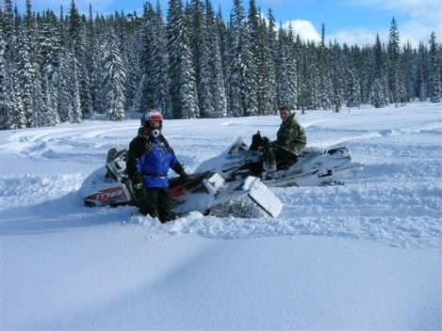
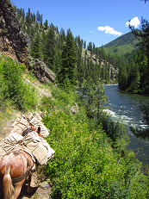
- Building and restoring resiliency in our diverse landscapes, workforce, and relationships.
The Nez Perce-Clearwater NFs are a complex forest with diverse ecosystems that range from dry ponderosa pine to coastal disjunct communities. Wildfire is a primary driving force in the forested ecosystems.
The four-million-acre forest extends from the Selway-Bitterroot Continental Divide to Hells Canyon. Approximately one third of the Forest is wilderness, another third is roadless designated under the Idaho Roadless Rule, and the final third is referred to as the “Front Country” where most of the timber harvest and roaded recreation occurs.
There are six Ranger Districts with approximately 325 permanent employees and over 225 seasonal employees during the summer field season. The Forests also host the Grangeville Smokejumper, Grangeville Air Center and Grangeville Interagency Dispatch Center.
There is an active collaborative group with strong regional and national relationships. The Clearwater Basin Collaborative represents all interests and have been instrumental in garnering support for restoration projects, including projects under the Collaborative Forest Landscape Restoration Program. There is one CFLRP area on the Forest - Clear Creek.
The Forest also has multiple partnerships that are critical for accomplishing our work including: Selway-Bitterroot Foundation, Rocky Mountain Elk Foundation, Nez Perce Tribe, and multiple recreation groups amongst others.
The current Forest priorities are:
- Landscape Restoration focusing on working with partners to accomplish landscape-scale restoration to improve watershed function, habitat for wildlife, recreational opportunities, and reduce hazardous fuels, as well as providing local employment.
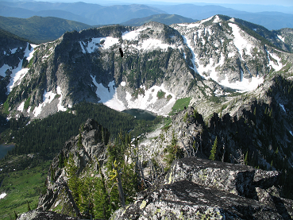
- Forest Plan Revision under the 2012 Planning Rule. The Forest is an early adopter of the Planning Rule and the resulting Forest Plan will be viewed by many as an example. The Forest Plan and accompanying environmental impact statement will be completed within two years.
- Wildland Fire Preparedness including training and preparedness to manage wildland fire incidents on the Forest and across the country.
More information about the Nez Perce-Clearwater NFs is available at: http://www.fs.usda.gov/nezperceclearwater

KAMIAH AND THE SURROUNDING AREA

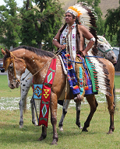
The Nez Perce-Clearwater National Forests are in an area rich with history, abundant fish and wildlife and unique recreation opportunities.
Kamiah is within the Nez Perce Reservation. The Tribe holds events in Kamiah and welcomes non-tribal members’ participation at most of their events. History of the Nez Perce Tribe and Lewis and Clark’s Journey is a big draw for visitors to the area. The town’s population is approximately 1300; however, there are about twice that many residents in the surrounding area. The climate in the Kamiah valley is much milder than the surrounding prairies and mountains, with very little snow in winter, long autumns, and early springs. The Clearwater Valley provides abundant sunshine in the summer and protection from harsh winds.

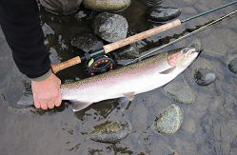
The area is known for its excellent outdoor recreational opportunities. The Clearwater River, the most productive salmon and steelhead watersheds in the Columbia River Basin, runs adjacent to Kamiah. To the south are the Salmon and Snake Rivers. Salmon and steelhead fishing is some of the best in the lower 48. The Forests’ rivers and streams, including Kelly Creek, Lochsa River, and Selway River, also provide nationally renowned blue ribbon catch-and-release trout fishing opportunities for large west slope cutthroat trout. Whitewater rafting is popular on the rivers. Four wilderness areas offer opportunities to explore on foot or horseback: Hells Canyon, Gospel Hump, Frank Church River of No Return and Selway-Bitterroot. For those that favor motorized recreation, the Forest has a developed system of ATV trails that go into the backcountry.
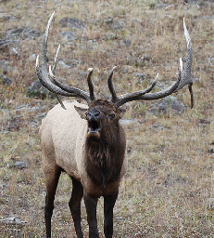
The Forest provides year-round habitat for one of the most significant elk herds in Idaho with an emphasis in restoring elk habitat. White tail deer are abundant.
Outdoor recreation, lumber production, farming and cattle ranching are the major industries in the area.
Communities - There’s several other communities within commuting distance: Kooskia – 8 miles; Orofino – 23 miles; Grangeville – 33 miles; Nezperce – 23 miles; and Cottonwood – 26 miles. Larger communities are Lewiston, Idaho - 64 miles; Moscow, Idaho - 93 miles; Missoula, Montana - 152 miles and Spokane, Washington - 166 miles.
Housing - Government housing is not available. Rental rates for an average three-bedroom home range from $400 to $700 per month. Purchase price for a three-bedroom home in the Kamiah area ranges from $75,000 to $800,000 with numerous homes currently on the market.
Schools and Churches - Public schools are available in Kamiah from preschool through 12th grades. There is a private Catholic school in Cottonwood, Summit Academy. The University of Idaho at Moscow is a two hour drive from Kamiah, and Washington State University at Pullman, Washington is 15 miles beyond that. Lewis-Clark State College at Lewiston is approximately an hour and half drive. Most major religious affiliations are represented in the area.
Medical - A medical clinic is in Kamiah. There are small hospitals in Grangeville, Cottonwood and Orofino. Full service medical facilities are in Lewiston, Spokane and Missoula.
For more information about living in Kamiah, visit these websites:
www.kamiahchamber.com
http://clearwaterprogress.com/

http://www.usclimatedata.com/climate/kamiah/idaho/united-states/usid0424
https://en.wikipedia.org/wiki/Kamiah, Idaho
http://www.fs.usda.gov/npnht/
The U.S. Department of Agriculture Forest Service prohibits discrimination in all its programs and activities on the basis of race, color, national origin, sex, religion, age, disability, political beliefs, sexual orientation, and marital or family status (not all prohibited bases apply to all programs). Persons with disabilities who require means for communication of program information (Braille, large print, audiotapes, etc) should contact USDA's TARGET Center at (202) 720-2600 (voice and TDD).

To file a complaint of discrimination write: USDA, Director, Office of Civil Rights, Room 326-W, Whitten Building, 14th and Independence Ave, SW, Washington, DC
•
20250-9401 or call (202) 720-5964 (voice or TDD). USDA Forest Service is an equal opportunity provider and employer.

OUTREACH RESPONSE FORM
Nez Perce-Clearwater National Forest
Supervisor’s Office

Recreation Special Uses-Agreement Specialist (permanent, temporary promotion, 120 day detail)
GS-0301-GS9/11

Please complete and submit the outreach notice form and/or a resume by COB Sunday, Sept 24, 2023 to Quentin Smith, RELM Staff Officer, Nez Perce-Clearwater National Forests at quentin.smith@usda.gov .

PERSONAL INFORMATION:

Name: |  | Date:
Address: |  | Phone:
 |  | e-mail:

Type of appointment you are currently under:
(e.g., Career, Career-Conditional, Excepted-ANILCA, Excepted VRA, etc)
Are you currently a Federal employee: | YES |  | NO
Current title/series/grade if Federal employee:

Briefly describe why you will be a quality candidate for this position (if additional space is needed, attach below):

