Outreach Notice – Not to Exceed 120-Day Detail-Temporary Promotion and Permanent Vacancy

Kootenai National Forest

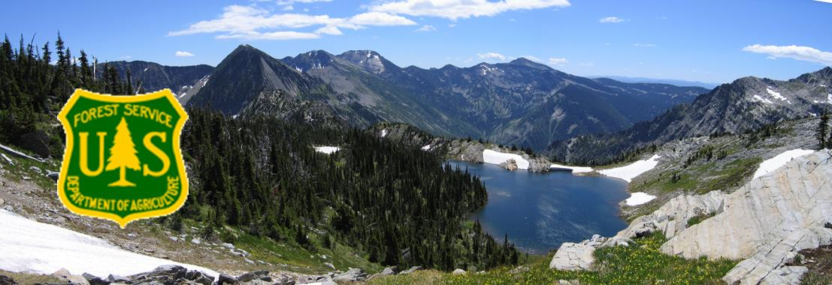

CABINET RANGER DISTRICT
NEPA Planner
GS-0401- 9/11
The Northern Region (R1), Kootenai National Forest is seeking to fill a Not To Exceed 120-day detail/temporary promotion opportunity and the permanent fill for the NEPA Planner (GS-0401- 9/11) position on the Cabinet Ranger District. Duty station will be Trout Creek, MT, however, full remote/telework option may be available.
The results of the outreach will help determine the area of consideration for the vacancy announcement.
Interested applicants are requested to respond utilizing the Employee Outreach Database.
For Forest Service applicants the database is located in ConnectHR.
For external applicants this may be accessed by an internet search for FS Outreach or the following link https://fsoutreach.gdcii.com/Outreach.

Position
The Cabinet Ranger District is looking for strong and innovative leadership in the NEPA Coordinator position. The District’s program is active and diverse in its program of work, including a diversity of timber and vegetation restoration; natural fuels; aquatics, fisheries and wildlife habitat restoration; recreation infrastructure; mining and minerals; and other projects. Complex landscapes, listed fish and wildlife (including grizzly bear), wilderness, and highly prized recreation values add to the complexity of the workload and it’s challenges.
This position works with an interdisciplinary team (IDT) to develop project proposals, assess effects of proposed actions and compile environmental documentation (e.g., decision memos, environmental assessments) so that Responsible Officials can make decisions on issues and affected resources. Provides leadership and oversight to individual projects as delegated. Offers technical knowledge to others concerning technical writing, project record development, and consistency with policy and direction. Reviews documents for NEPA consistencies. Manages the Planning Appeals Litigation System (PALS) database. Coordinates with District and Forest Leadership to monitor and update the status of projects. The ability to work successfully on a team is paramount as this position works both autonomously as well as collaboratively with the Forest NEPA Coordinator.
To receive consideration for this position, you must meet all qualification requirements and application procedures, as listed in the announcement.
Government housing may be available.
The Forest does not offer federal day care facilities.
Upon advertisement and fill of the vacancy, Transfer of Station will not be available for the position. Recruitment or Relocation incentive may be considered. Situational and Full-time telework may be negotiable.
For more information regarding this position, please Michael Feiger (District Ranger) at 406/827-3533 or email at michael.feiger@usda.gov.

Position Duties
Oversight of District NEPA program and environmental analysis program of work, including, but not limited to:
- Oversight, facilitation, and leadership of project-level analysis in support of District projects, including vegetation management/timber actions, natural fuels actions, hydrologic and terrestrial habitat enhancement actions, recreation infrastructure actions, and District Special Uses programs. Directs development of proposed actions, scoping efforts, issue and alternative development, affected environment and effects analysis, and project records in support of respective analyses;
- Coordinates and collaborates with resource specialists and resource areas (wildlife, fisheries, forest vegetation, wildland fire and natural fuels, hydrology, recreation, minerals, and other relevant specialty areas in support of environmental documents and analyses;
- Formulates and edits environmental documentation, including Environmental Impact Statements, Environmental Assessments, actions Categorically Excluded from detailed analysis, and associated Decision documents in support of Line Officer decisions. Supports resource specialist documentation. Applies affective and state of the art writer-editor techniques in support of those products;
- Serves as subject matter expert (SME) for NEPA law, policy, and manual and handbook direction for project analysis and Forest Plan implementation;
- Oversight and management of Project Records for District analyses and Decisions;
- Point of Contact for NEPA analysis activities on the Unit. Coordinates with Forest and District counterparts in relevant resource areas for monitoring and leading annual program of work. Coordinates and updates District Line Officer on project progress;
- As needed, provides contracting officer’s representative oversight for NEPA analysis contracts. Includes SME support to contractors with respect NEPA law, policy, and manual and handbook direction for project analysis and Forest Plan implementation.
ABOUT THE DISTRICT
The Cabinet Ranger District is one of four districts on the Kootenai National Forest in northwestern Montana. Of the 528,000 acres within the District boundary, about 432,000 are federally administered. The Kootenai NF covers 2.2 million acres.
The District has 35 permanent employees and up to 50 temporary employees during the summer field season. District offices are located two miles west of Trout Creek, Montana along Highway 200. At Trout Creek the elevation is 2400 feet with annual precipitation totaling 25 inches. Fall and spring are generally mild; summers can be moderately hot with short periods of 100 degree weather; and winter brings snow and temperatures that are warmer than generally associated with Montana.
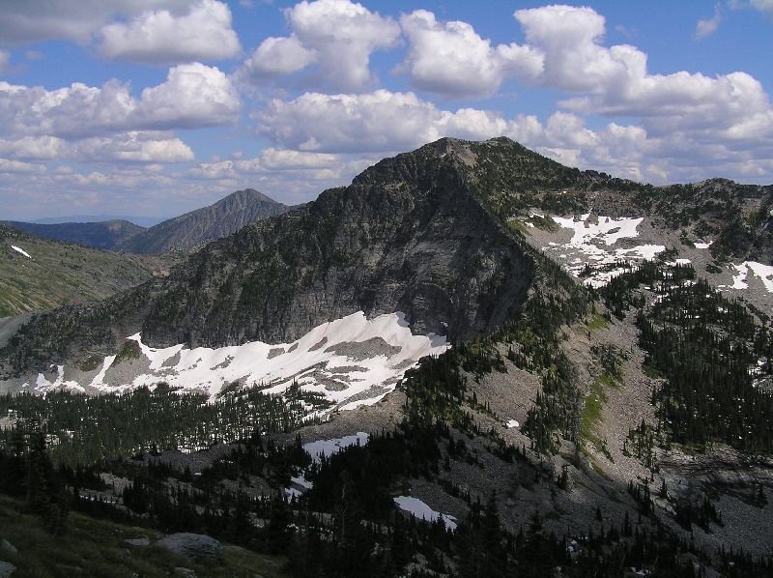
Two reservoirs along the Clark Fork River and nearby streams provide abundant water based recreation with fishing, boating, skiing, and rafting opportunities. Hunting is popular in the autumn. Outdoor winter activities include cross-country skiing, snowmobiling, snowshoeing, and ice fishing. A ski resort is 60 miles away near Sandpoint, Idaho. Hiking and camping opportunities abound in the 94,000 acres Cabinet Mountains Wilderness which is partially on the District. There are several developed campgrounds and three rental lookouts on the District.
This area offers an adventure for those seeking outdoor activities with a view! Although services are limited in the local area; the opportunity to experience the wildlife, huckleberries, and the quiet side of nature are abundant. Trout Creek hosts the annual Huckleberry Festival, which attracts hundreds of tourists. The town has a small grocery store and two card-operated gas stations, two motels, three eateries, and small businesses. Noxon is a similar sized community about 12 miles northwest. Thompson Falls, with a population of 1800, is about 20 miles southeast and serves as the county seat. It has a larger grocery store, two banks, medical services, dentist, bowling alley, hardware stores, public library, nine-hole golf course, and an airport. Hospitals are located in Plains, Montana (45 miles southeast of Trout Creek) and Sandpoint, Idaho (60 miles west of Trout Creek). Churches of various denominations are found in all communities. Other shopping and commercial service opportunities are found in Missoula (120 miles from Trout Creek), Sandpoint, Idaho, Kalispell (130 miles), and Spokane, Washington (130 miles). Commercial airline service is available in Missoula, Kalispell, and Spokane. Railroad passenger service is available in Sandpoint.
Trout Creek has an elementary school while Noxon and Thompson Falls offer elementary and high schools Internet services, including DSL, are available in most areas through internet providers. Wi-Fi is only available through providers or some local businesses. Cell phone coverage is limited, major TV networks are available, however specialty TV channels are only available by satellite.
Housing prices vary from $175,000 for a small, older home to $450,000 or more for a larger home with acreage. Housing inventory can be limited. Bare land is also available. Rental property is challenging to find, but a limited amount is available. Government housing may be available. District employees live in Trout Creek, Thompson Falls, Noxon, or Heron, Montana (near Idaho state line); and at the Ranger Station. For more information on Trout Creek go to Sanders County.
ABOUT THE FOREST
The Kootenai National Forest encompasses over 2.2 million acres of NFS lands. The forest is located in the extreme northwest corner of Montana, including a small portion of northeast Idaho. The forest consists of 4 Ranger Districts located in Eureka, Troy, Libby and Trout Creek; 3 Staff Units located in the Supervisor’s Office and Engineering located throughout the units. The forest is bordered on the north by British Columbia, Canada and on the west by Idaho.
The Kootenai is truly a forest with multiple uses. The vegetation management program is aimed at restoring and maintaining Northern Rockies fire dependent habitats. The diversity of tree and other plant species is among the greatest in the Northwest. Management and recovery of threatened and endangered species, such as grizzly bear, lynx, and bull trout emphasize the forest wildlife and fisheries programs. Other wildlife on the forest include gray wolf, wolverine, cougar, elk, moose, white-tailed and mule deer, mountain goat, bighorn sheep, bald and golden eagles and other species of birds, mammals, amphibians, and reptiles.
INDIAN TRIBES
The Kootenai National Forest (KNF) encompasses lands that are part of the Confederated Salish and Kootenai Tribes (CSKT) Aboriginal Territory. In the Hell Gate Treaty of 1855 the CSKT ceded over 22 million acres to the United States Government retaining 1.2 million acres for their own use that today is the Flathead Indian Reservation. The Flathead Indian Reservation is approximately 85 miles southeast of the Kootenai National Forest. The Tribes retain Treaty rights under the Hell Gate Treaty on federal lands such as the KNF. These rights include hunting, gathering, digging plants and roots, fishing, and grazing on Kootenai National Forest lands.
The Kootenai National Forest holds many places in the natural environment that are important to the Kootenai people. These are known as cultural sites and traditional cultural properties. The relationship and bonds that Kootenai people have to these places were established before there was a Kootenai National Forest and the stories, place names and songs from these sites have been handed down from generation to generation. This is called a cultural landscape and is the basis for or essence of Kootenai identity and culture.
USDA Nondiscrimination Policy, June 2, 2015
In accordance with Federal civil rights law and U.S. Department of Agriculture (USDA) civil rights regulations and policies, the USDA, its Agencies, offices, and employees, and institutions participating in or administering USDA programs are prohibited from discriminating based on race, color, national origin, religion, sex, gender identity (including gender expression), sexual orientation, disability, age, marital status, family/parental status, income derived from a public assistance program, political beliefs, or reprisal or retaliation for prior civil rights activity, in any program or activity conducted or funded by USDA (not all bases apply to all programs). Remedies and complaint filing deadlines vary by program or incident.
Persons with disabilities who require alternative means of communication for program information (e.g., Braille, large print, audiotape, American Sign Language, etc.) should contact the responsible Agency or USDA’s TARGET Center at (202) 720-2600 (voice and TTY) or contact USDA through the Federal Relay Service at (800) 877-8339. Additionally, program information may be made available in languages other than English.
To file a program discrimination complaint, complete the USDA Program Discrimination Complaint Form, AD-3027, found online at ASCR_USDAGOV and at any USDA office or write a letter addressed to USDA and provide in the letter all of the information requested in the form. To request a copy of the complaint form, call (866) 632-9992. Submit your completed form or letter to USDA by: (1) mail: U.S. Department of Agriculture, Office of the Assistant Secretary for Civil Rights, 1400 Independence Avenue, SW, Washington, D.C. 20250-9410; (2) fax: (202) 690-7442; or (3) email: program.intake@usda.gov (link sends e-mail).
USDA is an equal opportunity provider, employer and lender.

