Outreach Notice

Kootenai National Forest
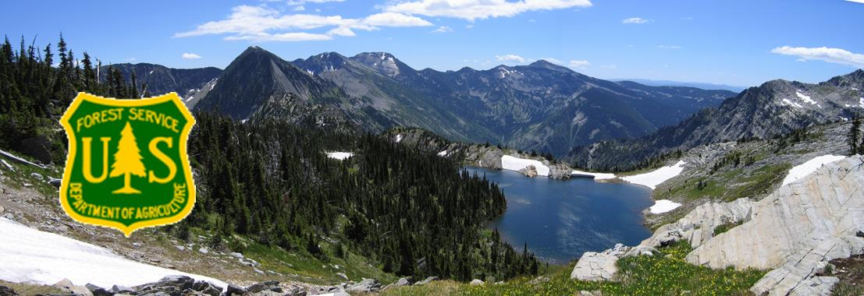
KSANKA RANGER DISTRICTS
NEPA Planner
(GS-401/9-11)

The Northern Region (R1), Kootenai National Forest, Ksanka Ranger District will be filling one NEPA Planner(GS-401- 9/11) position. Duty station is Eureka MT. This outreach is to seek candidates interested in a 120 day temporary promotion, as well as filling a permanent fulltime position.
The results of the outreach will help determine the area of consideration for the vacancy announcement.
Interested applicants are requested to respond utilizing the Employee Outreach Database or contact the supervisors listed below by 29 September,2023.
For external applicants this may be accessed by an internet search for FS Outreach or the following link https://fsoutreach.gdcii.com/?id=15C42BFAB26E429881BE2DFE8356AA04
Duties:
This is a permanent, full-time position. The incumbent serves as a the primary NEPA Planner on the Ranger District and is a member of the District Leadership Team. The position is responsible for performing work involved in Natural Resources Planning and Environmental law compliance, including the National Environmental Policy Act (NEPA).
The position will be supervised by the District Ranger and the duty location will be at the Ksanka Ranger Station in Eureka, MT.
Primary roles and responsibilities may include:
- Participates in developing the unit program of work for all aspects or portions of the unit-planning program. Primary staff to the District Ranger
- Is responsible for leading the interdisciplinary teams and developing the environmental analysis reports concerning resources activity. Participates in public relations events involving speaking engagements and field trips.
- Serves as contact for facilitating the project planning efforts between inter—and intra-agency organizations. Coordinates the assimilation of needed requirements, i.e., environmental design art, budget, safety, etc. in all unit program-planning efforts. Sets program of work goals, timelines, priorities, and schedules.
- Responsible for the collection and the analysis of professional and environmental data to measure and evaluate the effects of impacts of management proposals of resources (natural, social, or economic).
Serves as the main point of contact for NEPA activities for the unit and the primary expert in the development and processing of NEPA documents. Is the units primary contact to the public and other federal or public office on the NEPA processing of documents, appeals, etc.
We are looking for an individual that is strong in leadership, relationships, working with a variety of teams and resource management. In addition to a strong natural resource management background, an ideal candidate would have good oral and written communication skills, and experience in project development, design, management and monitoring.
Interested individuals should complete the attached outreach response form. This ensures that you will receive notification when the vacancy announcement is posted on www.usajobs.com.
For questions about this position, please contact:
Seth Carbonari, Ksanka District Ranger, seth.carbonari@usda.gov phone (406) 296-2536.
Interested applicants will need to monitor usajobs.gov and apply to the announcement when it becomes available. To receive consideration for this position, you must meet all qualification requirements and application procedures, as listed in the announcement.
Government housing may be available.
Duty location does not offer federal day care facilities.
TOS will not be paid for applicants selected through the announcements open to the public.
ABOUT THE EUREKA COMMUNITY
The Ksanka Ranger District is in Northwest Montana. The duty station is Eureka, MT which is located just eight miles from the Canadian border. The District’s entire northern boundary is contiguous with Canada, and it is one of the four districts on the Kootenai National Forest. The combined District encompasses 613,500 acres, of which 574,300 are National Forest lands. The district employs approximately 45 permanent employees, with an additional 60 seasonal employees during the summer months.
The town of Eureka has a population of approximately 1300 people and is the largest town in the Tobacco Valley. Residents in the Tobacco Valley number approximately 4200. The Valley runs from the Canadian Border on the north to just south of Murphy Lake. The major industry is tourism, with recreation in the form of hunting, fishing, motorized use, and winter sports drawing in a many people from the United States and Canada. Other employers include logging and wood products manufacturing, communications and power utilities, government, and service-related work.
The major industries are timber, with recreation, in the form of hunting, fishing and winter sports, drawing in tourists. Employees generally live in the Valley and some commute daily from the Whitefish area. Eureka offers a post office, three banks, three grocery stores, medical clinic, one dentist, two chiropractors, a physical therapist, one drug store, 2 motels, a bed & breakfast, masseuses, several second-hand stores, numerous small variety shops, restaurants, three golf courses, and businesses. Churches of various denominations are also available in the area.
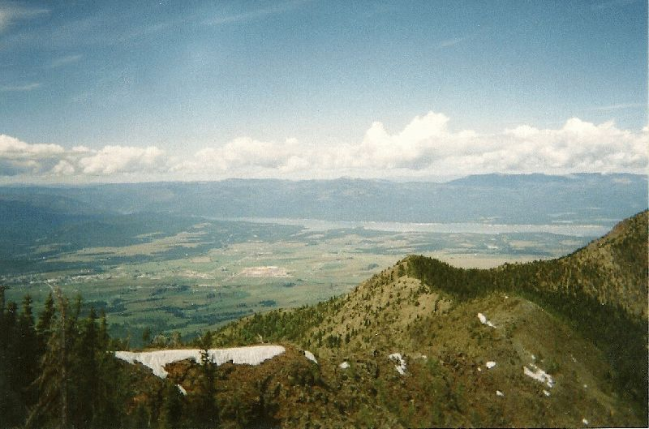
In Eureka there is an elementary school, which includes K-4, a middle School (5-8), and the Lincoln County High School. A Head Start program is also available.
The larger communities of Whitefish (50 miles) and Kalispell (65 miles) offer a wide variety of shopping and other service-oriented businesses. Eureka is approximately four hours from Spokane, Washington (population 342,000), and four hours from Missoula (population 70,000). Glacier Park International Airport near Kalispell provides daily departures and an AMTRAK station is available in Whitefish. Glacier National Park to the east and Banff National Park in Canada are also close enough to be enjoyed for the day or weekend.
Eureka has both mild winters and summers compared to other Montana cities. The District includes the popular Lake Koocanusa Reservoir, beautiful mountains and many surrounding fresh water lakes. There are many recreational opportunities, such as swimming, water skiing, camping, rock climbing, fishing and hiking for summertime fun; hunting in the fall and spring; ice fishing, snowmobiling and cross-country skiing in the winter; and ATV and motorcycle riding on Lake Koocanusa reservoir draw down area in the spring. Eureka is just 60 miles north of the Whitefish Mountain Resort Ski Area in Whitefish and 35 miles south of the Fernie Ski Area in Canada. Average rainfall for the area is 14.6” and the average snowfall is 44.4”.

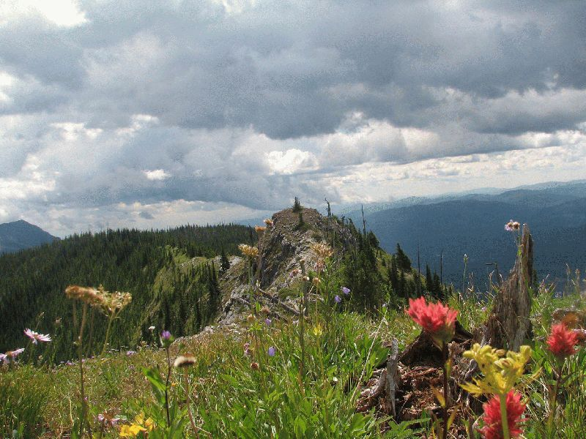
Located 15 miles south of Eureka is the community of Fortine. The Fortine community has a school (Grades preschool-8), post office, grocery store, church, golf course and bar.
The community of Trego is located approximately 18 miles south of Eureka and offers a Civic Center, Post Office restaurant and school (Grades K-8).
Housing prices have increased in the recent years similarly to other areas. A three-bedroom home sells for $200,000-$400,000. Rentals are scarce, however can be found. Government housing may be available.
Gardening opportunities vary depending on where you live in the Valley, those closer to Eureka usually have a bit longer season than those farther south.
ABOUT THE KOOTENAI NATIONAL FOREST
The Kootenai National Forest (KootenaiHome) encompasses over 2.2 million acres of NFS lands and located in the extreme northwest corner of Montana and a small portion of northeast Idaho. The forest consists of 4 Ranger Districts located in Eureka, Troy, Libby and Trout Creek; 3 Staff Units located in the Supervisor’s Office and Engineering located throughout the units. The Forest is bordered on the north by British Columbia, Canada, and on the west by Idaho. Of the total acres, 50,384 are within the State of Idaho. Access into the Forest is via U.S. Highways 2 and 93 and Montana State Highways 37, 56, 200 and 508.
Ranges of high craggy peaks mark the Forest with Snowshoe Peak in the Cabinet Mountains at 8,738 feet, the highest point. The Whitefish Range, Purcell Mountains, Salish Mountains, and Cabinet Mountains are all part of the rugged terrain radiating from the river valleys. In the north central part of the Forest, the land is more open with gently rolling timbered hills lying in the shadows of the Whitefish Range.
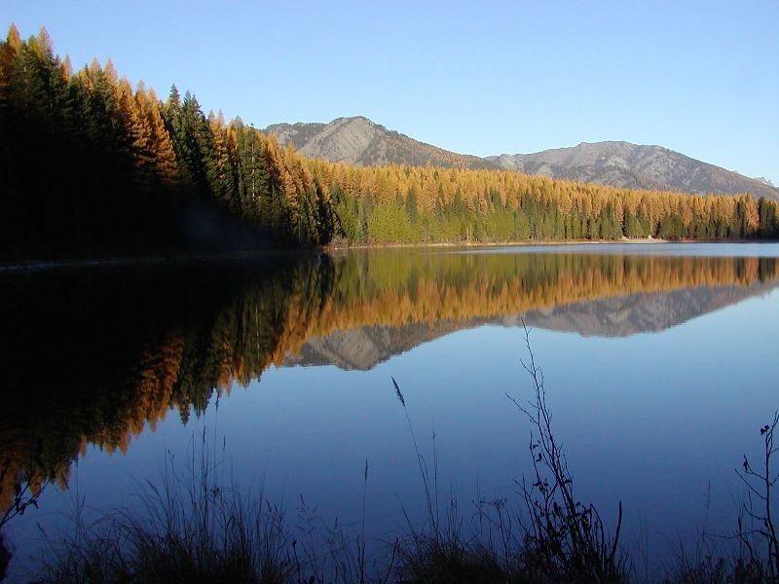
The Forest is dominated by two major rivers, the Kootenai and the Clark Fork, along with several smaller rivers and their tributaries. Two hydroelectric dams on the Clark Fork have created the Cabinet Gorge and Noxon reservoirs within the Forest boundary. State Highway 200 parallels these reservoirs as it crosses the Forest. The Kootenai River is spanned by another hydroelectric (and flood-control) project, Libby Dam. This structure located about 17 miles upstream from Libby, Montana, created Lake Koocanusa, a 90-mile-long reservoir reaching northward into the Canadian Rockies. Lake Koocanusa is almost surrounded by national forest lands, no private summer home or condominium developments here. State Highway 37 follows the east shore to Rexford and beyond to Eureka, Montana. The elevation of the Kootenai River as it leaves the Forest and the State is 1,862 feet, the lowest point in Montana.

The Yaak, Fisher, Tobacco, and Vermillion Rivers are smaller rivers within the confines of the Forest. There are over 100 lakes inside the boundaries of the Kootenai ranging from small alpine lakes to 1,240 acres McGregor Lake.
The climate of the Kootenai has been described as "modified Pacific maritime" in character, meaning that compared to the remainder of Montana, this area's climate resembles that found along the Pacific coast. The character becomes "modified" by occasional intrusions of the arctic air masses, more commonly found in the remainder of the State, which can bring winter temperatures down to -30° F with heavy snowfalls in the mountains. Average annual temperatures of 45° F reflect the moderating influence of the Pacific air masses. Summer temperatures are moderate with few days reaching over the 100° mark. The wet season in the Forest usually occurs in the fall and early winter.

The Kootenai is truly a forest with multiple uses. The vegetation management program is aimed at restoring and maintaining Northern Rockies fire dependent habitats. The diversity of tree and other plant species is among the greatest in the Northwest. Management and recovery of threatened and endangered species, such as grizzly bear, lynx, and bull trout emphasize the forest wildlife and fisheries programs. Other wildlife on the forest include gray wolf, wolverine, cougar, elk, moose, white-tailed and mule deer, mountain goat, bighorn sheep, bald and golden eagles and other species of birds, mammals, amphibians, and reptiles.
The Forest overlaps with a portion of the original Kootenai Tribal Territory. Under the Hell Gate Treaty, the Tribe retains rights to hunt, gather, collect plants and roots, fish, and water rights resulting in stories, place names and songs passed down through the generations. The Kootenai Tribe of Idaho was not represented at the treaty signing as each of the seven bands has their own Tribal Chief. The Kootenai Tribe of Idaho challenged the US Government to the rights of ownership for 12 acres in Idaho, with those rights recognized in 1974.
USDA Nondiscrimination Policy, June 2, 2015In accordance with Federal civil rights law and U.S. Department of Agriculture (USDA) civil rights regulations and policies, the USDA, its Agencies, offices, and employees, and institutions participating in or administering USDA programs are prohibited from discriminating based on race, color, national origin, religion, sex, gender identity (including gender expression), sexual orientation, disability, age, marital status, family/parental status, income derived from a public assistance program, political beliefs, or reprisal or retaliation for prior civil rights activity, in any program or activity conducted or funded by USDA (not all bases apply to all programs). Remedies and complaint filing deadlines vary by program or incident.
Persons with disabilities who require alternative means of communication for program information (for example Braille, large print, audiotape, American Sign Language, etc.) should contact the responsible Agency or USDA’s TARGET Center at (202) 720-2600 (voice and TTY) or contact USDA through the Federal Relay Service at (800) 877-8339. Additionally, program information may be made available in languages other than English.
To file a program discrimination complaint, complete the USDA Program Discrimination Complaint Form, AD-3027, found online at Filing a Program Discrimination Complaint as a USDA Customer and at any USDA office or write a letter addressed to USDA and provide in the letter all the information requested in the form. To request a copy of the complaint form, call (866) 632-9992. Submit your completed form or letter to USDA by: (1) mail: U.S. Department of Agriculture, Office of the Assistant Secretary for Civil Rights, 1400 Independence Avenue, SW, Washington, D.C. 20250-9410; (2) fax: (202) 690-7442; or (3) email: program.intake@usda.gov.
USDA is an equal opportunity provider, employer, and lender.

USDA OUTREACH NOTICE FORM
KOOTENAI NATIONAL FOREST
Ksanka Ranger District- DETAIL
NEPA Planner GS-0401 9/11
Eureka, MT
Please include: Outreach Notice Form and resume
Please respond by 29 September, 2023

Mail to:
seth.carbonari@usda.gov For the Ksanka Ranger District.

NAME:__________________________________________________

EMAIL ADDRESS:___________________________________________

TELEPHONE NUMBER:______________________________________

AGENCY EMPLOYED WITH: _____USFS _____BLM _____OTHER

TYPE OF APPOINTMENT: _____PERMANENT _____TEMPORARY _____TERM

CURRENT REGION/FOREST/DISTRICT:_________________________

CURRENT SERIES AND GRADE:________________________________

CURRENT POSITION TITLE:____________________________________

Thank you for your interest in our vacancy!
USDA is an equal opportunity provider, employer and lender.

