OUTREACH NOTICE
Mt. Baker-Snoqualmie National Forest
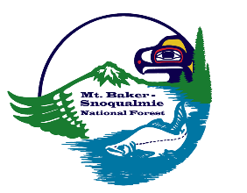

Forester-Silviculture
GS-0460-11, Permanent Full Time (One position)

Forester (Timber Sale Prep)
GS-0460 – 7/9, Permanent Full Time (Two Positions)

The Mt. Baker-Snoqualmie National Forest is participating in a national hiring event to fill two Timber Sale Prep Forester positions and one Silviculturist position. These permanent positions will be open to current federal employees and open to the public.

Position | Tour | Duty Station | # of Pos. | Contact for Info | Email
Forester (Silviculture) | PFT | Everett, WA | 1 | Sarah Thibeault | sarah.thibeault@usda.gov
GS-0460-11
Merit (Open to current federal employees): https://www.usajobs.gov/GetJob/ViewDetails/638961700
Forester (Timber Sale Prep) | PFT | Darrington, WA | 1 | Luke Semler | luke.semler@usda.gov
GS-0460-7/9
Forester (Timber Sale Prep) | PFT | North Bend, WA | 1 | Tim Seaman | timothy.seaman2@usda.gov
GS-0460-7/9
Merit (Open to current federal employees): https://www.usajobs.gov/job/639004500
Demo (Open to the public): https://www.usajobs.gov/job/639008900
Please contact the people listed above for more information about the positions and duty locations.

Duties for the one (1) Silviculturist position may consist of duties such as, but not limited to:
- Prepares silvicultural prescriptions
- Plans, coordinates, and administers reforestation and stand improvement activities
- Plan and coordinate training on silvicultural principles and practices and timing of silvicultural treatments to achieve multiple-use land management objectives
- Participate in preparation and review of environmental analysis reports and environmental impact statements
- Write planning documents to identify and explain the basis for silvicultural decisions and discuss alternatives for treatment of vegetation with specialists to coordinate the needs of the land management plan

Duties for the two (2) Timber Sale Prep positions may consist of duties such as, but not limited to:
- Develops logging plans, performs timber sale area reconnaissance, and lays out harvest units and roads
- Performs sale prep activities such as GPS & hand traversing, boundary marking, timber cruising, stand exams, and data management
- Estimates volume, defect, and quality of timber in a timber sale area. Measures and defects timber on the ground using maps and written cruise plans provided by an advanced cruiser that explain sampling intensity, plot locations, type of cruise and any special instructions
- Prepare and ensure quality documentation such as detailed maps, appraisals, advertisements, prospectus, and sample contracts in support of timber sale and harvest activities

Applications are being accepted through https://www.usajobs.gov/, open now through March 10, 2022. Job announcements will not list duty locations; applicants will provide location preferences prior to the interview phase.

Interested candidates are encouraged to apply now on USA Jobs. Current employees of the Forest Service interested in applying should update their USA Jobs profiles and upload the following documents:
- Resume that includes:
- personal information such as name, address, contact information.
- education.
- detailed work experience related to this position as described in the major duties, including work schedule, hours worked per week, dates of employment, title, series, and grade.
- supervisor's phone number and if the supervisor may be contacted for a reference check.
- other qualifications.
- A copy of your college transcripts
- Most recent non-award Notification of Personnel Action (SF-50), if applicable.
- Most recent performance appraisal (dated within 18 months), if applicable.

Review the job announcements carefully for deadlines and any other required information to include in your application.

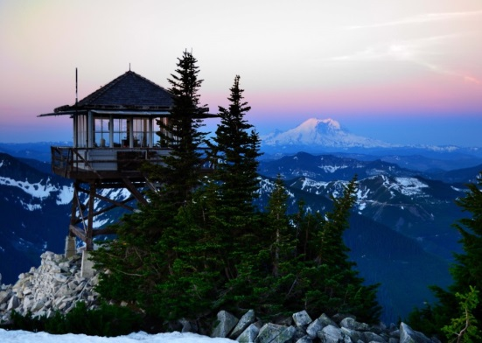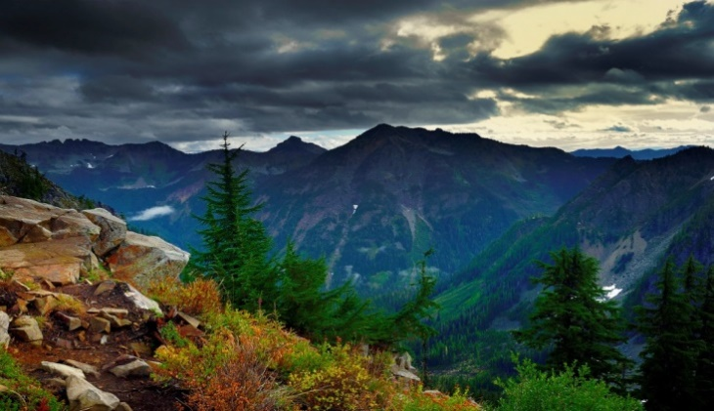

About The Forest:
The Mount Baker-Snoqualmie National Forest extends 140 miles along the western slopes of the Cascade Mountains from the Canadian border to Mt. Rainer National Park. The Forest covers portions of Whatcom, Skagit, Snohomish, King and Pierce Counties. Together, these counties contain over 55 percent of the state’s total population. Nearly five million people live in or near the Puget Sound metropolitan area. Another two million people live in southwest British Columbia and make frequent use of the Forest. This coupled with the fact that four major mountain passes cross the Cascades through the Mt. Baker-Snoqualmie National Forest, makes this one of the most visited National Forests in the country.

The Mt. Baker-Snoqualmie is rich in natural diversity, with a complex ecosystem that includes glacier-covered peaks, volcanoes, alpine lakes, and many, many rivers and streams, old-growth stands of timber, and a multitude of plant, animal, and fish species. Recreation opportunities abound, including hiking/backpacking, climbing, fishing, and winter sports at four major ski areas.

The Forest Supervisor’s Office is located in Everett, Washington. There are four Ranger Districts, with offices in Sedro-Wooley, Darrington, Skykomish, and North Bend, in addition to a number of other visitor centers. For more information about the National Forest, please visit our web site at www.fs.fed.us/r6/mbs

About the Area:
The Puget Sound area has an abundance of opportunities. A number of large cities are within a short drive from MBS offices, including Seattle, Tacoma, Olympia, Everett, and Bellingham. Recreation opportunities are virtually endless. Puget Sound residents have access to a number of top quality hospitals and health care facilities, excellent educational systems which offer numerous programs for students with varying needs and interests, and a variety of cultural activities which include performing arts and museums, all-star sports and recreational activities. The area hosts a great diversity of religious beliefs and denominations.

The cost of living in the Puget Sound area is high. Please do your homework on this before applying for the job. No government housing is available. With that said, employees have found ways to make it work and still be able to enjoy the majority of activities the greater Seattle area has to offer!
North Bend:
North Bend is in the Snoqualmie Valley on the outskirts of the Seattle metro area, with a population of about 6,000. It has a small downtown that includes several resturants, a movie theater, grocery stores, and a variety of other services. It is around a half hour drive to downtown Seattle. Known as the filming location for Twin Peaks, it has a network of multi-use trails and easy access to a variety of recreation opprotunities.
Darrington:
Darrington is nestled in the mountains about an hour from Everett, and has a population of about 1,000. It has a grocery store and handful of resturaunts and other stores. Darrington hosts an annual bluegrass festival, has a network of mountain bike trails outside town, and
Everett:
Everett is a city of approximately 110,000 and the largest city in Snohomish County. It is located on Puget Sound and the I-5 corridor, 25 miles north of Seattle. Everett and the surrounding area offer quality schools, colleges, hospitals, health care providers and specialists, shopping, entertainment and activities. Transportation options include commercial flights from Paine Field, an Amtrak station, and the Sounder commuter train to Seattle. Everett stages annual festivals and is also home to minor league baseball, Aquasox, and hockey, Silvertips.
Outreach Response Form
GS-0460-11 Forester (Silviculture)
GS-0460-7/9 Forester (Timber Sale Prep)

Please complete this Outreach Response form and send with a current resume to the appropriate contact listed above. This is not an application – please apply at USAJobs:

Your Name: Email:

Mailing Address:

Phone Number:

Position Seeking:

If Current Federal Employee, Agency Employed With: ____USFS ____BLM ____OTHER________

If Current Federal Employee, Type of Appointment: ____Perm ____Temp ____Term
____VRA ____PWD ____Other

Current FS Employee, Region/Forest/District:

Current Series and Grade:

Current Position Title:

Please briefly describe your qualifications/interest for this position:

How did you learn of this vacancy? ______________________________________________

Thank you for your interest and response!

