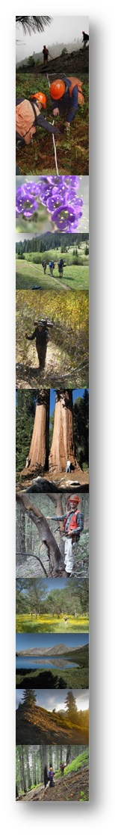
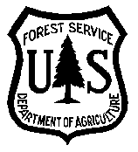
JOB ANNOUNCEMENT NOTICE

USDA Forest Service

Pacific Northwest Research Station (PNWRS)

Forest Inventory and Analysis (FIA) Data Collection Team

Natural Resource Specialist GS-0401- 05/07 Crew Leader PFT/PSE

PFT/PSE – Urban Crew Leader, Portland, OR
PFT – Crew Leader, Fresno, CA

Positions advertised on USA Jobs NOW.
Must apply no later than April 20, 2023.

The Forest Service Pacific Northwest Research Station, Forest Inventory & Analysis Data Collection Team is filling the positions referenced above through the Recent Graduates Program and in association with the 2023 Minorities in Agriculture, National Resources, and Related Sciences Conference (MANRRS) recruitment event. You do not need to attend the conference to apply. However, you can still meet virtually with Forest Service Recruiters. For those who are unable to attend the event, Forest Service Recruiters will host a virtual Microsoft Teams Meeting April 14, 12 PM to 2 PM EST. To Register for the virtual meeting, visit Eventbrite: Agriculture & Business Career Opportunities Q&A sign-up webpage.

Applications are being accepted now via USA Jobs at the following link: USAJOBS - Job Announcement

The PNWRS FIA unit is part of a nationwide program which collects, processes, analyzes, evaluates, and publishes comprehensive information on forest and other related renewable resources. Administration for the data collection team is located in Portland, Oregon and field crews are remotely stationed throughout Washington, Oregon and California. Crew leaders work under the direction of a state coordinator and lead a two to four person field crew.

About the positions:

FIA Urban Crew Leader-Portland, OR
The incumbent will serve in a permanent seasonal position as a Crew Leader with the U.S. Forest Service, Forest Inventory and Analysis program Urban Inventory. The Urban FIA position will be primarily conducting tree and vegetation surveys in the urban environments of Portland, OR and San Diego, CA, ranging from densely forested city and regional parks to vacant city lots, sidewalks and beautification areas. The familiarity with ornamental flora is also preferred but not required. Extensive landowner outreach and communication is required. The position will start and be based in Portland, with the expectation to work ~2 months in continuous travel status in San Diego. Interested candidates should select Portland, OR as their duty location.

FIA Crew Leader- Fresno, CA
The incumbent is responsible for performing duties as a field crew leader, which includes: scheduling, organizing, and executing field data collection projects; developing and amending annual work plans; and organizing and refining data collected. This requires navigating to remote research sites using GPS coordinates, compass, topographic maps, and aerial photographs. Access to remote sites will require strenuous physical exertion, such as long periods of standing, driving, and hiking on and off-trail. The crew leader is responsible for supervising and managing one to two employees. Our crews operate remotely for long periods of time in small 2-3 person crews that do not change in composition. Strong interpersonal skills and leadership skills will be a major component of success. Interested candidates should select Fresno, CA as their duty station.

You can visit the PNW-FIA program team website for more information about the program: https://www.fs.usda.gov/research/pnw/programs/fma

For more information about the duties and work conditions of this positions, please contact:
PNW-FIA program coordinators at Sm.fs.pnw_fia_jobs@usda.gov.

The U.S. Department of Agriculture (USDA) prohibits discrimination in all its programs and activities on the basis of race, color, national origin, age, disability, and where applicable, sex, marital status, familial status, parental status, religion, sexual orientation, genetic information, political beliefs, reprisal, or because all or part of an individual’s income is derived from any public assistance program.(Not all prohibited bases apply to all programs.) Persons with disabilities who require alternative means for communication of program information (Braille, large print, audiotape, etc.) should contact USDA’s TARGET Center at (202) 720-2600 (voice and TDD).To file a complaint of discrimination, write USDA, Director, Office of civil Rights, 1400 Independence Avenue, S.W., Washington, D.C. 20250-9410, or call (800) 795-3272 (voice) or (202) 720-6382 (TDD).

