Immediate Summer Job Opportunity
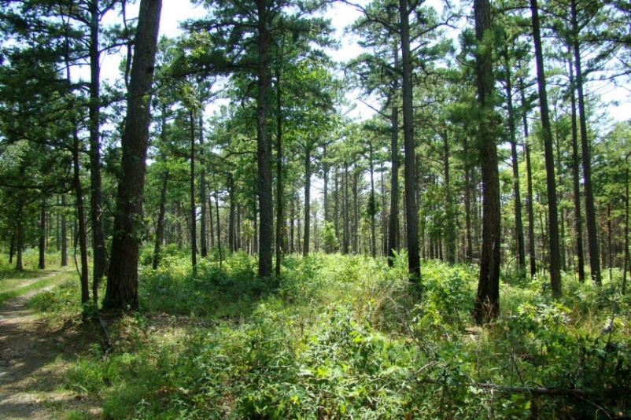
Seasonal Research Technician –Forestry Sampling – Missouri
Description: We are seeking two highly motivated, seasonal research technicians to sample forests habitats in the Ozark Highlands and Mississippi River Bottoms of Missouri from mid-May through early August 2022. This field work will be providing important ground control information about forest community structure. This data will later be linked to high quality LiDAR data so that various forest conditions may be extrapolated across a greater scale and help inform landscape management decisions. Housing and work vehicle will be provided while in the field. Primary responsibilities include collection of forestry plot data and vegetation data in upland, riparian, and bottomland forests on public and private lands. The technicians will work closely with a postdoctoral researchers and the Missouri Department of Conservation.
Data gathering, entry, and management skills will be required. The position requires early, long and irregular hours outdoors, under remote and adverse conditions (heat, rain, mosquitoes, etc.). Individuals will be required to work alone and in groups.
The surrounding area offers exceptional outdoor recreation opportunities (hiking, fishing, camping, Ozark stream paddling).
Qualifications: At a minimum, candidates should be enrolled in or recently graduated from a Forestry, Wildlife, Ecology, Biology, or a related natural resources undergraduate program. Candidates must also be in good physical condition to traverse rough and rugged terrain.
Preferred candidates will have field experience with forest measurement techniques and will have experience identifying Missouri tree, shrub, and plant species. The ability to be self-motivated, maintain a positive attitude, and work well in teams is also desired.
Salary: $15/hour
Location: Ellington, MO and Poplar Bluff, MO
Application:
To apply, email letter of interest, resume, and contact information for at least two references to:
Dr. Thomas Bonnot
School of Natural Resources
University of Missouri, Columbia, MO 65211.
Email: bonnott@missouri.edu

We will begin reviewing and selecting applicants immediately and applications will be accepted until the position is filled.

