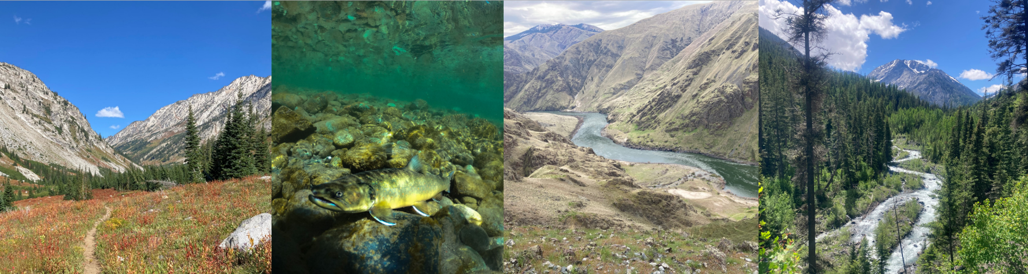

Wallowa-Whitman National Forest is hiring
Natural Resources Technicians (permanent seasonal)
Positions available in fisheries, botany, wildlife, and hydrology

Open Date: 10/19/2023 – 11/22/2023
Start Date: Spring or Summer 2024, exact start date to be determined
Locations: Joseph, OR: 3 positions (fisheries, botany, wildlife)
La Grande, OR: 4 positions (fisheries, hydrology, botany, wildlife)
Baker City, OR: 4 positions (fisheries, hydrology, botany, wildlife)
Wallowa-Whitman National Forest is hiring 11 new permanent seasonal natural resources technicians across the forest’s three districts. Positions are available in fisheries, wildlife, botany, and hydrology. Technicians will assist district specialists with field work to monitor sensitive and threatened species, conduct water resource inventories, assess effects of forest projects on natural resources, implement and monitor stream or habitat restoration projects, and more. Technicians will also have office duties including data entry, working with GIS and maps, maintaining equipment, and basic technical writing tasks such as drafting field reports.
These GS-5/6/7 career ladder positions are entry-level permanent seasonal jobs that provide a sequence of training steps that lead to progressively more advanced jobs and skillsets throughout a Forest Service employee's career.
About the Forest: Wallowa-Whitman National Forest encompasses 2.4 million acres of public lands in northeastern Oregon and western Idaho. District offices are located in Baker City, La Grande, and Joseph, Oregon. Ecosystems range from the alpine peaks of the Elkhorn, Seven Devils, and Wallowa Mountains (reaching as high as 9,843 feet), to the spectacular grasslands and canyons surrounding the Snake River (as low as 875 feet), and the vast watersheds, rangelands, and conifer forests in between. The forest has ten Wild and Scenic Rivers, four Wilderness Areas, and the Hells Canyon National Recreation Area.
Requirements: All positions will require field work, candidates should be able to hike off trail in rough terrain and work outdoors in variable weather. Candidates should be capable of working both independently and in small groups, solving problems and troubleshooting in the field, navigating using GPS and topographic maps, accurately following field protocols and recording data, and driving 4x4 trucks on forest roads. Job experience or education relevant to the specific position you are applying to (botany, fisheries, hydrology, or wildlife) is preferred, but these are entry level positions and we are able to train motivated candidates with relevant experience in other natural resources fields.

Requirements continued: All positions are being advertised as series 462 (Forestry Technician), but positions will be assigned to different disciplines within Natural Resources (wildlife, hydrology, fisheries, botany) based on preference and experience. To qualify for these positions at the GS-05 level you must have either:
One year of specialized job experience equivalent to the GS-04 level in the Federal Service – for example, past technician jobs in the natural resources field or related fields
or
A Bachelor’s degree or 4 years of successfully completed education above high school (120 semester/180 quarter hours) with major study relevant to the position or at least 24 semester hours in natural resources related courses. Details on qualifying experience and coursework can be found in the USAJobs announcement.
Pay and benefits: All positions are GS-5/6/7 (18.06 – 22.37 per hour). These are 13/13 permanent seasonal positions – permanent seasonal employment guarantees a minimum of 13 pay periods (6 months) of work each year with the possibility of additional pay periods of work. Permanent seasonals typically work during spring, summer, and fall, and are furloughed in winter. Selected applicants will be hired as GS-5 permanent seasonals with a 13/13 schedule. However, once hired there may be an option to convert to a permanent full-time (PFT) or 18/8 after 90 days, and if eligible, acquire a non-competitive, rapid promotion within 90 days for each grade. Permanent seasonal employees get standard federal employee benefits including health insurance, retirement, and paid holidays, annual leave, and sick leave.
To Apply: apply online at USAJobs announcement number 24-TTP-HRM-FS026-5DP-KL https://www.usajobs.gov/job/755177600# during the open period of 10/19/2023 – 11/22/2023. This is a large, group vacancy announcement with positions available all over the country.
For More Information: Please fill out this survey https://forms.office.com/g/Hh3AM5Krre to share your contact information and what positions you are interested in directly with staff on Wallowa-Whitman National Forest. This survey must be completed to indicate your duty station and Natural Resource discipline preferences.
Forest hiring information: https://www.fs.usda.gov/main/wallowa-whitman/about-forest/jobs
Contact one of the district specialists below for more information. We’re able to answer any questions you have about the jobs or locations, and can also provide advice on submitting your application if you are not familiar with USAJobs and federal hiring.
Fisheries: Jan.Boyer@usda.gov (Joseph) or William.Glenn@usda.gov (Baker City)
Botany: Susan.Geer@usda.gov (Joseph), Thomas.Hender@usda.gov (La Grande), or Sabrina.Smits@usda.gov (Baker City)
Hydrology: Megan.Hederman@usda.gov (La Grande) or Robert.Hassmiller@usda.gov (Baker City)
Wildlife: Marie.a.gaylord@usda.gov (Joseph) or Julia.Boland@usda.gov (La Grande, Baker City)

