R1 Grants Management Specialist, GS-1109-11/12
Permanent Position
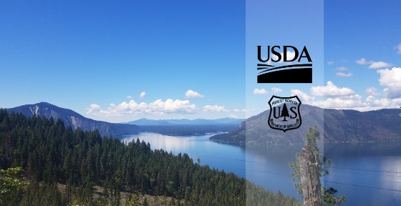
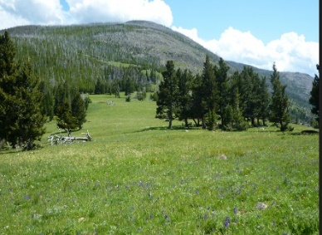
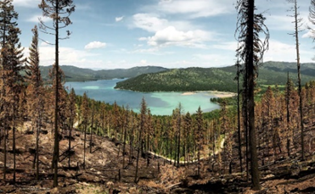

The Northern Region is conducting an outreach for interest in 3 permanent Grants Management Specialist positions, GS-1109-11/12 in the Northern Region. The duty station is likely in Missoula, Montana however remote options withing Region 1 or within the geographic areas of adjacent Regions in the Pacific and Mountain time zones and within 49 miles of a Forest Service office will be considered for the detail and based on outreach responses and analysis possibly for the permanent position. Responses to this outreach notice will help us determine how to advertise the positions and which candidates will be considered. Lateral reassignments, temporary promotions, and details will be considered based on outreach response. If you are interested in any of these positions, your response is greatly appreciated. Please respond in the Outreach Database and by completing and sending the attached Outreach Response Form and Resume to Kim Pierson, Director of Public and Governmental Relations, Grants, Agreements, and Partnerships, by August 31, 2023. For further information please contact Kim Pierson, kimberly.pierson@usda.gov or (208) 630-4139.

DUTIES

The Northern Region (R1) Office of Grants & Agreements (OGA) will be advertising for 3 permanent full-time GS-1109-11/12 Grants Management Specialists. The positions will report to one of four Supervisory Grants and Agreement Specialists that comprise the overhead team of the Region 1 Grants and Agreements organization. Each position supervises 1 - 4 lower graded grants management specialists and assists with training, certifications, and endorsements.

Duties
- Duties listed are for the full performance level, GS-11.
- Provides advice and counsel to managers and program staff on a wide variety of grants, cooperative agreements, and other agreements (instruments).
- Develops instruments, disseminates grant and cooperative agreement requests for proposals, reviews and analyzes responses, and recommends acceptance by higher authority as appropriate.
- Reviews applications and other agreement proposals for technical adequacy and compliance with applicable laws, regulations, and policy.
- Reviews grant applications and other agreement proposals for technical adequacy and compliance with applicable rules, regulations, and policies.
- Duties listed are for the full performance level, GS-12.
- Provides interpretation of laws and regulations concerning use of Federal funds and qualifying program expenditures.
- Determines appropriate legislative and program authority prior to execution of each grant or agreement. Approves all grants and agreements for the unit, as well as notification(s) of funding availability.
- Develops instruments within the delegated authority, circularizes requests for proposals for grants and agreements, reviews and analyzes responses, and makes or recommends acceptance by higher authority as appropriate.
- Monitors and analyzes the effect of changes in laws, regulations and policies pertaining to grants and agreements, administration and management, and performance reporting.
- Stays abreast of changes in policy, regulations, and legal authorities affecting grants and agreements.

Additional Information:
Please contact Kim Pierson, Director of R1 Public and Government Relations, Grants, Agreements, and Partnerships, at 208-630-4139 or kimberly.pierson@usda.gov if you have any questions regarding this position.
How to Respond:
Respond directly in the outreach database and/or complete the attached Outreach Interest Form.

Please Note:
The purpose of this Outreach Notice is to determine the potential applicant pool for this position and to establish the appropriate recruitment method and area of consideration for the advertisement (e.g., target grade, multi-grade, service-wide, and government-wide). Responses received from this outreach notice will be relied upon to make this determination.
The Duty Station:
Remote within the geographic area of the Northern Region (North Idaho, Missoula, Dakotas) or within the geographic areas of adjacent Regions in the Pacific and Mountain time zones and within 49 miles of a Forest Service office.

OUTREACH RESPONSE FORM
R1 Grants Management Specialist, GS-1109-11/12
Permanent Positions Please complete the information below and submit the form and a resume to Kim Pierson at kimberly.pierson@usda.gov. Please respond by August 31, 2023.
Applicant Information
Please indicate your interest in: ______ Permanent appointment
Name: |  |  |  |  | E-Mail Address:
Mailing Address:
Work Phone: |  |  |  |  | Alternate Phone:
Agency Employed with: |  |  | USFS Other_____________________
Type of Appointment: |  |  | Permanent Temporary Term VRA  Other Not Current Employee
Current Region/Forest/District:
Current Series And Grade If Applicable:
Current Position Title:
Are you eligible to be hired under any of the following authorities:
Reinstatement  Veterans Recruitment Act  Disabled Veteran with 30% Compensable Disability  Veteran’s Employment Opportunities Act of 1998 |  |  |  |  |  | Person with Disabilities  Former Peace Corps Volunteer  Demonstration Project (external recruitment from the general public)  Other
Additional Remarks
Please use this space to identify special qualifications, interests, needs, or provide other information. Please explain why you are interested in the permanent appointment.

