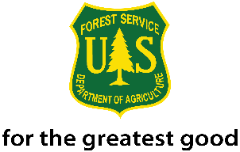
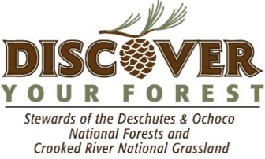
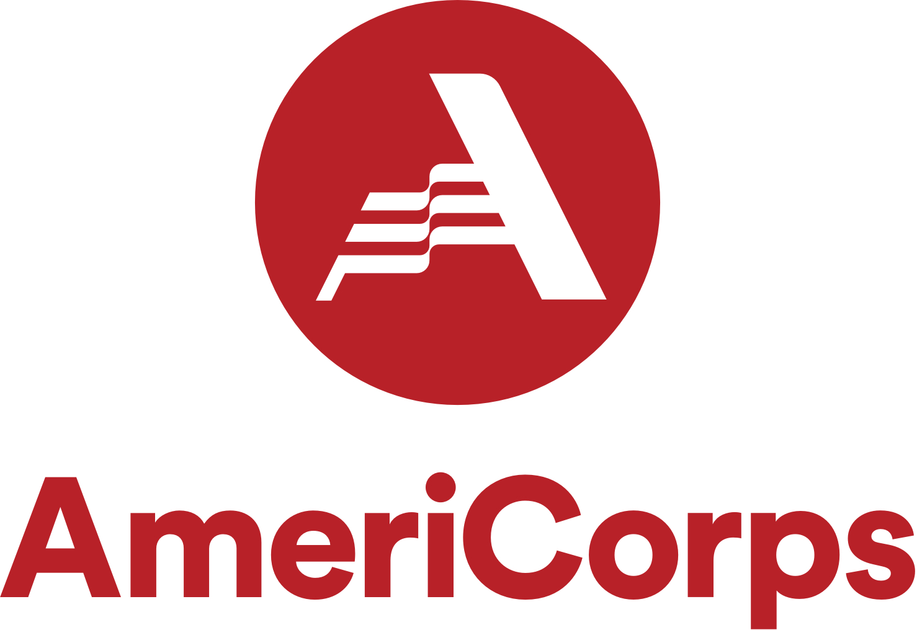

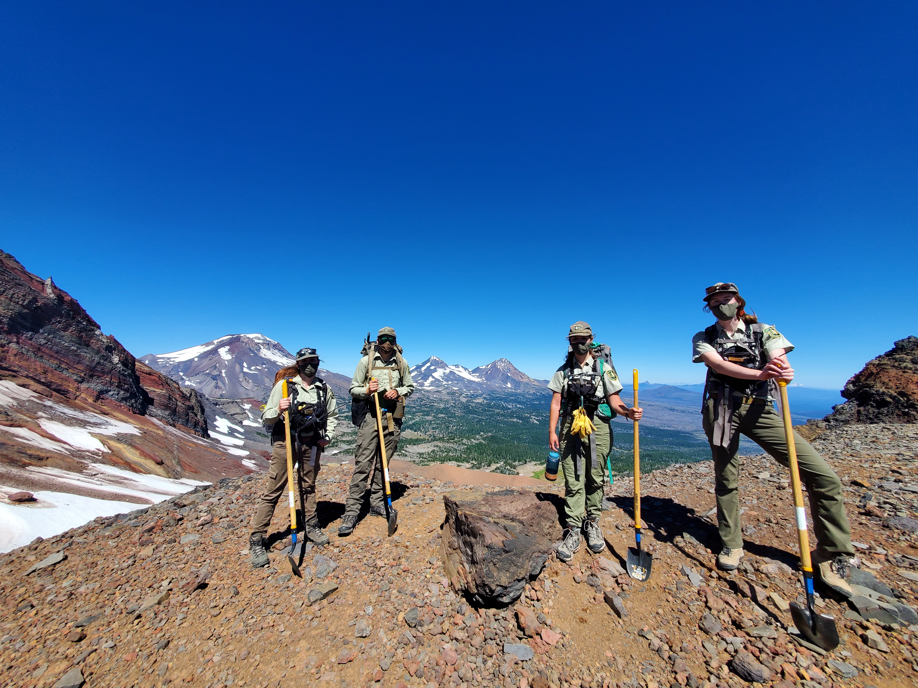
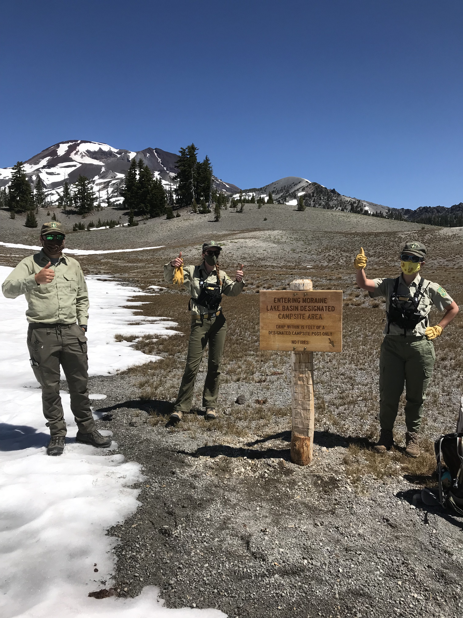
Generation Green Heart of Oregon AmeriCorps Wilderness Member 2022
Position Announcement

Spend the summer outdoors as a Heart of Oregon Corps AmeriCorps Wilderness Ranger!
Description: The Deschutes National Forest, in partnership with Discover Your Forest and Heart of Oregon Corps, is seeking four individuals to serve as Generation Green Heart of Oregon Corps (GGHOC) AmeriCorps Members for the summer of 2022. The GGHOC AmeriCorps Wilderness Member will support the Deschutes National Forest with service related to Wilderness stewardship. Members will report daily to the Forest Service and serve as GGHOC AmeriCorps Wilderness Members for the duration of their service. GGHOC Members will serve with other Corps Members, Forest Service staff, and wilderness volunteers to complete daily duties. The GGHOC AmeriCorps Partnership is passionate about promoting equity while celebrating the diversity of our community and providing empowering opportunities for those who are under-represented.
Generation Green Heart of Oregon AmeriCorps Program is as follows:
- Age requirement: 18-30
- Salary: $7,200 total stipend. $450/week, paid bi-weekly
- Scholarship: $2,417.14 Segal Education Award
- Term of Service: 675 hours
- Certification: Upon completion of full service hours, GGHOC AmeriCorps Member will receive the Public Land Corps Hiring Authority certificate. PLC Hiring Authority provides 2 years of non-competitive hiring status*. (*Non-competitive hiring status is the ability to apply and be considered for permanent vacancies within the Forest Service without competitive examination or competing with career or career-conditional employees under internal merit staffing procedures for any position which eligible. Candidates applying under this authority are considered with other non-competitive status candidates.
- Provide conservation education and exposure to natural resources through mentorship and experiential shadow opportunities.
- All participants, based on personal interests, will have additional opportunities to explore other Forest Service specialties.
- Housing is not offered through this program.

Primary duties include:
- Provide education to visitors at trailheads and in the backcountry. Education topics include; trail/campsite/forest conditions, Wilderness Regulations and compliance, Leave No Trace ethics and best practices, and general Wilderness Stewardship information.
- Restore illegal and inappropriate campsites and trails to improve habitat, specifically around riparian areas.
- Clean up campsites and day use areas to mitigate recreation impacts to wilderness resource.
- Monitor and document use patterns.
- Clear and maintain wilderness trails to minimize recreation impacts.
- Documenting prescribed treatments to public lands by use of photos or videos
- Completing project narratives for reporting purposes
- Participate in all trainings and orientations
Secondary duties include: Opportunities to participate in projects with HOC crews include -
- Clearing areas of dangerous fire fuels
- Building or repairing fencing to protect vulnerable habitat
- Restoring trails and waterways
- Habitat restoration
- Herbicide application on invasive plant species
- Assisting with driving and project logistics
- Conducting tool/equipment/vehicle inventory tracking and maintenance

Qualified candidates will be/have:
- Must be a US Citizen and pass a background check.
- A current driver’s license with good driving record.
- Excellent communication skills and the ability to easily talk to large groups of people every day.
- Exceptional work ethic, enthusiasm, and a high degree of flexibility.
- Commitment to serve a minimum of 4-ten hour days, Thursday-Sunday, with weekend work required. Weeks regularly range from 40-50 hours.
- Service will consist of primarily day excursions with 1-2 opportunities for an overnight outing.
- Ability to spend long days in the field under varying weather conditions.
- Ability to hike over rough, uneven terrain.

What is the education value to the applicant?
- The term of service will allow the student to put into practice their academic knowledge.
- Enhance employment opportunities in Natural Resources and the Forest Service.
- Gain a broad perspective of wilderness management and sustainability through exposure to a variety of duties.
- Discover strengths and weaknesses.
- Opportunity to network with a diverse group of professionals: formal and non-formal educators, scientists, and U.S. Forest Service specialists.
- Gain valuable hands-on experience on projects in an outdoor setting.
- Cultivate resources from experts on how to develop your personal career pathway.

Partnership Overview:
This opportunity is made possible through a partnership between the Deschutes National Forest, Discover Your Forest, and Heart of Oregon Corps. Staff from each partner supports the GGHOC AmeriCorps Members. General guidelines for partner roles are:

Forest Service Staff provides:
- Experiential, in the field, training and support.
- Daily work activities direction.
- Daily supervision.

Heart of Oregon Corps Staff:
- Ensures understanding and compliance of all AmeriCorps policies and procedures.
- Submitting time sheets and reimbursement checks facilitation.
- Service hours tracking and AmeriCorps program benefits.
Discover Your Forest Staff:
- Serve as primary liaison between partners.
- Additional support to both partners and Members as needed.
- Career Pathways workshop and information sharing.
- Delivers PLC Hiring Authority Certificate upon successful completion of service hours.

Onboarding & Orientation:
Reference checks and a two-part criminal history background check will be conducted on all final candidates, as required for this position. Selected candidates must complete both AmeriCorps and Forest Service onboarding and attend all required Forest Service trainings/orientations.

Questions and How to Apply:
- For more information contact Stacey Cochran, Discover Your Forest’s Community Engagement Director, at 541-383-5530, stacey.cochran@discovernw.org or Jasmine Berg, Wilderness Volunteer and Workforce Trainee Coordinator at 541-419-4609, jasmine.berg@usda.gov.
- To apply: Email Cover Letter and Resume to both jasmine.berg@usda.gov and stacey.cochran@discovernw.org. Please include your outdoor experience and interest in the Natural Resources field in your cover letter.
- Please apply before close of business Friday, April 15th, 2022. (contact if you miss deadline)
- Interviews will be held the week of April 18th – April 28, 2022
- Selections will be made by May 12th, 2022
- Anticipated Start Date - June 9th, 2022
- Anticipated End Date – September 25th, 2022
- Once a member starts, they must be available to serve full-time
Heart of Oregon Corps is an equal opportunity employer and encourages all qualified applicants to apply for open service opportunities. Upon request, reasonable accommodations will be pursued for any interested and qualified applicants. Furthermore, people of color, women, and members of vulnerable or underrepresented communities are strongly encouraged to apply. As a recipient of Federal financial assistance, Heart of Oregon Corps is prohibited from discriminating on the grounds of race, color, religion, gender, national origin, age, disability, political affiliation or belief, and against any beneficiary of programs on the basis of the beneficiary’s citizenship/status as a lawfully admitted immigrant authorized to work in the United States.

