Forestry Internship Available
$ Paid Position $

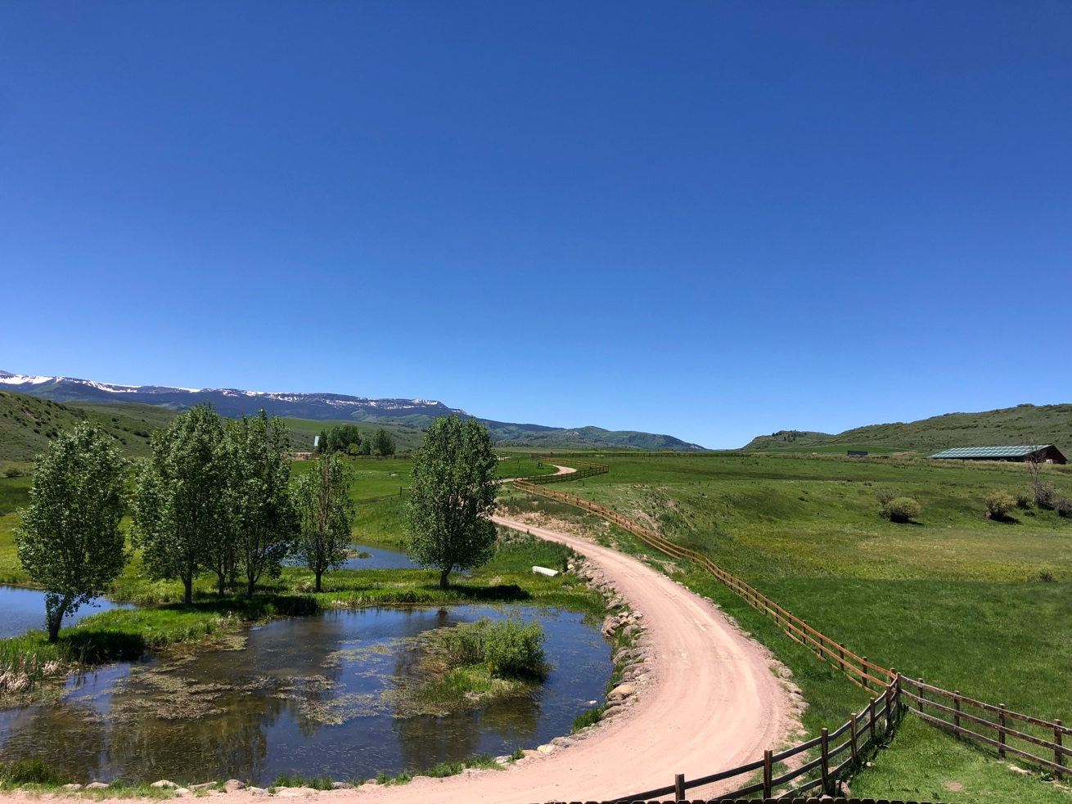

Job Description:
This position requires employees to survey, record and maintain the forest on an 1800-acre property Approximately half of the property is wooded. Employees will report their survey findings and compile a multi-year action plan to improve the overall health of the forest. On the property, there are many groves of dead Engelmann Spruce trees and Aspen trees. Employees would be asked to remove the groves of already dead trees to facilitate opportunity for new growth. This would be a chainsaw- based position after the initial survey.

Timeframe:
Employees will be required to make a minimum of a two-month commitment. The position will start mid- June and last through late-August/early September. Exact dates are negotiable.

Responsibilities:
- Remove stands of dead trees from the property
- Demonstrate proper chainsaw operation, timber felling, limbing, and bucking
- Harvest wood for firewood in vehicle accessible areas
- Effectively work both within a team setting and independently in remote areas, in all seasons and weather conditions
- Maintain equipment properly
- Conduct a survey of the property and report the findings to the owner

Qualifications:
- Must be at least 18 years old
- Enrolled in a college/university Forestry or Natural Resources program
- Experience with Forest Management planning
- Ability to organize, plan, and perform work safely and effectively with minimum supervision
- Must have interpersonal skills including ability to communicate effectively, both orally and in writing with the land owner
- Skill writing clear and concise reports that include recommendations and conclusions
- A strong work ethic and enthusiasm conducting fieldwork
- Previous experience operating a chainsaw and felling dead trees is preferred

Compensation:
This is a paid position with compensation depending on experience. Rustic style housing is included. Housing will include dry camping in an RV or canvas wall tent with access to an indoor shared kitchen and bathhouse with running water.

Location:
North Hunt Creek Ranch is located about 20 miles South of Steamboat Springs, Colorado. The small town of Oak Creek, with a few restaurants and a small grocery store, is located approximately 10 min away. The larger town of Steamboat Springs is approximately 40 minutes away. The ranch is 10 minutes away from the Flattops Wilderness area with over a million acres of national forest to explore.

How to Apply:
Please send a resume to Emily at Emilynhc23@gmail.com to apply for this position. I look forward to hearing from you!

