Forester (Natural Resource Specialist 1 – State Forests Program)

Oregon Department of Forestry – Veneta, Oregon

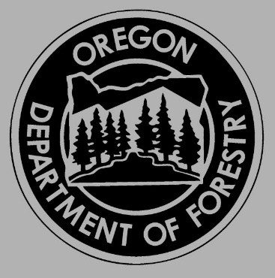

Initial Posting Date: 04/28/2022
Application Deadline: 05/16/2022
Salary Range: $3,439 - $5,234

To Apply Visit: Oregon.gov/jobs and search for “Natural Resource Specialist 1 – Veneta”

For questions about the position:
Chet Behling
chet.behling@odf.oregon.gov
(541) 228-5471

Interested in enhancing environmental, economic and community sustainability?! We are looking to hire a Natural Resource Specialist 1 in our State Forests Program - duties include cruising timber and timber sale layout, involvement in reforestation and young stand management projects, and assisting our Roads Specialist with road design and road layout projects. There is also opportunity to assist in our Fire Program both locally and throughout the State, if interested. If you have experience, and/or education, and an interest in these areas; you can learn more about the position and can apply by visiting oregon.gov/jobs. To search, type in "Natural Resource Specialist 1 - Veneta". For questions email chet.behling@odf.oregon.gov

Forester/NRS1 Overview- Position Overview:
Performs a variety of duties for a State program directly related to the conservation, management, protection or utilization of natural resources. The Natural Resources Specialist 1 does general scientific and technical data collection, analysis, evaluation and monitoring, or inspection and investigation. The Natural Resources Specialist 1 frequently participates in the activities of a team project or program.

In this position you will assist in accomplishing all the land management activities on State Forest lands in Lane, Douglas, Coos, Curry, Jackson and Josephine Counties, particularly in the preparation of timber sales and other natural resource management responsibilities associated with implementing Forest Management Plans and Greatest Permanent Value to the citizens of Oregon.

What You Need to Qualify:
A Bachelor's degree in forestry or natural resource area
OR
Three years of experience in forestry or natural resource area and level of responsibility.

The ideal candidate will possess a combination of some or all of the following skills:
- Timber Sale Layout - Strong background in timber sale layout. This includes experience, training or education in: administering timber sale contracts, preparing timber sale contracts, layout out of timber sales, timber cruising, and laying out logging roads.
- Logging Systems - Strong background in logging systems. This includes experience and/or education in both ground and cable harvest unit design.
- Reforestation/Plantation Maintenance - Strong background in reforestation methods and plantation maintenance. This includes experience, training or education in: conducting/coordinating stocking surveys, planting inspections, herbicide applications, seedling evaluations and nurseries, and pre-commercial thinning operations.
- Computer/GIS - Experience, training or education with computers, handhelds data recorders and Geographic Information Systems (GIS) is required. This includes familiarity and some experience with GIS software such as ESRI GIS. It also includes experience working with Microsoft Windows server and desktop operating systems, printers and Microsoft Office applications (Word, Excel, Access, Outlook, and PowerPoint). College classroom experience counts.
- Active listening/Teamwork - Ability to develop strong working relationships and to maintain those relationships when resolving natural resource issues.

Explore a new career with ODF – where our people are our greatest resource! The Oregon Department of Forestry is an Equal Opportunity, Affirmative Action Employer Committed to Workforce Diversity.

