Fire Management Officer (EMNRD #00005329)
Agency Enrgy, Minrls & Ntrl Rsrcs Dpt
Posting End Date 02/25/2023
Job Posting Type Continuous Job Opening
For more Job Requirements & Classification Description: Click Here
Job ID 129124
Location Cimarron
Full/Part Time Full-Time
Regular/Temporary Regular - PERM for State

Salary
$18.15 - $29.04 Hourly
$37,752 - $60,403 Annually
This position is a Pay Band 60

Purpose of Position
THIS POSTING WILL BE USED FOR ONGOING RECRUITMENT AND MAY CLOSE AT ANY TIME. APPLICANT LISTS MAY BE SCREENED MORE THAN ONCE.

Why does the job exist?
This position functions as the district fire management officer. This position requires protection of life, property, and that state natural resources through the planning, coordination, and implementations of wildlife prevention and mitigation programs, wildfire suppression response activities, and prescribed burn programs.

How does it get done?
Supervise and coordinate the training and orientation of new and current firefighters. Plan and implement an annual training program to introduce staff to new techniques and concepts while continuing education of current firefighters. Supervise the maintenance of equipment and vehicles to ensure safety and effectiveness. Participate in the budgeting process for annual expenses and revenue. Participate and provide input to the fire chief for the expenditure of funds and coordinate the procurement of wildland equipment and apparatus. Participate in the policy, procedure and guideline development for fire and medical response to ensure crew safety during response. Provide guidance to other senior leadership related to wildland response and hazard pre-planning. Provide leadership and supervision to field staff to ensure safety and effective response. Prepare pre-incident plans and prepare emergency response procedures for high risk and high hazard risks within the community. Complete hazard mitigation prior to catastrophic events to reduce risk for the community

Who are the customers?
The State of New Mexico, US Forest Service, Bureau of Land Management, Bureau of Indian Affairs, local government agencies.

Ideal Candidate
Fire Management System (FMS) Experience Federal Excess Personal Property (FEPP)

Minimum Qualification
Bachelor's degree in Forestry, Range Management, Forest Management, Natural Resources, Wildlife Science, Fire Science and/or Ecology and one (1) year of experience in Forestry, Range Management, Forest Management, Natural Resources, Wildlife Science, Fire Science or Ecology. Five (5) years of active duty service in the Armed Forces will substitute for the required education and experience. Substitutions Apply. See Substitution Table below.

Substitution Table
These combinations of education and experience qualify you for the position:

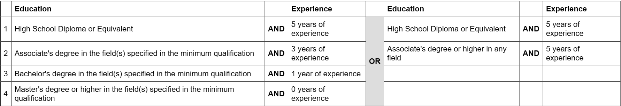
• Education and years of experience must be related to the purpose of the position.
• If Minimum Qualification requires a specific number of "semester hours" in a field (e.g. 6 semester hours in Accounting), applicants MUST have those semester hours in order to meet the minimum qualifications. No substitutions apply for semester hours.

Employment Requirements
Must possess and maintain a valid Driver's License. Express ideas both orally and in writing, Demonstrate an understanding of fire suppression techniques and Incident Command System.

Working Conditions
State of New Mexico employees may be impacted by the Public Health Order dated August 12, 2022, which requires facilities licensed or certified by the Centers for Medicare and Medicaid Services ("CMS"), including all hospital types, long-term care facilities, nursing homes, hospice facilities and rehabilitation facilities, as well as assisted living facilities and adult day care settings, to adhere to all COVID-related requirements prescribed by CMS, including, but not limited to masking and staff vaccination.
In addition, employees working in State correctional facilities who have the potential for direct or indirect exposure to inmates are required to be vaccinated against COVID-19.
Extensive travel & work in rough terrain. Work irregular or extended hours including evening, weekends, & holidays. May be exposed to a variety or weather conditions, including conditions associated with forest & wildfire management activities. Weekend/holiday Work.

Supplemental Information
Benefits:
Do you know what Total Compensation is? Click here
Agency Contact Information: Mary Stuever mary.stuever@emnrd.nm.gov
For information on Statutory Requirements for this position, click the Classification Description link on the job advertisement.

Bargaining Unit Position
This position is not covered by a collective bargaining agreement.

