  - VACANCY Outreach Notice
Executive Assistant
GS-0301-07/09
120 Day Detail & Single Vacancy Announcement
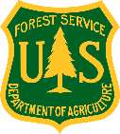
USDA Forest Service, Region 1
Nez Perce-Clearwater National Forests
Kamiah, Idaho
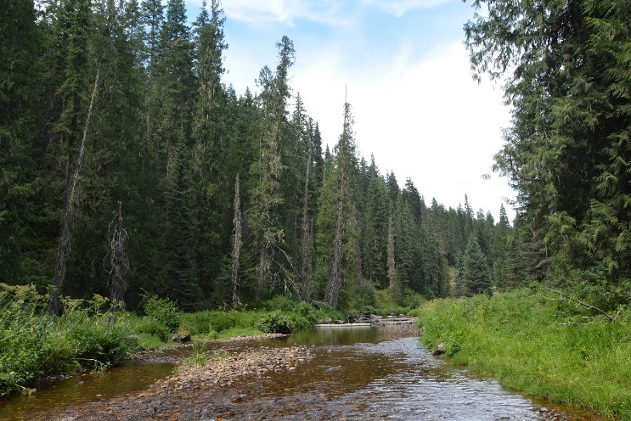

USFS photo.
The Nez Perce-Clearwater National Forests is looking for a uniquely skilled individual to join our team. If you like variety, challenges, and bringing people together, then this is the position for you!
The Nez Perce-Clearwater National Forests intends to advertise one (1) position working as the Executive Assistant to the Forest Supervisor and Deputy Forest Supervisor. The official duty station for the single vacancy will be Kamiah, ID.
This Outreach is for a permanent position as well as a 120-day detail/temp promotion. Once the vacancy opens, the announcement number will be noted in the U.S. Forest Service Outreach Database (https://fsoutreach.gdcii.com/Outreach).

ABOUT THE POSITION

The Executive Assistant is responsible for calendars, meetings, and travel for the Forest Supervisor and Deputy Forest Supervisor. Scheduling meetings and making arrangements such as preparing agendas, notifying participants, reserving conference space and similar matters are just to name a few of the daily tasks. The incumbent will schedule, take notes and attend Forest Leadership Team meetings, working closely with the facilitator to draft meeting agendas and organize a changing meeting schedule as needed.

The incumbent will coordinate with internal and external participants to ensure key staff members are present at meetings and briefs the participants before the meeting occurs. Developing background information, briefing materials, and ensuring the supervisor has necessary information in advance of meetings. Additionally, it is necessary to routinely follow-up on action items with appropriate staff members.

DESIRED SKILLS/EXPERIENCE FOR POSITION
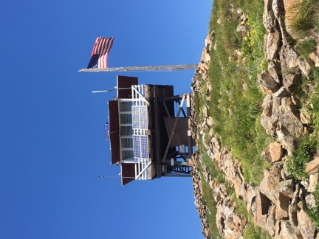
- Strong written and oral communication skills
USFS photo.
- Ability to effectively communicate with a variety of individuals.
- Ability to work under pressure.
- An adaptive personality that can identify and resolve competing priorities and deadlines.
- Detail oriented
- Team player with a positive attitude
- Willingness to learn new things and bring new ideas forward.

HOW TO APPLY
Interested applicants can submit an Outreach Response Form at any time before the vacancy closes. All responses received will be notified when the vacancy opens. Outreach response forms should be submitted to Joslyn Osborn-Gaines, Administrative Operations Specialist at joslyn.osborngaines@usda.gov.

CONTACT INFORMATION
To learn more about the Executive Assistant position, please contact Joslyn Osborn-Gaines, Administrative Operations Specialist at joslyn.osborngaines@usda.gov.

ABOUT THE NEZ PERCE-CLEARWATER NATIONAL FORESTS
The Nez Perce-Clearwater National Forests is a fast-paced, highly productive forest comprised of more than 4 million acres of land ranging in elevation from 1,600 feet to almost 9,000 feet. Approximately 1.8 million acres of the Forest was recently designated as a Wildland Crisis Strategy Landscape. The entire Forest is within the ancestral homelands of the Nez Perce Tribe and we actively work with the Tribe on our projects and programs. The weather is characterized by four distinct seasons. Much of the forest is snowbound December through May. A pleasant summer season usually extends from June through September, but higher elevations remain inaccessible until early July. Summer temperatures in the 90s are possible, but nights are cool. Lightning storms are common in July and August.
The forest offers an abundance of recreation opportunities. If you enjoy hiking, horseback riding, camping, whitewater trips, snowmobiling, mountain biking, bird watching, or big-game hunting and Blue Ribbon trout stream fishing, this is the place for you! Because of its proximity to metropolitan areas, the forest receives high recreation visitation. Of course, there’s plenty of opportunities for solitude in the backcountry and the Selway-Bitterroot, Frank Church-River of No Return, and Gospel Hump Wilderness areas on the forest.
The Nez Perce-Clearwater spans the dry, rugged canyons of the Salmon River to the moist cedar forests of the Selway drainage and north to the fertile, rolling uplands of the Palouse. These lands are part of the aboriginal homeland of the Nez Perce people. The forests include a complex mix of designated Wilderness areas and Wild and Scenic Rivers, two National Historic Trails, a National Historic Landmark, rugged backcountry, Idaho Roadless Areas, productive timber ground, rangeland, mineral claims, and an array of outstanding recreation opportunities to satisfy nearly every outdoor enthusiast.
The Nez Perce-Clearwater hosts a myriad of aquatic and terrestrial species, including Threatened and Endangered species like Chinook salmon, steelhead, and Canada lynx, as well as iconic creatures like bald eagles, wolves, elk, and bighorn sheep.
Perhaps the only thing more diverse than the forests and wildlife are the people that love it and their unique perspectives on how we should manage it. This makes for a dynamic social and political landscape. These forests offer almost every land management opportunity and challenge imaginable.
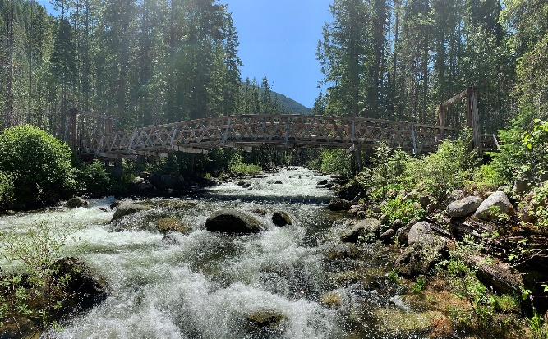
USFS photo.

Visit www.fs.usda.gov/nezperceclearwater for more information about the Nez Perce-Clearwater NFs!

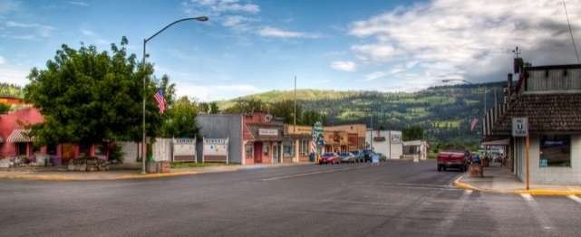
ABOUT THE LOCATION –
KAMIAH, IDAHO
Courtesy photo.
Kamiah, Idaho is located in north-central Idaho along U.S. Highway 12. The town’s population is about 1,300; however, there are about twice that many residents in the surrounding areas. The climate is much milder than surrounding prairies and mountains, with very little snow in winter, long autumns, and early springs. The town sits at around 1,250 feet elevation within the Clearwater River valley. Expect lots of summer sun and protection from harsh winds.
Kamiah is located within the Nez Perce Reservation. History surrounding the Nez Perce Tribe and Lewis and Clark Expedition draws many visitors.
The Clearwater River, the most productive salmon and steelhead watershed in the Columbia River Basin, runs adjacent to Kamiah and provides some of the best fishing in the lower 48. Trout fishing opportunities are abundant. The forest provides year-round habitat for one of the most significant elk herds in Idaho, and whitetail deer and game birds are similarly abundant, making the Clearwater Valley a popular hunting destination as well.
Whitewater rafting is popular on the rivers as well. Nearby Wilderness areas offer opportunities to explore on foot or horseback. The forest also has a developed system of ATV trails to access the backcountry.
Government housing is not available in Kamiah. Rental rates for an average three-bedroom home range from $700 to $1500/month. Three-bedroom homes in the Kamiah area are priced for sale between $200,000 and $850,000. There are ample opportunities for purchase or rent in the city, the surrounding countryside, or nearby communities like Grangeville (50 miles) or Orofino (25 miles).
Public schools are available in Kamiah from pre-school through 12th grade. The University of Idaho is located in Moscow (92 miles) and Washington State University in Pullman is 15 miles beyond that. Lewis Clark State College in Lewiston, Idaho is approximately 65 miles from Kamiah.
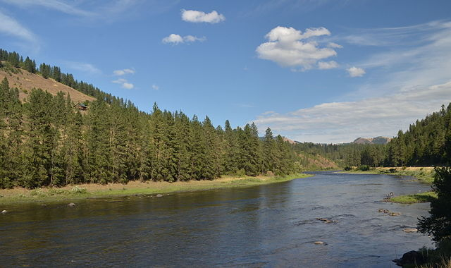
Most religious affiliations are represented by churches in the area.
USFS photo.
A medical clinic is located in Kamiah. There are two small hospitals within a short drive, located in Orofino and Grangeville. Full service medical facilities are located farther away in Lewiston, Idaho; Spokane, Washington; and Missoula, Montana.

NEZ PERCE-CLEARWATER NATIONAL FORESTS OUTREACH RESPONSE FORM

  - GS-0301-07/09 – EXECUTIVE ASSISTANT
  - SUPERVISOR’S OFFICE -Kamiah, Idaho

To express interest, please submit this Outreach Form to Joslyn.osborngaines@usda.gov
To enter in check-box fields, double click in the check box and select “Checked.” Type entries into other fields.

Applicant Information
Name: |  |  |  |  |  |  |  |  | E-Mail Address:
Mailing Address:
Work Phone: |  |  |  |  |  |  |  |  | Alternate Phone:
Agency Employed with: |  |  |  |  | USFS BLM NPS Other____________
Type of Appointment: |  |  |  |  | Permanent Temporary Term VRA  Other Not Current Employee
Current Region/Forest/District:
Current Series And Grade If Applicable:
Current Position Title:
Where Did You Hear About Vacancy/Outreach?
If you are NOT a current permanent (career or career conditional) employee, are you eligible to be hired under any of the following authorities:
Reinstatement  Veterans Recruitment Act  Disabled Veteran with 30% Compensable Disability  Veteran’s Employment Opportunities Act of 1998 |  |  |  |  |  |  |  |  |  | Person with Disabilities  Former Peace Corps Volunteer  Demonstration Project (external recruitment from the general public)  Other
Additional Remarks
Please use this space to identify special qualifications, duty location interests, needs, or provide other information:

To express interest in the EXCUTIVE ASSISTANT position, please send this completed form to joslyn.osborngaines@usda.gov. Thank you for your interest in this position!

