outreach Notice
Kootenai National Forest
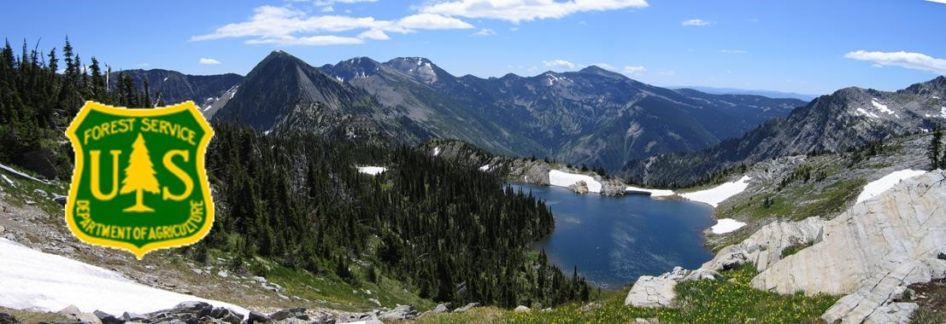
Environmental Engineer
“Libby OU3 On-Scene Coordinator”
GS-0819-12

The Northern Region (R1), Kootenai National Forest will be filling an Environmental Engineer, GS-0819-12 position. This is a detail/temporary promotion position for up to 120 days.

Duty Station: Libby, MT Alternate duty locations maybe considered for this detail. Determination of the duty station for the vacancy announcement will be made based on response to this outreach.

Interested applicants are requested to respond utilizing the Employee Outreach Database.
For Forest Service applicants the located in ConnectHR.
For external applicants this may be accessed by an internet search for FS Outreach or the following link https://fsoutreach.gdcii.com/Outreach.

Duties:
-Coordinate with multiple agencies including the EPA (Lead Agency) and the State on technical items for development of the Libby Asbestos Superfund Site Operable Unit 3 (OU3) remedy.
-Manage all work items related to OU3.
-Manage USFS (Lead Agency) CERCLA projects associated with OU3.
-COR I designation (minimum) and contract oversight duties for multiple contracts.
-Assist as necessary with implementation of the Kootenai National Forest Libby Asbestos Program Manual which is the asbestos related employee health and safety plan for the Forest.
-Coordinate with subject matter experts as necessary for projects associated with OU3 including fire personnel, silviculturists, natural resource specialists, and management.
Qualifications:
-HAZWOPER - 40 hours plus 3 days supervised field work, plus 8 hours project specific. (Acceptable field work experience alternatives are given in 29 CFR 1910.120(e)(9) and reprinted in Appendix 10 of the Forest Service Guide to CERCLA.)

-On-Scene Coordinator Training (sponsored by the Washington Office)

Interested applicants must respond by September 6th, 2023.

To receive consideration for this position, you must meet all qualification requirements and application procedures, as listed in the announcement.
Government housing may be available.
The Forest does not offer federal day care facilities.
For more information regarding this position, please contact Kenneth Wickward at (406)283-7766 or email Kenneth.wickward@usda.gov; or Seth Cole at (406)283-7632 or email Seth.cole@usda.gov

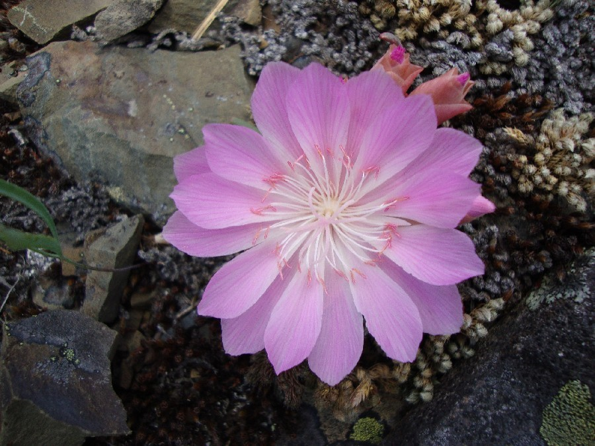ABOUT THE COMMUNITY
The Libby Ranger District operates out of the Canoe Gulch Ranger Station. The Ranger Station is located along the Kootenai River, 13 miles north from Libby, Montana.
Libby lies in the northwest corner of Montana and is nestled in a valley carved by the Kootenai River on the flank of the majestic Cabinet Mountain Range and Wilderness Area. Today, about 2,800 people live within Libby proper. The main industries are lumber and wood products, mining, tourism, and recreation. The movies “The Revenant”, "The River Wild" and "Always" were filmed here. Contact the Libby Chamber of Commerce for brochures, information on lodging and events, general area information, and contact information for local businesses and services.
Libby, Montana is basically a full-service community providing education from K through 12th grade. A Head Start program is also available. Libby offers a post office, multiple banks, two grocery stores, a hospital, multiple medical clinics, multiple dentists, chiropractors, and physical therapists, three fitness centers, two drug stores, multiple motels, a bed & breakfast, masseuses, several second-hand stores, numerous small variety shops, restaurants, a golf course, and other businesses. Churches of various denominations are also available in the area. Libby also has excellent parks and walking paths.

Glacier National Park is 115 miles to the east and Spokane, Washington is 150 miles to the west. For more information on Libby go to CityofLibby

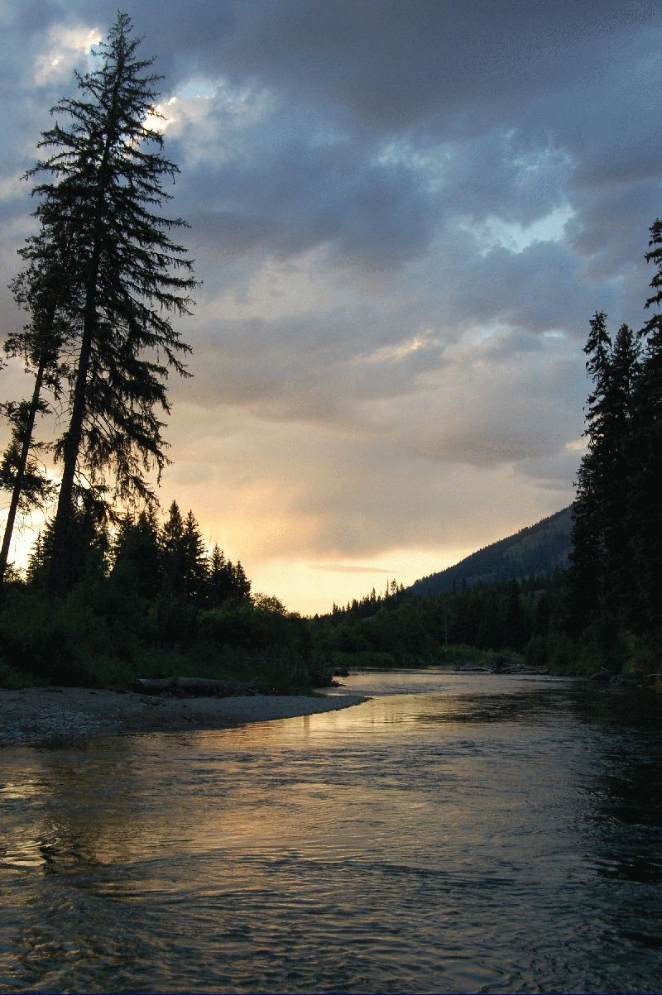The Libby Ranger District encompasses 620,000 acres. Libby has a strong resource management program with heavy workloads in vegetation management, fire, wildlife, recreation and watershed restoration. During the peak of the summer, there are approximately 35 permanent employees and a temporary work force of approximately 60 working on the District.

The Libby Valley has documented presence of Libby Amphibole Asbestos (LAA) as determined by the Environmental Protection Agency (EPA). As of November 2018, EPA has completed cleanup of residential and commercial properties in Libby and Troy. Cleanup of other areas, such as the now defunct mine site, continues. Interested applicants are urged to research the possible hazards of LAA to human health. Further information can be found at EPA (EPALibby) and the Center for Asbestos Related Disease (CARD) (LibbyAsbestos).
The former mine site and surrounding forested area encompasses approximately 10,000 acres and is known as the Libby Asbestos Superfund Site Operable Unit 3 (OU3). The site is located on the Libby Ranger District. This area presents special resource management concerns due to the established presence of asbestos fibers in the tree bark, duff and soil. The Forest Service has taken additional precautions outside of OU3 for employee health and safety. This are is not currently actively managed as part of the Forest’s vegetation management program and has controlled access. Additional description of the area is available at the EPA (OperableUnit3). Applicants may also contact the Libby District Ranger for more information.
SUMMER
When the weather warms and the mountain snows melt away, the Kootenai National Forest comes alive with over 2.2 million acres of public land as a playground. Mountain trails and lakes open up, beautiful wildflowers come in bloom, and wildlife have their young. Libby is the base camp for the Cabinet Mountains Wilderness Area, Lake Koocanusa, Northwest Peaks Scenic Area, and the Ten Lakes Scenic Area. There is good access to most of the Forest and plenty of room to get away from it all!
- Blue ribbon fishing in the Kootenai River
- Cabinet Wilderness Area hiking and exploring
- 90-mile long Lake Koocanusa Reservoir
- Camping in dispersed and developed campgrounds
- Miles of hiking, backpacking & mountain biking trails
- 2.2 million acres to play on the Kootenai National Forest
- Boating on the Kootenai, Lake Koocanusa, and numerous area lakes
- Golfing at Cabinet View Country Club Golf Course
FALL
Northwest Montana, the Kootenai National Forest, and adjacent State of Montana and private lands have abundant wildlife. In Montana, hunting is primarily a family sport. There are general seasons for elk, deer (white tail and mule deer), and bear. There are annual drawings for permits to hunt moose, bighorn sheep, mountain goat, and mountain lion. For bird hunters there are turkey, grouse, and some ducks. For more information: Hunting - Montana Fish, Wildlife & Parks
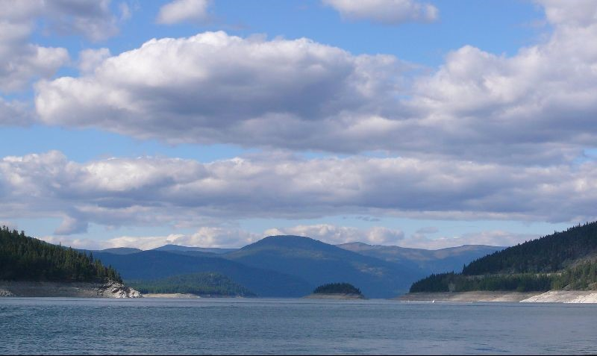WINTER
Winter in Montana means snow, and lots of it! For those who love to play in the deep powder, the Libby area offers tremendous winter fun. Turner Mountain Ski Area, located just 22 miles from Libby, offers challenging downhill skiing with a beautiful view. Their slogan is "steep, deep and cheap", and Turner definitely lives up to that. It's still fairly undiscovered, so you can escape the crowds and get the cheapest lift tickets around. For those who love snowmobiling, there are hundreds of miles of backcountry roads to sled on in the Kootenai National Forest. Cross-country skiers and ice fishermen also can find solitude on a lake and miles of quiet forest trails to enjoy the outdoors. Those who are a bit on the wild and crazy side will love the antics of the Libby Polar Bear Club. Members take winter-time "swims" in frigid Libby Creek every Sunday from October to April. Plungers have ranged in age from 3 to 61. As long as the ice can be broken on the creek, if it has formed, the group will take their plunge, no matter the temperature. LibbyMT
ABOUT THE FOREST
The Kootenai National Forest located in the extreme northwest corner of Montana and a small portion of northeast Idaho encompassing over 2.2 million acres of NFS lands, an area nearly three times the size of Rhode Island. The forest consists of 4 Ranger Districts located in Eureka, Troy, Libby and Trout Creek; 3 Staff Units located in the Supervisor’s Office and Engineering located throughout the units. The Forest is bordered on the north by British Columbia, Canada, and on the west by Idaho. Of the total acres, 50,384 are within the State of Idaho. Access into the Forest is via U.S. Highways 2 and 93 and Montana State Highways 37, 56, 200 and 508.
Ranges of high craggy peaks mark the Forest with Snowshoe Peak in the Cabinet Mountains at 8,738 feet, the highest point. The Whitefish Range, Purcell Mountains, Salish Mountains, and Cabinet Mountains are all part of the rugged terrain radiating from the river valleys. In the north central part of the Forest, the land is more open with gently rolling timbered hills lying in the shadows of the Whitefish Range.
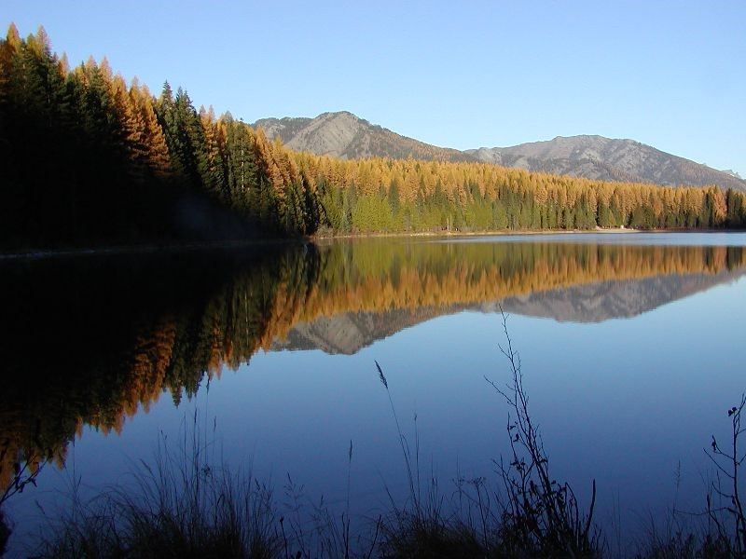The Forest is dominated by two major rivers, the Kootenai and the Clark Fork, along with several smaller rivers and their tributaries. Two hydroelectric dams on the Clark Fork have created the Cabinet Gorge and Noxon reservoirs within the Forest boundary. State Highway 200 parallels these reservoirs as it crosses the Forest. The Kootenai River is spanned by another hydroelectric (and flood-control) project, Libby Dam. This structure located about 17 miles upstream from Libby, Montana, created Lake Koocanusa, a 90-mile-long reservoir reaching northward into the Canadian Rockies. Lake Koocanusa is almost surrounded by national forest lands, no private summer home or condominium developments here. State Highway 37 follows the east shore to Rexford and beyond to Eureka, Montana. The elevation of the Kootenai River as it leaves the Forest and the State is 1,862 feet, the lowest point in Montana.

The Yaak, Fisher, Tobacco, and Vermillion Rivers are smaller rivers within the confines of the Forest. There are over 100 lakes inside the boundaries of the Kootenai ranging from small alpine lakes to 1,240 acres McGregor Lake.
The climate of the Kootenai has been described as "modified Pacific maritime" in character, meaning that compared to the remainder of Montana, this area's climate resembles that found along the Pacific coast. The character becomes "modified" by occasional intrusions of the arctic air masses, more commonly found in the remainder of the State, which can bring winter temperatures down to -30° F with heavy snowfalls in the mountains. Average annual temperatures of 45° F reflect the moderating influence of the Pacific air masses. Summer temperatures are moderate with few days reaching over the 100° mark. The wet season in the Forest usually occurs in the fall and early winter.

The Kootenai is truly a forest with multiple uses. The vegetation management program is aimed at restoring and maintaining Northern Rockies fire dependent habitats. The diversity of tree and other plant species is among the greatest in the Northwest. Management and recovery of threatened and endangered species, such as grizzly bear, lynx, and bull trout emphasize the forest wildlife and fisheries programs. Other wildlife on the forest include gray wolf, wolverine, cougar, elk, moose, white-tailed and mule deer, mountain goat, bighorn sheep, bald and golden eagles and other species of birds, mammals, amphibians, and reptiles.
INDIAN TRIBES
The Kootenai National Forest (KNF) encompasses lands that are part of the Confederated Salish and Kootenai Tribes (CSKT) Aboriginal Territory. In the Hell Gate Treaty 1855 the CSKT ceded over 22 million acres to the United States Government retaining 1.2 million acres for their own use that today is the Flathead Indian Reservation. The Flathead Indian Reservation is approximately 85 miles southeast of the Kootenai National Forest. The Tribes retain Treaty rights under the Hell Gate Treaty on federal lands such as the KNF. These rights include hunting, gathering, digging plants and roots, fishing, and grazing on Kootenai National Forest lands.
The Kootenai National Forest holds many places in the natural environment that are important to the Kootenai people. These are known as cultural sites and traditional cultural properties. The relationship and bonds that Kootenai people have to these places were established before there was a Kootenai National Forest and the stories, place names and songs from these sites have been handed down from generation to generation. This is called a cultural landscape and is the basis for or essence of Kootenai identity and culture.
USDA Nondiscrimination Policy, June 2, 2015
In accordance with Federal civil rights law and U.S. Department of Agriculture (USDA) civil rights regulations and policies, the USDA, its Agencies, offices, and employees, and institutions participating in or administering USDA programs are prohibited from discriminating based on race, color, national origin, religion, sex, gender identity (including gender expression), sexual orientation, disability, age, marital status, family/parental status, income derived from a public assistance program, political beliefs, or reprisal or retaliation for prior civil rights activity, in any program or activity conducted or funded by USDA (not all bases apply to all programs). Remedies and complaint filing deadlines vary by program or incident.
Persons with disabilities who require alternative means of communication for program information (e.g., Braille, large print, audiotape, American Sign Language, etc.) should contact the responsible Agency or USDA’s TARGET Center at (202) 720-2600 (voice and TTY) or contact USDA through the Federal Relay Service at (800) 877-8339. Additionally, program information may be made available in languages other than English.
To file a program discrimination complaint, complete the USDA Program Discrimination Complaint Form, AD-3027, found online at ASCR_USDAGov and at any USDA office or write a letter addressed to USDA and provide in the letter all of the information requested in the form. To request a copy of the complaint form, call (866) 632-9992. Submit your completed form or letter to USDA by: (1) mail: U.S. Department of Agriculture, Office of the Assistant Secretary for Civil Rights, 1400 Independence Avenue, SW, Washington, D.C. 20250-9410; (2) fax: (202) 690-7442; or (3) email: program.intake@usda.gov (link sends e-mail).
USDA is an equal opportunity provider, employer and lender.

