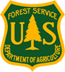
Outreach Notice
USDA-Forest Service
Northern Region
Lolo National Forest
___________________________________________________________________

Lolo National Forest District Ranger

GS-0340-12/13
Detail/Temp Promotion/Permanent Position
Plains/Thompson Falls Ranger District

Plains, MT

REPLY DUE: September 15, 2023
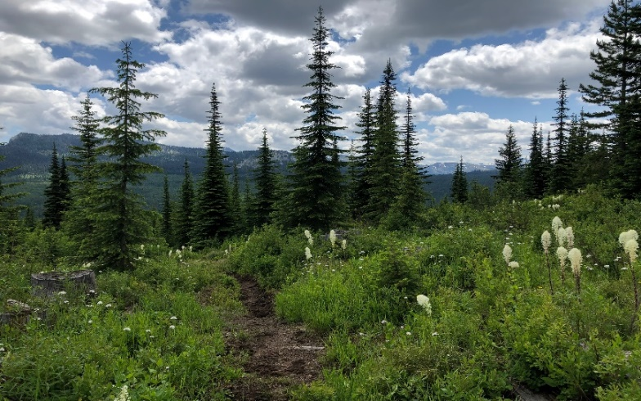

The Lolo National Forest is outreaching for a detail/temporary promotion (NTE 120 days) and a permanent position as the Plains/Thompson Falls District Ranger. The official duty station will be the Plains/Thompson Falls Ranger District in Plains, MT. This is not a virtual position. The projected start date for the detail/temporary promotion is early-October 2023.

Interested applicants may respond to this outreach by close of business on September 15, 2023. Please email the Response Form and your resume to Jeremy Casterson, Deputy Forest Supervisor, at Jeremy.casterson@usda.gov.

About the Position: Located in Plains, MT, this position serves as a District Ranger with responsibility for the management of the resources, goods, and services of a designated area on a National Forest. Directly responsible for the development, production, conservation, and utilization of the natural resources of forests and associated lands of the District; and the inventory, planning, evaluation, and management of each forest resource including timber, soil, land, water, wildlife and fish habitat, minerals, forage, wilderness and visual areas, and outdoor recreation.

As a member of the Forest Leadership Team, this position works to formulate plans, policies, and objectives for the Forest. They will provide recommendations to the Forest Supervisor concerning budget and personnel, timber, recreation, fire, wildlife, wilderness, range, lands and special uses, minerals, law enforcement, watershed, pest management and social, economic, and political considerations within the District.

The District Ranger will advise staff and make decisions or changes to programs and projects within delegated authority.

The District Ranger will establish and maintain cooperative relations with local, county, and state officials, and special interest groups, civic groups, private industry, Tribal government, permittees, and the general public. This position will promote understanding and acceptance for Forest Service program goals and objectives, policies, and regulations. The District Ranger is responsible for program management and planning identifying work force and organizational needs, and district priorities.

This position is the direct supervisor for the primary District staff as well as several zoned personnel.

About the Forest: The Lolo National Forest is in west-central Montana and includes five Ranger Districts in the heart of one of America’s most recognized and visited western landscapes. The Lolo National Forest Ranger Districts are Missoula, Seeley Lake, Plains/Thompson Falls, Ninemile, and Superior. In 2008, the forest estimated approximately one million visitors. The Lolo National Forest is west of the Continental Divide and is influenced by both continental and maritime climates.

Missoula has a population of about 77,000 serving a trade area of over 300,000. Consequently, the city has more amenities and services than most cities of its size. Missoula is home to the University of Montana, College of Technology, three public and two private high schools, and several public and private elementary schools. Missoula's economic base is tourism, Federal Government, motor carriers, and the University of Montana. Neighborhoods and residential settings are diverse ranging from urban to very rural. Missoula has two large hospitals which provide a full array of inpatient and outpatient services.

Missoula residents enjoy all four seasons of the year. The elevation of Missoula is 3,205 feet, with an average annual temperature of 44.6 F, with a January daily minimum of 15.4 F. and July daily maximum of 83.4 F. Recreation facilities and opportunities are abundant. Many rivers provide for rafting, fishing, and swimming opportunities. There is one downhill ski area less than an hour from town and three within two hours.

For more information about Missoula, go to http://www.ci.missoula.mt.us/.

- Lolo National Forest website: https://www.fs.usda.gov/lolo/
- Lolo NF Facebook
- Lolo NF Twitter

The U.S. Department of Agriculture Forest Service prohibits discrimination in all its programs and activities based on race, color, national origin, sex, religion, age, disability, political beliefs, sexual orientation, and marital or family status (not all prohibited bases apply to all programs). Persons with disabilities who require means for communication of program information (Braille, large print, audiotapes, etc.) should contact USDA's TARGET Center at (202) 720-2600 (voice and TDD).

To file a complaint of discrimination, write: USDA, Director, Office of Civil Rights, Room 326-W, Whitten Building, 14th and Independence Ave, SW, Washington, DC
•
20250-9401 or call (202) 720-5964 (voice or TDD). USDA Forest Service is an equal opportunity provider and employer.

OUTREACH RESPONSE FORM
Lolo National Forest
Plains/Thompson Falls Ranger District

District Ranger
GS-0340-12/13

PLEASE RESPOND NO LATER THAN SEPTEMBER 15, 2023
Complete this form and send it and your resume to Jeremy Casterson, Jeremy.casterson@usda.gov, or respond via the Outreach Database.

PERSONAL INFORMATION

Name: |  |  |  |  |  |  |  |  |  |  |  |  |  |  |  |  |  | Date:
Address:
City: |  |  |  |  |  |  |  |  |  |  |  |  |  | State:
E-Mail: |  |  |  |  |  |  |  |  |  |  |  |  |  |  |  |  | Phone:
EMPLOYMENT
Are you currently a Federal Employee? |  |  |  |  |  |  |  |  |  |  |  | Yes |  |  |  | No
 |  |  | If Yes:
 |  |  |  |  | Name of your Agency & Location:
 |  |  |  |  | Current title/series/grade:
 |  |  |  |  | Appointment Type: |  |  |  |  | Permanent Term Temporary
 |  |  | If No:
 |  |  |  |  | Current Employer:
 |  |  |  |  | Current Position Title & Salary:
 |  |  |  |  | Are you eligible for appointment under any of the following special authorities?
Former Peace Corps
Person with Disabilities (Schedule A)
Student Employment Program
Veteran with 30% Compensable Disability
Veteran’s Employment Opportunities Act of 1998
Veteran’s Readjustment
Reinstatement Eligibility
Other

Briefly describe why you will be a quality candidate for this position (if additional space is needed, attach below):

