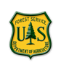

“Caring for the Land and Serving People”

OUTREACH NOTICE

Deschutes National Forest
GS-0482/1315-7/9/11 Fish Biologist/Hydrologist
Permanent Position (telework eligible) and
120-day Detail/Time Limited Promotion
(combination of in-person and virtual engagement)

Deschutes NF Supervisor’s Office
Bend, Oregon

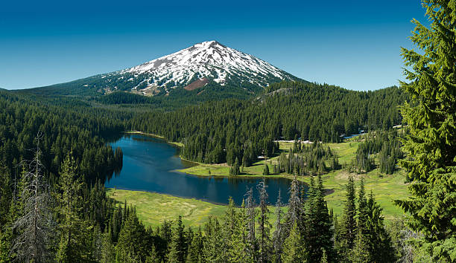

Reply due date is no later than August 31st, 2023.

We are outreaching to determine interest in the permanent and detail/TLP opportunity for this position. The purpose of this Outreach Notice is to determine the potential applicant pool for this position and to establish the appropriate recruitment method and area of consideration for the advertisement, and to inform prospective applicants of this opportunity.

ABOUT THE POSITION:
The incumbent provides professional input regarding fisheries and hydrology needed to implement the Forest Plan and other laws and regulations, such as the Endangered Species Act, Clean Water Act, etc. Participates in the development of a variety of projects. Prepares environmental analysis reports as needed, and develops biological evaluations/assessments for threatened, endangered, and sensitive species consultation.

This position would support two new IDTs that are being formed on the Forest, a Special Projects IDT and a Contract NEPA IDT. The Special Projects IDT would work on projects Forest-wide, especially those that address special planning challenges or are Forest-wide or multi-District in scope. The Contract NEPA IDT will focus on 3rd party NEPA contracts, being the conduit between the Forest Service and private contracts to contract out all or parts of NEPA analyses.

Some specific tasks for the detail/TLP opportunity would include:
- Providing input to NEPA projects (potentially on special uses, recreation, post and pole, and reforestation type projects).
- Providing analysis direction and review for contracted NEPA projects.
- Assist with the validation and mapping of special habitats to assist with ongoing landscape analyses.

Position would be supervised by the Natural Resources Staff Officer, with the Forest Fish Biologist or Watershed Program Manager as their work lead. Please contact Jason Wilcox (Forest Fisheries Program Manager) with any questions about the position at jason.wilcox@usda.gov.

EMPLOYEE WELLBEING AND WORKPLACE ENVIRONMENT

Employee wellbeing is a core value and one that is strongly supported by the FLT and employees themselves. We have several complimentary efforts working together to enhance the workplace environment and support individual wellness such as the Central Oregon Comprehensive Wellness Advocates, Workplace Culture Working Group, and Women in COFMS (Central Oregon Fire Management Services). In addition, the Central Oregon Civil Rights Committee is very active in promoting and honoring cultural awareness, allyship, and diversity, equity, and inclusion. We take pride in our grassroots approaches to supporting employees locally by listening to their needs, providing peer support, and amplifying regional and national resources.

ABOUT BEND

The City of Bend resides at the base of the beautiful Cascade mountains in central Oregon and has become one of the fastest growing communities in the nation. The area has long been a mecca for outdoor enthusiasts, with easy access to mountain biking, Nordic ski trails, hiking trails, river and lake recreation, and Mt. Bachelor ski resort. Bend and the surrounding area also boast over 30 breweries, dozens of restaurants, and year-round entertainment such as downtown festivals, summer concert series, the Bend Film Fest, and numerous athletic events.

More detailed information about the Bend/Central Oregon area may be obtained from the Bend Chamber of Commerce web site at www.bendchamber.org.

Information about the nearby community of Prineville and Crook County can be found at: http://co.crook.or.us/AbouttheCounty/tabid/56/Default.aspx and at http://www.cityofprineville.com/

Please indicate your interest in this position by returning the attached Outreach Interest Form. If you are interested in the detail, please include your resume as well. For additional information or questions, please contact:

Sasha Bertel, Deschutes NF Forest Environmental Coordinator
Deschutes National Forest, 63095 Deschutes Market Road, Bend, Oregon 97701
Email: sasha.bertel@usda.gov
Phone: (541) 383-5563
Reply due date is no later than August 31st, 2023.

USDA Non-Discrimination Statement
Revised 6/8/2005
“The U.S. Department of Agriculture (USDA) prohibits discrimination in all its programs and activities on the basis of race, color, national origin, age, disability, and where applicable, sex, marital status, familial status, parental status, religion, sexual orientation, genetic information, political beliefs, reprisal, or because all or part of an individual’s income is derived from any public assistance program. (Not all prohibited bases apply to all programs.) Persons with disabilities who require alternative means for communication of program information (Braille, large print, audiotape, etc.) should contact USDA’s TARGET Center at (202)720-2600 (voice and TDD). To file a complaint of discrimination, write to USDA, Director, Office of Civil Rights, 1400 Independence Avenue, S.W., Washington, DC 20250-9410, or call (800) 795-3272 (voice) or (202) 720-6382 (TDD). USDA is an equal opportunity provider and employer.”
OUTREACH INTEREST FORM

Deschutes National Forest

Fish Biologist/Hydrologist GS-0482/1315-7/9/11
120-day Detail or Temporary Promotion and Permanent Position

NAME:

EMAIL ADDRESS:

MAILING ADDRESS:

TELEPHONE NUMBER:

GOVERNMENT AGENCY EMPLOYED WITH: USFS____ BLM____ OTHER:

TYPE OF CURRENT APPOINTMENT: PERMANENT TEMPORARY TERM OTHER

CURRENT AGENCY/REGION/FOREST/DISTRICT:

CURRENT SERIES AND GRADE:

CURRENT POSITION TITLE:

ARE YOU INTERESTED IN THE DETAIL, PERMANENT POSITION OR BOTH?

If interested in the permanent position, are you eligible for employment under any of the following special hiring authorities?
☐ Former Peace Corps
☐ Person with disabilities
☐ Veteran with 30% Compensable Disability
☐ Veteran’s Employment Opportunities Act of 1998
☐ Reinstatement Eligibility
☐ Pathways Program
☐ Other

Completed form and a copy of your resume should be sent to:

Sasha Bertel, Deschutes NF Forest Environmental Coordinator
Deschutes National Forest, 63095 Deschutes Market Road, Bend, Oregon 97701
Email: sasha.bertel@usda.gov
Phone: (541) 383-5563

Reply due date is no later than August 31, 2023.

