## 

## Region 1

**Medora Ranger District; McKenzie Ranger District**

**\*\*\*\*\*\*\*\*\*\*\*\*\*\*\*\*\*\*\*\*\*OUTREACH NOTICE\*\*\*\*\*\*\*\*\*\*\*\*\*\*\*\*\*\*\*\*\*\***

**Deputy District Ranger – two positions!**

**Job Announcement Opening – coming soon!**

***GS-0340-12***

The Dakota Prairie Grasslands (DPG) is outreaching for two Deputy District Rangers for the Medora Ranger District in Dickinson, North Dakota and the McKenzie Ranger District in Watford City, North Dakota.

**Position Title:** Deputy District Ranger GS-0340-12

**Description of Duties:** The Deputy District Ranger (DDR) serves as a line officer under the District Ranger on the districts of the Little Missouri National Grasslands in the stunning badlands of western North Dakota (ND). The primary duties are to provide leadership capacity for our critical national oil and gas program and the largest grazing program in the Forest Service. In addition, this position would provide supervision and direction to employees as assigned for a complex special uses program, administrative support, and recreation. The incumbent works directly for the District Ranger and coordinates with staff at the District, Grasslands Supervisor Office, and Regional Office. The DDR supports the accomplishment of the Dakota Prairie Grasslands program of work.

**THE GRASSLANDS:** The DPG stretches over 1,259,000 acres and is not composed of solid blocks of National Forest System lands; rather, they are intermingled with other federal, state, and privately-owned lands. This mixed proprietorship pattern contributes to the uniqueness of the Grasslands. The DPG encompasses the Little Missouri, Sheyenne, Grand River and Cedar River National Grasslands.

Each of the National Grasslands has a flavor all its own. The tall grass prairies on the rolling hills of the Sheyenne National Grassland are a significant contrast to the stark badlands found in the Little Missouri National Grassland. The resources of the LMNG are unique, including paleontological and archeological digs, oil and gas production, cattle grazing, and recreation.

**THE DISTRICTS:** The Medora Ranger District encompasses the southern portion of the Little Missouri National Grasslands. The McKenzie Ranger District encompasses the northern portion of the Little Missouri National Grasslands. Portions of the Districts are directly adjacent to Theodore Roosevelt National Park. These units manage a significant portion of the Nation’s largest range program on NFS, including projects for range improvements and vegetation management over approximately 500,000 acres of NFS lands. The districts also manage the longest non-motorized trial in North Dakota (the 144-mile Maah Daah Hey Trail), and the largest oil and gas minerals program on NFS, with related special uses and lands programs. In addition, the districts both oversee important fire, recreation, and trail programs and have wildlife biology, archeology, hydrology, and botany specialists within each unit.

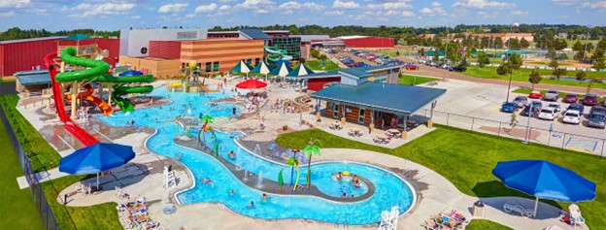**COMMUNITY: Dickinson, ND,** is a progressive city, having undergone strong exponential growth in recent years, fueled by a diverse economy and fed by new wealth from energy, agriculture, and manufacturing. The population of Dickinson hovers at around 25,000; however, the community retains a small-town warmth and charm while embracing substantial growth during the last ten years. The school system is considered excellent and includes K-12 options within the Dickinson Public School System and Trinity Catholic School System. The community also hosts Dickinson State University, which includes bachelor’s and Graduate level programs in a variety of areas. The city has 26 churches representing most denominations. Several medical clinics with a full trauma care hospital are in town, along with a regional airport. The city has a variety of entertainment, shopping and business services. Dickinson has an excellent Park and Recreation Department with programs available for kids and adults, to include an Exhibition League baseball team, the Badlands Big Sticks. Plus, there are community events, such as BBQ and chili cookoffs, a farmers market, The Medora Musical (in Medora), rodeos, fairs, downtown street fairs, paleo museum, and winter music series, just to name a few. Dickinson benefits from state of the art, all season indoor recreational facilities with full complements of exercise opportunities from swimming and weights to running, volleyball, racquetball, basketball, and tennis.

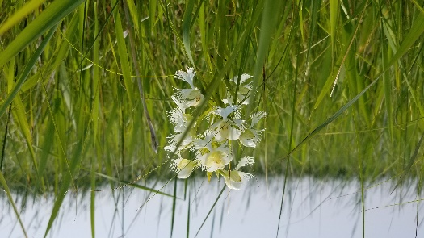**Watford City, ND,** is a bustling community that hosts a large sector of the oil and gas industry in North Dakota. The counties are well-funded and the community hosts new schools and municipal facilities including indoor hockey and athletics facilities. Wages for employees in the area are above national averages. The Williston airport, about 35 miles away, hosts two major air carriers. This community is full service and friendly, with numerous public events.

**Housing:** Government housing may be available at both locations.

**QUALIFICATION REQUIREMENTS**: Applicants must meet the qualification requirements and time-in-grade requirements for the GS-11 series.

**FOR MORE INFORMATION CONTACT:**

|  |
| --- |
| Misty Hays Medora District Ranger [misty.hays@usda.gov](mailto:misty.hays@usda.gov)  Kim Anderson McKenzie District Ranger [kim.anderson@usda.gov](mailto:kim.anderson@usda.gov) |
|  |
|  |
|  |

|  |
| --- |
|  |





