Outreach Notice

Kootenai National Forest
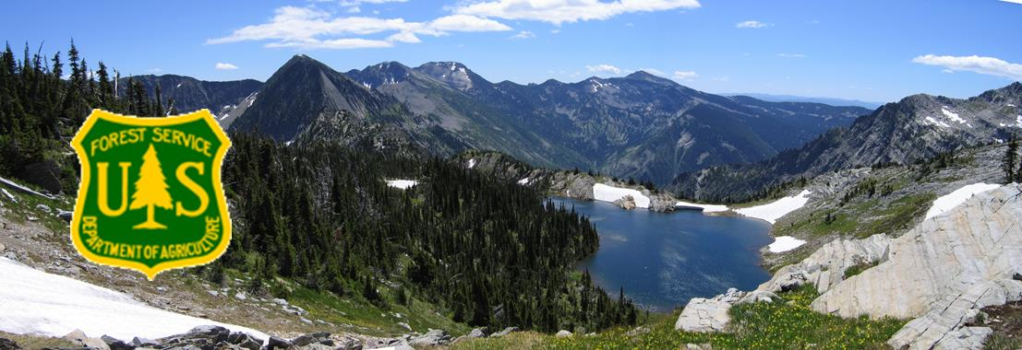
KSANKA RANGER DISTRICT
(Formerly the Rexford and Fortine Ranger Districts)
LIBBY RANGER DISTRICT
BIOLOGICAL SCIENCE TECHNICIAN
GS-0404-5/6/7
Wildlife Technician
The Northern Region (R1), Kootenai National Forest, Ksanka and Libby Ranger Districts will each be filling a Biological Science Technician (Wildlife), GS-0404-5/6/7, position. Duty station for one position is Eureka, MT and the other position is Libby, MT. Only one position will be filled at each location. These are permanent seasonal (18/8) positions.
The results of the outreach will help determine the area of consideration for the vacancy announcement.
Interested applicants are requested to respond utilizing the Employee Outreach Database.
For Forest Service applicants the database is in ConnectHR.
For external applicants this may be accessed by an internet search for FS Outreach or the following link https://fsoutreach.gdcii.com/Outreach.
Duties:
The technician works independently or with Forest Service specialists, Montana Department of Fish, Wildlife & Parks, and non-government partners to manage wildlife habitat on the National Forest. Work includes aquatic and terrestrial habitat assessments, surveys to monitor habitat treatments and habitat for sensitive, threatened, and endangered wildlife species, and collection of data for the development of wildlife management plans and environmental analyses. Data are collected, compiled and summarized on wildlife species, vegetation, and habitat. As required, data are entered into databases and mapping platforms. Additional duties include: habitat improvement and habitat management, information and education duties, and non-native invasive species control work.
Using effective communication skills, the technician provides detailed reports on work methods, data collected and project evaluation; determines need and recommends equipment for the project at hand and assures its operational status and availability; and participates with others in planning work by contributing productive ideas on uses of materials and methods.
This position will lead seasonal employees or volunteers. It is supervised by the District Wildlife Biologist.
Performs a variety of routine and frequently complex tasks involving techniques and practices relating to natural resources, i.e., water, land, food, plants, animals, and soils. Assignments support field projects and program planning activities. Such tasks might include:
Independently, or as part of a team, conducts wildlife inventories and habitat surveys; takes and records data, counts, sorts, identifies species, and performs measurements. Analyzes information; prepares reports of findings with appropriate recommendations; assembles information for development of natural resource plans and coordination of resource need information for analytical reports.
Utilizes ArcGIS, Survey123 and Collector AGOL programs as well as topographic maps; photographs, and data that identify a variety of natural resource areas and conditions. May draft maps or diagrams of survey areas.
Utilizes a variety of tools to collect and record data such as numbers, measurements, weights, samples, and special notes. Keeps records of all data and develops these into statistical reports.

To receive consideration for these positions, you must meet all qualification requirements, as listed in the announcement when it is available.
Government housing may be available in Eureka. Government housing is not available in Libby.
The Forest does not offer federal day care facilities.
Transfer of Station may be available for the position if filled through the internal announcements. TOS will not be paid for applicants selected through the announcements open to the public.
The recently consolidated Rexford and Fortine Ranger Districts are proposed to be renamed the Ksanka Ranger District in the near future.
For more information regarding the position in Eureka, please contact Lynn Johnson at 406/296-7102 or email at lynn.m.johnson@usda.gov. For the position in Libby, please contact Ed Morgan at 406/283-7558 or email at edward.morgan@usda.gov.
ABOUT THE KSANKA DISTRICT and the surrounding communities
The Ksanka Ranger District is in Northwest Montana. The duty station is Eureka, MT which is located just eight miles from the Canadian border. The District’s entire northern boundary is contiguous with Canada, and it is one of the four districts on the Kootenai National Forest. The combined District encompasses 613,500 acres, of which 574,300 are National Forest lands. The district employs approximately 45 permanent employees, with an additional 60 seasonal employees during the summer months.
The town of Eureka has a population of approximately 1300 people and is the largest town in the Tobacco Valley. Residents in the Tobacco Valley number approximately 4200. The Valley runs from the Canadian Border on the north to just south of Murphy Lake. The major industry is tourism, with recreation in the form of hunting, fishing, motorized use, and winter sports drawing in a many people from the United States and Canada. Other employers include logging and wood products manufacturing, communications and power utilities, government, and service-related work.
Employees generally live in the Valley and some commute daily from the Trego and Fortine area. Eureka offers a post office, three banks, three grocery stores, medical clinic, one dentist, three chiropractors, a physical therapist, one drug store, 2 motels, a bed & breakfast, masseuses, several second-hand stores, numerous small variety shops, restaurants, three golf courses, and businesses. Churches of various denominations are also available in the area.
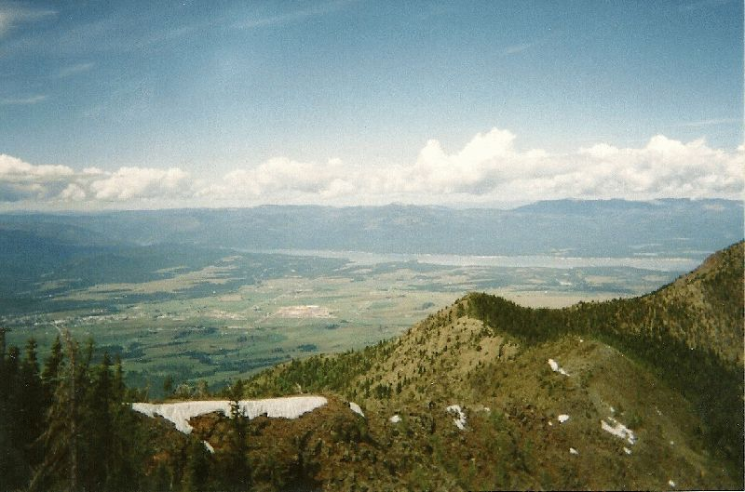
In Eureka there is an elementary school, which includes K-4, a middle School (5-8), and the Lincoln County High School. A Head Start program is also available.
The larger communities of Whitefish (50 miles) and Kalispell (65 miles) offer a wide variety of shopping and other service-oriented businesses. Eureka is approximately four hours from Spokane, Washington (population 342,000), and four hours from Missoula (population 70,000). Glacier Park International Airport near Kalispell provides daily departures and an AMTRAK station is available in Whitefish. Glacier National Park to the east and Banff National Park in Canada are also close enough to be enjoyed for the day or weekend.
Eureka has both mild winters and summers compared to other Montana cities. The District includes the popular Lake Koocanusa Reservoir, beautiful mountains and many surrounding fresh water lakes. There are many recreational opportunities, such as swimming, water skiing, camping, rock climbing, fishing and hiking for summertime fun; hunting in the fall and spring; ice fishing, snowmobiling and cross-country skiing in the winter; and ATV and motorcycle riding on Lake Koocanusa reservoir draw down area in the spring. Eureka is just 60 miles north of the Whitefish Mountain Resort Ski Area in Whitefish and 35 miles south of the Fernie Ski Area in Canada. Average rainfall for the area is 14.6” and the average snowfall is 44.4”.

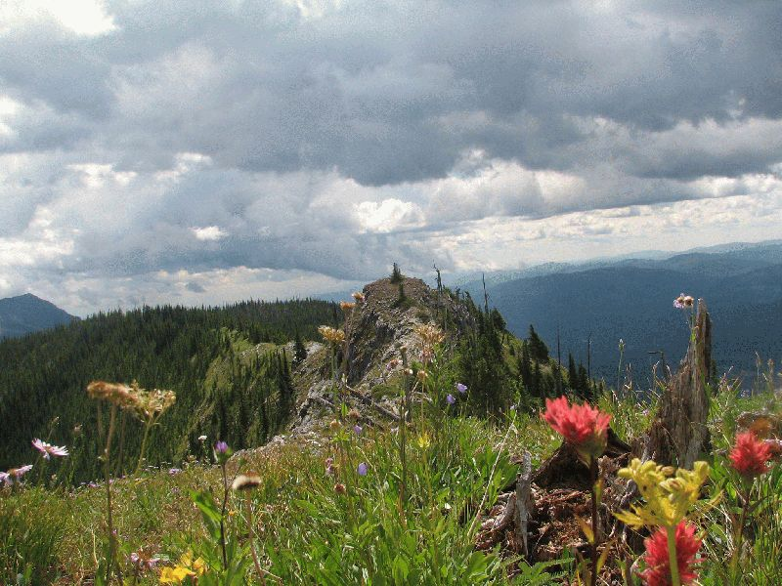
Located 15 miles south of Eureka is the community of Fortine. The Fortine community has a school (Grades preschool-8), post office, grocery store, church, golf course and bar.
The community of Trego is located approximately 18 miles south of Eureka and offers a Civic Center, Post Office restaurant and school (Grades K-8).
Housing prices are moderate in the Tobacco Valley. A three-bedroom home sells for $100,000-$400,000. Rentals are scarce, however can be found. Government housing may be available.
Gardening opportunities vary depending on where you live in the Valley, those closer to Eureka usually have a bit longer season than those farther south.
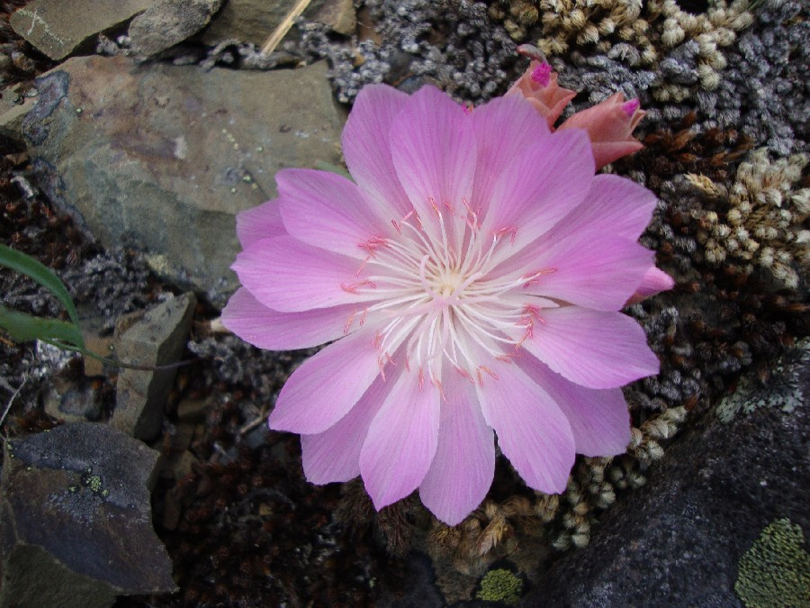
ABOUT THE LIBBY DISTRICT and community
The Libby Ranger District operates out of the Canoe Gulch Ranger Station. The Ranger Station is located along the Kootenai River, 13 miles from Libby, Montana.
Libby lies in the northwest corner of Montana and is nestled in a valley carved by the Kootenai River on the flank of the majestic Cabinet Mountain Range and Wilderness Area. Today, about 2,800 people live within Libby proper. The main industries are lumber and wood products, mining, tourism, and recreation. The movies “The Revenant”, "The River Wild" and "Always" were filmed here. Contact the Libby Chamber of Commerce for brochures, information on lodging and events, general area information, and contact information for local businesses and services.
Libby, Montana is basically a full-service community providing education from K through 12th grade. A Head Start program is also available. Libby offers a post office, multiple banks, two grocery stores, a hospital, multiple medical clinics, multiple dentists, chiropractors, and physical therapists, three fitness centers, one drug stores, multiple motels, a bed & breakfast, masseuses, several second-hand stores, numerous small variety shops, restaurants, a golf course, and other businesses. Churches of various denominations are also available in the area. Libby also has excellent parks and walking paths.

Glacier National Park is 115 miles to the east and Spokane, Washington is 150 miles to the west. For more information on Libby go to CityofLibby

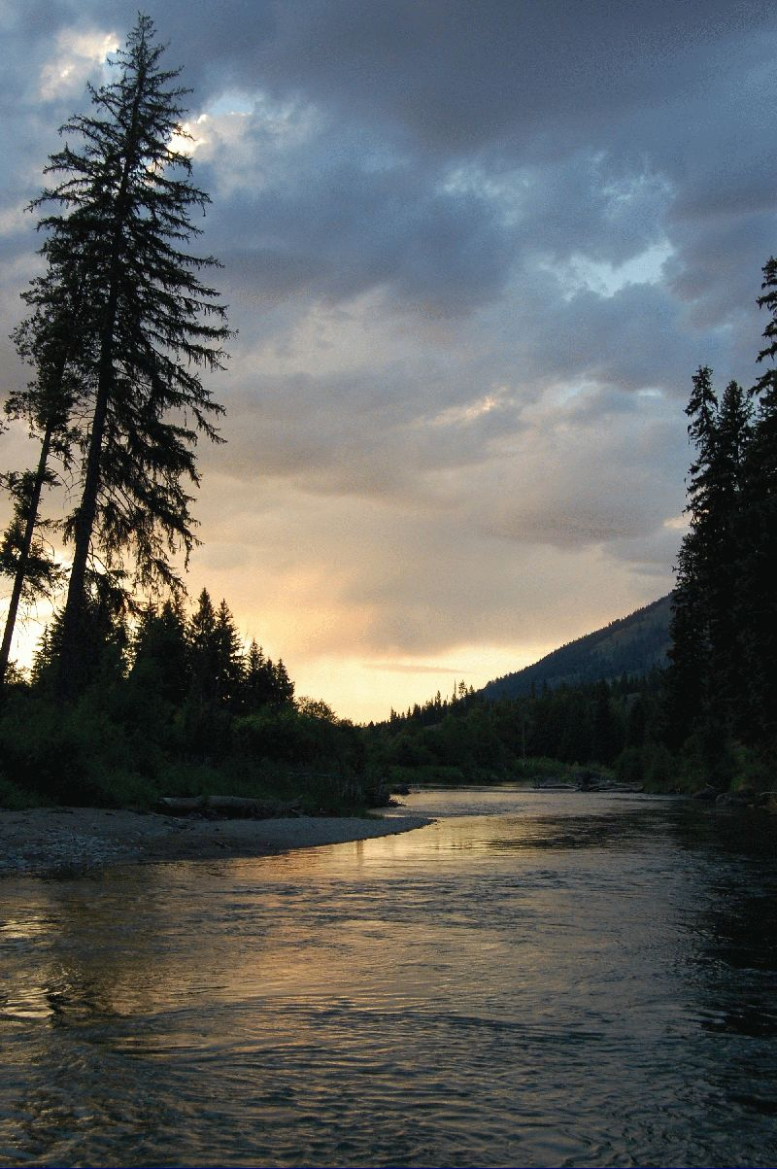
The Libby Ranger District encompasses 620,000 acres. Libby has a strong resource management program with heavy workloads in vegetation management, fire, wildlife, recreation, and watershed restoration. During the peak of the summer, there are approximately 35 permanent employees and a temporary work force of approximately 60 working on the District.

The Libby Valley has documented presence of Libby Amphibole Asbestos (LAA) as determined by the Environmental Protection Agency (EPA). As of November 2018, EPA has completed cleanup of residential and commercial properties in Libby and Troy. Cleanup of other areas, such as the now defunct mine site, continues. Interested applicants are urged to research the possible hazards of LAA to human health. Further information can be found at EPA (EPALibby) and the Center for Asbestos Related Disease (CARD) (LibbyAsbestos).
The former mine site and surrounding forested area encompasses approximately 10,000 acres and is known as the Libby Asbestos Superfund Site Operable Unit 3 (OU3). The site is located on the Libby Ranger District. This area presents special resource management concerns due to the established presence of asbestos fibers in the tree bark, duff and soil. The Forest Service has taken additional precautions outside of OU3 for employee health and safety. This area is not currently actively managed as part of the Forest’s vegetation management program and has controlled access. Additional description of the area is available at the EPA (OperableUnit3). Applicants may also contact the Libby District Ranger for more information.
SUMMER
When the weather warms and the mountain snows melt away, the Kootenai National Forest comes alive with over 2.2 million acres of public land as a playground. Mountain trails and lakes open up, beautiful wildflowers come in bloom, and wildlife have their young. Libby is the base camp for the Cabinet Mountains Wilderness Area, Lake Koocanusa, Northwest Peaks Scenic Area, and the Ten Lakes Scenic Area. There is good access to most of the Forest and plenty of room to get away from it all!
- Blue ribbon fishing in the Kootenai River
- Cabinet Wilderness Area hiking and exploring
- 90-mile long Lake Koocanusa Reservoir
- Camping in dispersed and developed campgrounds
- Miles of hiking, backpacking & mountain biking trails
- 2.2 million acres to play on the Kootenai National Forest
- Boating on the Kootenai, Lake Koocanusa, and numerous area lakes
- Golfing at Cabinet View Country Club Golf Course
FALL
Northwest Montana, the Kootenai National Forest, and adjacent State of Montana and private lands have abundant wildlife. In Montana, hunting is primarily a family sport. There are general seasons for elk, deer (white tail and mule deer), and bear. There are annual drawings for permits to hunt moose, bighorn sheep, mountain goat, and mountain lion. For bird hunters there are turkey, grouse, and some ducks. For more information: Hunting - Montana Fish, Wildlife & Parks
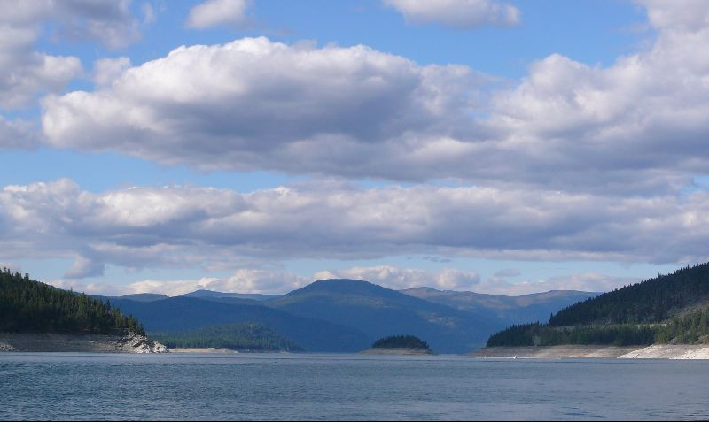
WINTER
Winter in Montana means snow, and lots of it! For those who love to play in the deep powder, the Libby area offers tremendous winter fun. Turner Mountain Ski Area, located just 22 miles from Libby, offers challenging downhill skiing with a beautiful view. Their slogan is "steep, deep and cheap", and Turner definitely lives up to that. It's still fairly undiscovered, so you can escape the crowds and get the cheapest lift tickets around. For those who love snowmobiling, there are hundreds of miles of backcountry roads to sled on in the Kootenai National Forest. Cross-country skiers and ice fishermen also can find solitude on a lake and miles of quiet forest trails to enjoy the outdoors. Those who are a bit on the wild and crazy side will love the antics of the Libby Polar Bear Club. Members take winter-time "swims" in frigid Libby Creek every Sunday from October to April. Plungers have ranged in age from 3 to 61. As long as the ice can be broken on the creek, if it has formed, the group will take their plunge, no matter the temperature. LibbyMT
ABOUT THE FOREST
The Kootenai National Forest (KootenaiHome) encompasses over 2.2 million acres of NFS lands. The forest is in the extreme northwest corner of Montana, including a small portion of northeast Idaho. The forest consists of 4 Ranger Districts located in Eureka, Troy, Libby and Trout Creek; 3 Staff Units located in the Supervisor’s Office and Engineering located throughout the units. The forest is bordered on the north by British Columbia, Canada and on the west by Idaho.
The Kootenai is truly a forest with multiple uses. The vegetation management program is aimed at restoring and maintaining Northern Rockies fire dependent habitats. The diversity of tree and other plant species is among the greatest in the Northwest. Management and recovery of threatened and endangered species, such as grizzly bear, lynx, and bull trout emphasize the forest wildlife and fisheries programs. Other wildlife on the forest include gray wolf, wolverine, cougar, elk, moose, white-tailed and mule deer, mountain goat, bighorn sheep, bald and golden eagles and other species of birds, mammals, amphibians, and reptiles.

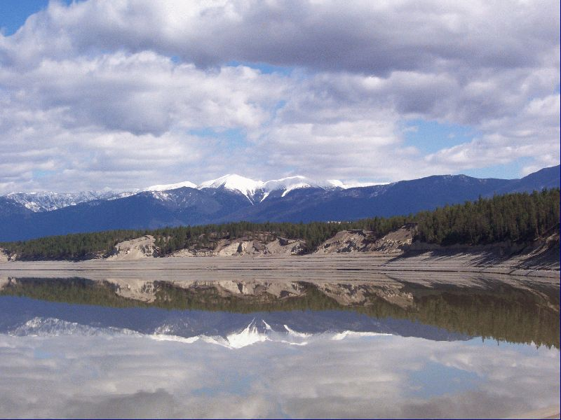
INDIAN TRIBES
The Kootenai National Forest (KNF) encompasses lands that are part of the Confederated Salish and Kootenai Tribes (CSKT) Aboriginal Territory. In the Hell Gate Treaty of 1855 the CSKT ceded over 22 million acres to the United States Government retaining 1.2 million acres for their own use that today is the Flathead Indian Reservation. The Flathead Indian Reservation is approximately 85 miles southeast of the Kootenai National Forest. The Tribes retain Treaty rights under the Hell Gate Treaty on federal lands such as the KNF. These rights include hunting, gathering, digging plants and roots, fishing, and grazing on Kootenai National Forest lands.
The Kootenai National Forest holds many places in the natural environment that are important to the Kootenai people. These are known as cultural sites and traditional cultural properties. The relationship and bonds that Kootenai people have to these places were established before there was a Kootenai National Forest and the stories, place names and songs from these sites have been handed down from generation to generation. This is called a cultural landscape and is the basis for or essence of Kootenai identity and culture.
USDA Nondiscrimination Policy, June 2, 2015
In accordance with Federal civil rights law and U.S. Department of Agriculture (USDA) civil rights regulations and policies, the USDA, its Agencies, offices, and employees, and institutions participating in or administering USDA programs are prohibited from discriminating based on race, color, national origin, religion, sex, gender identity (including gender expression), sexual orientation, disability, age, marital status, family/parental status, income derived from a public assistance program, political beliefs, or reprisal or retaliation for prior civil rights activity, in any program or activity conducted or funded by USDA (not all bases apply to all programs). Remedies and complaint filing deadlines vary by program or incident.
Persons with disabilities who require alternative means of communication for program information (e.g., Braille, large print, audiotape, American Sign Language, etc.) should contact the responsible Agency or USDA’s TARGET Center at (202) 720-2600 (voice and TTY) or contact USDA through the Federal Relay Service at (800) 877-8339. Additionally, program information may be made available in languages other than English.
To file a program discrimination complaint, complete the USDA Program Discrimination Complaint Form, AD-3027, found online at ASCR_USDAGov and at any USDA office or write a letter addressed to USDA and provide in the letter all of the information requested in the form. To request a copy of the complaint form, call (866) 632-9992. Submit your completed form or letter to USDA by: (1) mail: U.S. Department of Agriculture, Office of the Assistant Secretary for Civil Rights, 1400 Independence Avenue, SW, Washington, D.C. 20250-9410; (2) fax: (202) 690-7442; or (3) email: program.intake@usda.gov (link sends e-mail).
USDA is an equal opportunity provider, employer and lender.

