OUTREACH NOTICE

Forester (Inventory/Monitoring), Full-time Permanent

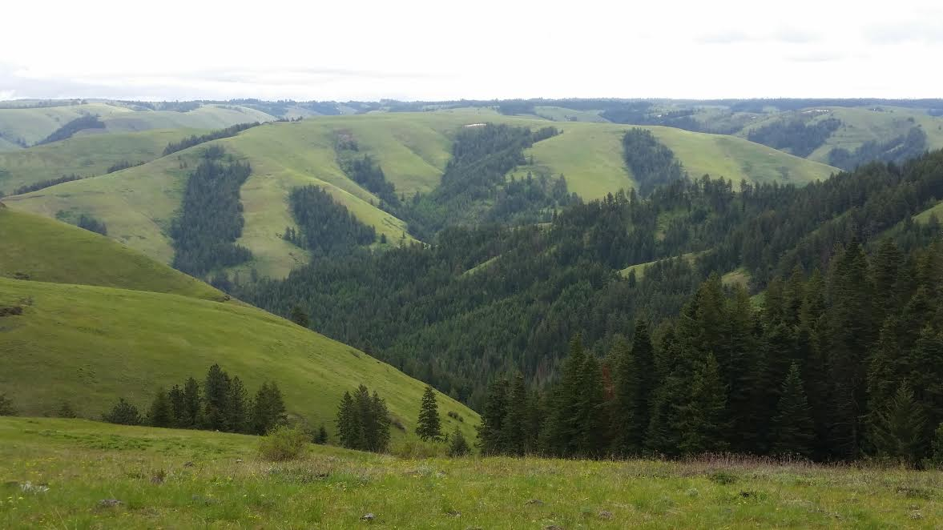
CONFEDERATED TRIBES OF THE UMATILLA INDIAN RESERVATION

The Department of Natural Resources for the Confederated Tribes of the Umatilla Indian Reservation (CTUIR) is seeking qualified applicants for a professional forester position. This is a full-time permanent position located in Pendleton, OR. The incumbent would be responsible for supporting the CTUIR Range, Ag. & Forestry Program by developing and maintaining forest vegetation inventories that inform the overall goals and objectives of the CTUIR. The position will also be involved in refining and implementing monitoring protocols related to considerations within the Forest Management Plan and First Foods Mission/Upland Vision that are not otherwise addressed within a growth and yield forest inventory framework. This information will be utilized to support an adaptive management approach for active and proposed forest treatments and support forest management planning and project reporting. There are also opportunities for involvement in general forest management activities including: assisting in timber sale preparation and administration, non-commercial thinning contract development and administration, timber stand improvement, reforestation, and the planning and implementation of prescribed fire.

The position is advertised as of April 18, 2023 and the initial round of applications are due May 25th, 2023. The first screening of applications will be on June 1st, 2023. The vacancy announcement and application materials and application instructions for this position are posted on the CTUIR public website at https://ctuir.org/career-opportunities/forester-inventory-monitoring/

The Position

The forester reports to the supervisory forester and is part of a team of 4 foresters and seasonal technicians with the goal of ecologic and economic management of forest resources for the beneficial owners (CTUIR and Allotment owners). Some common tasks assigned to the forester (Inventory/Fuels) are:
- Maintain a database of forest inventory information (FPS/FVS), updating as new information is gathered.
- Conduct or oversee examinations of forest stands.
- Develop, administer, and/or analyze monitoring protocols to assess forest treatment effects or determine status/impacts of Upland First Foods species.
- Provide feedback and assist with the development of silvicultural treatments.
- Frequent use of ArcGIS software for planning, spatial analysis, creating and editing and attribute data.

Description of CTUIR Forest Resources

There are approximately 25,000 acres of managed forest on the Umatilla Indian Reservation (UIR), all of which is located on the western slope of the Blue Mountains in Eastern Oregon. Forest types range from dry ponderosa pine to moist mixed conifer with pine, larch, Douglas-fir, lodgepole pine, true fir, and spruce at higher elevations. Like much of the dry forests in the western US, the UIR has been subjected to over a century of fire suppression and modest levels of management activity. There is a strong commitment and ample opportunity to guide future succession toward stand conditions which are more historically relevant and sustainable.

Location AND COMMUNITY INFORMATION

Pendleton, OR is full-service service community with a population of ~17,000, located immediately west of the Umatilla Indian Reservation. The Umatilla River flows through the heart of town and Main Street is dotted with local shops and restaurants. Pendleton is home of the famous Pendleton Roundup, a week-long celebration of western culture and rodeo events.

HOUSING

Pendleton has a limited number of rental apartments and rental homes available. The real estate market is stable and with fair prices, especially considering costs of other Oregon communities. The outlying communities of Pilot Rock, Athena, Adams, and Helix offer more rural options for those not wanting to live in a ‘bigger’ town.

SCHOOLS

A variety of pre-schools and day-care centers are available in addition to elementary, junior and senior high schools. Blue Mountain Community College has a major campus in Pendleton and has a range of AA, AS, and certificate degrees available.

RECREATION NEAR PENDLETON, OR

We are situated near the western boundary of the Umatilla National Forest and within a short drive of the Wallowa/Whitman National Forest and about 2 hours from Mt. Hood and the Gifford Pinchot National Forest. Eastern Oregon hosts some of the best hunting opportunities in the State including white-tail and mule deer, Rocky Mountain Elk, upland and wetland birds, turkey, bear. The area also has year-round fishing for various native and sport fish on everything from headwaters creeks in the Wallowa Mountains to the main-stem Columbia River. Other mountain recreation opportunities include river running, backcountry and resort skiing (at Anthony Lakes Resort), backpacking, trail running/hiking, mountain biking, and much more. Pendleton also has a number of city parks, including a river walk along the Umatilla River.

For more information about the Confederated Tribes of the Umatilla Indian Reservation can be found at www.ctuir.org. Contact Andrew Addessi at andrewaddessi@ctuir.org or 541-429-7245 if you have specific questions about this position.

