Outreach Notice
Region One Vegetation Analysis Team
Biological Scientists (GS - 0401/1301 - 11/12)
Northern Regional Office (R1) Missoula, MT

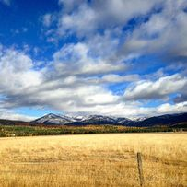
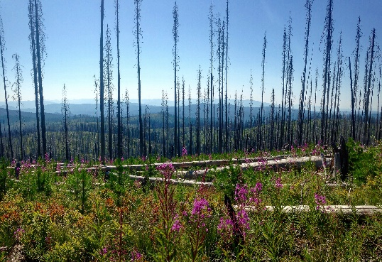
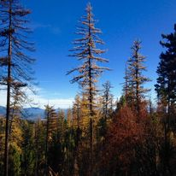

The Northern Region is outreaching to fill three permanent biological scientist positions on the Region One (R1) Vegetation Inventory and Analysis Team, part of the Forest Management Staff, at the Northern Region Regional Office, Missoula, MT. This notification is being circulated to inform prospective applicants of these upcoming permanent opportunities.

The Vegetation Inventory and Analysis Team’s Mission is to assist with the development, implementation, and support of the R1 multi-level vegetation classification, mapping, inventory, and analysis system to meet vegetation information needs in Region 1. These positions work with various national and regional databases, datasets, and analysis tools to support a broad range of national resource programs and vegetation information requests in the region. The group oversees a diverse set of workflows and analysis tools which support broad-level inventory and monitoring needs such as broad-scale monitoring and land management planning. The group also supports unit-based project planning and analysis including the development and use of applications, workflows and protocols to support efficient data collection in the field and subsequent data analysis. The group serves as the technical experts and regional data stewards for FSVeg, FSVeg Spatial, the Forest Vegetation Simulator, and the R1 Existing Vegetation Classification system putting on regional and forest trainings and providing technical assistance to end users as needed. The group also regularly coordinates with various directorates in the regional office, WO, RMRS, external partners, and a broad range of specialists at all levels of the agency to collaboratively identify and develop new workflows and protocols, as needed, or as technology changes.

Ideal candidates for these positions possess the following skills:
- Understanding of R1’s vegetation data housed in FSVeg and FSVeg Spatial, including Forest Inventory and Analysis (FIA) data.
- Understanding of R1’s analysis tools and workflows.
- Has a working knowledge of USFS corporate applications including FSVeg, FSVeg Spatial, FVS, Survey123/ArcGIS Online, ArcPro, Microsoft products, and can work with various datasets from these applications and the R1 Depot.
- Strong database management and analysis skills.
- Can effectively communicate in both writing and verbally with unit contacts, other R1 Vegetation Analysis team members and regional office employees, and a broad range of specialists at all levels of the agency.
- Detail-oriented and has a demonstrated ability to provide customer service and technical support to meet vegetation information needs.
- Proficiency working with high spatial and temporal resolution raster and vector data.
- Experience using geostatistical models and machine learning to develop spatial model products.

These positions serve all of Region 1. Position duties for the three positions will vary depending on individual skillsets and may include, but are not limited to the following:
One position will have a geospatial focus with the following duties:
- Provide support and assistance for the R1 FSVeg Spatial Walk-through web map/ R1 FSVeg Spatial walk-through form which includes troubleshooting errors, assisting with writing field data collection protocols and putting on field trainings.
- Help update and expand queries in the R1 FSVeg Spatial Walk-through QA/QC web map, write documentation and conduct trainings as needed.
- Provide technical support for regional and national geospatial products, tools and applications e.g., FSVeg spatial, Geospatial interface, Region 1 analysis tools, regional Survey 123 forms.
One position will be an analyst with the following duties:
- Provide analysis and customer service to units with their project data collection and analysis needs. This includes writing technical reports, fielding questions and assisting with development of project data collection protocols and loading and summarizing data to create analysis datasets using Region 1 tools and workflows.
- Assist all manners of analysis developing reports, tools and workflows using Forest Inventory and Analysis (FIA), common stand exam, walk-through and other data sets including the Forest Vegetation Simulator.
- Provide technical support for the mature/ old growth initiative for Region 1 as a technical representative as needed. Work may include providing technical/ analytical support and assisting with employee engagement sessions as needed.
One position will have an applied research focus with an emphasis on the following:
- Developing spatial products and tools that assist units with resource information to support agency priorities.
- This requires the design, development, adaptation and/or implementation of a wide array of technology and applications supportive of strategic planning; these may include a variety of operations research methods (such as simulation and optimization models), econometric and other scientific methods and techniques, and other resource planning and analysis technology and applications.
- The incumbent is responsible for providing technical expertise to regional staff in designing and implementing geospatial data analyses that display a variety of natural resource and ecological relationships on a regional, state-wide or multi-forest scale.
- Work with scientist and partners to maintain current and develop new science/manager partnerships to synthesize recent scientific findings, develop tools for managers and stakeholders and provide usable research results to natural resource managers.
- Maintain and enhance relationships with both the scientific and land management communities to assess, summarize, and communicate land manager needs to R1 Leadership.
- Works with vegetation data modeling, developing and managing spatial data, technology transfer of applications and analysis techniques and incorporating the latest research in support of Region 1 projects.
All positions are expected to assist with the following:
- Help with regional inventory and analysis training sessions and provide support to units as needed.
- Write documentation and other training materials/ presentations to support regional and national tools, applications, and workflows as needed.

Duty Station: These permanent assignments will be telework eligible with the potential for remote work, with a duty station location negotiable within the geographic boundary of Region 1. The final determination of the Permanent Duty Station(s) will be made by the Selecting Official at the time of the job offer. Travel will be required as needed for in-person training sessions/ meetings.
Biological Scientist/ Physical Scientist GS-0401/1301 - 11/12

To Express Interest in This Position

- Email your resume and the completed outreach form (below) to:
Natalie Morgan (natalie.a.morgan@usda.gov) by Sept. 15, 2023
- In the subject line please reference the position:
Biological Scientist/ Physical Scientist GS-0401/1301- 11/12
- For more information about this opportunity, please contact:
Natalie Morgan
Email: natalie.a.morgan@usda.gov Cell: (406) 303-0536

Resume Content and Resources:

  - Resumes should include the series and grade of the position(s) held within the federal government as well as work schedule and number of hours worked per week/pay period.

  - Resumes should be customized to ensure proper documentation of duties and accomplishments gained that are directly related to this position in order to verify that qualifications are met.

Click on the links below for assistance with writing your federal resume: Writing a Federal Résumé
5 Tips for Communicating Your Qualifications Recommended Government Resume Format

Contact Information:
Date: | 8/16/2023
Name: | Natalie Morgan
Email: | natalie.a.morgan@usda.gov
Mailing Address:
Phone:

Current Employment Information:
Current Agency | USFS | BLM | Other | Specify
If USFS, Current Organization
Current Appointment | Permanent | Temporary | Term | VRA | Pathways | Other
Current Title/Series/Grade
Current Location (City, State)

Duty Station Preference:
If more than one location is listed, which location are you interested in? | (enter location) | (enter location) | No preference

Do you qualify for any of the following programs?
VRA – Veterans Recruitment Appointment Authority (disabled veterans, veterans who served in a declared war, or in a campaign for which a campaign badge has been authorized, or awarded a Armed Forces Service Medal, and separated from active duty in the past 3 years)
Prior AmeriCorps/VISTA (persons are granted a one-year period to be non- competitively appointed to a normally competitive Federal position after leaving the Peace Corps or AmeriCorps VISTA with a certification of eligibility)
30% Disabled Veterans Appointing Authority (disabled veterans who were retired from active military service with a 30% or more disability rating; disabled veterans rated by the Veterans Affairs as having a compensable service-connected disability of 30% or more)
Prior Peace Corps (former Peace Corps volunteers who have satisfactorily completed 3 years of continuous service into career or career-conditional permanent positions)
Schedule A Disabled Persons Hiring Authority (persons with physical or mental disabilities certified by the Veterans Administration or a State Rehabilitation Agency as eligible)
Reinstatement Rights (agencies may reappoint people previously employed under a career or career-conditional appointment by reinstatement to a competitive service position)

Do you qualify for any of the following programs?
Pathways Student Hiring Authority (Internship Program: current students in an accredited high school, college [including 4-year colleges/universities, community colleges, and junior colleges]; professional, technical, vocational, and trade school; advanced degree programs; or other qualifying educational institution pursuing a qualifying degree or certificate; Recent Grads Program: recent graduates who have completed, within the previous two years, a qualifying associates, bachelors, masters, professional, doctorate, vocational or technical degree or certificate from a qualifying educational institution)
Additional Information - Briefly describe why you will be a quality candidate for this position: (Optional):

USDA Non‐Discrimination Statement Revised 6/8/2005
The U.S. Department of Agriculture (USDA) prohibits discrimination in all its programs and activities on the basis of race, color, national origin, age, disability, and where applicable, sex, marital status, familial status, parental status, religion, sexual orientation, genetic information, political beliefs, reprisal, or because all or part of an individual’s income is derived from any public assistance program. (Not all prohibited bases apply to all programs.) Persons with disabilities who require alternative means for communication of program information (Braille, large print, audiotape, etc.) should contact USDA’s TARGET Center at (202)720‐2600 (voice and TDD). To file a complaint of discrimination, write to USDA, Director, Office of Civil Rights, 1400 Independence Avenue, S.W., Washington, DC 20250‐ 9410, or call (800) 795‐3272 (voice) or (202) 720‐6382 (TDD). USDA is an equal opportunity provider and employer.

