United StatesForest Service
Outreach Notice for GS-0404-7
Biological ScienceTechnician (Plants)
Region 1
Idaho Panhandle National Forests
Coeur d’ Alene River Ranger District– Fernan or Silver Valley office, Coeur d’ Alene, Idaho

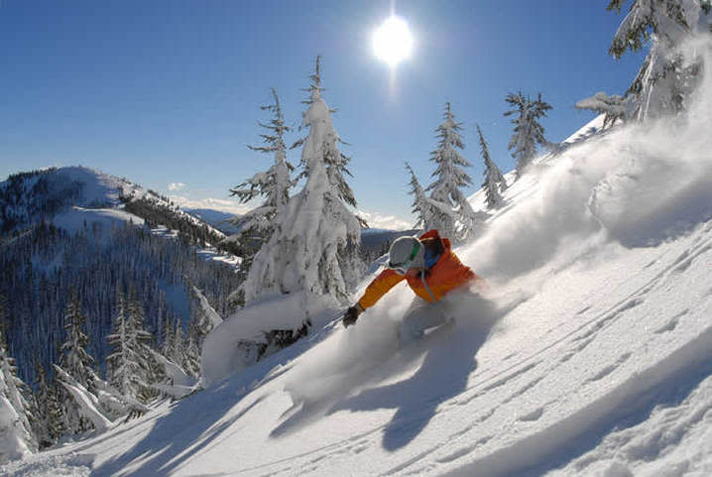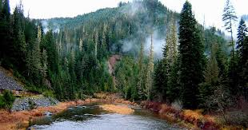

The Coeur d’Alene River Ranger District will soon be advertising and filling a Biological Science Technician GS-0404-7at the Fernan Office in Coeur d’Alene or Smelterville, Idaho.

TO EXPRESS INTEREST IN THE POSITION:

Please fill out the attached outreach response form and send to Jeremy Kleinsmith, Jeremy.kleinsmith@usda.gov, Rangeland Management Specialist, by close of business on September 15, 2023.The vacancy announcement for this position will be posted on the U.S. Government’s official website for employment, www.usajobs.gov. The announcement will be posted at a later, yet undetermined date. Once the announcement is posted, all who responded to the outreach notice will be contacted by email to let you know what the vacancy announcement number will be for this position. Applicants must have all required documentation to be considered for this position. Outreach responses will help determine the best way to advertise the position.

THE POSITION

This this position is responsible for performing a variety of complex and recurring technical duties in support of the Coeur d’Alene River Ranger District’s noxious weed program. The individual selected for the position is also responsible for, but not limited to the following duties:

- Schedules, organizes, and conducts field surveys to identify, document, and map noxious weed infestations.
- Actively manages noxious weeds involving a full range of integrated weed management techniques, e.g., biological, chemical, cultural, prevention and education.
- Operates a variety of field equipment commonly used in treating, preventing, and eradicating noxious weeds such as all-terrain vehicles (ATV’s), utility terrain vehicles (UTV’s), herbicide application equipment, ArcGIS Field Maps, GPS equipment, and cameras.
- Works cooperatively with other state, federal and private agencies in the management of noxious weeds.
- Provides noxious weed information for project analysis which may include written reports/summaries.
- Provide technical support to district staff, natural resource specialists and public in regards to noxious weed ecology, identification, and treatment methods.
- Project lead for a temporary workforce to meet the objectives of the forest-wide range/weeds program.
- Works directly with the Idaho Panhandle National Forest’s Range and Weeds Program Manager in coordination efforts related to project planning and management.
- Conducting weeds/range monitoring activities to assure compliance with forest and regional goals.
- Maintains invasive species inventory, treatment, and monitoring records in appropriate databases.

NOTE: The duties of this position require the incumbent to obtain and maintain a State Herbicide Applicator’s License. The incumbent must obtain the license within 120 days of the initial appointment to the position.

THE ORGANIZATION
THE IDAHO PANHANDLE NATIONAL FORESTS
The Idaho Panhandle National Forests (IPNFs) comprise about 2.5 million acres of public lands within "the panhandle" of northern Idaho and extend into eastern Washington and western Montana in some areas. The IPNFs offer a challenging and rewarding environment where projects involve a variety of individuals and stakeholder groups interested in collaborating and resolving issues. Resource management primarily revolves around vegetation management, watershed restoration, motorized and non-motorized recreation, white pine restoration, and habitat management for threatened and endangered species.
More than half of Idaho’s surface water is on the IPNF. These vast lakes and miles of rivers support a world class fishery. Rich in wildlife, the Forest is home to large game such as moose, black bear, elk, and deer, as well as species such as grizzly bears, wolves, box turtles, and snowshoe hares that add to the sense of "wildness." From lush evergreen mountains to the shores of big water lakes, the Idaho Panhandle National Forests have a rich history and great people that continues to link families and forest. Historic cabins and lookouts dot the landscape, while significant places such as Hiawatha Trail, Marble Creek Historic logging displays, and Pulaski Tunnel trail add depth to the heritage. Fire continues to play an important role in the landscape’s evolution. Forest roads and trails trace the past of American Indians, mining, logging, and Forest Service history.
The Idaho Panhandle National Forests are an aggregation of the Coeur d'Alene and portions of the Kaniksu and St. Joe National Forests. There are eight local points of contact including the Supervisor's Office, six district offices and the Coeur d'Alene Nursery. The Forest is within nine counties in three states: Boundary, Bonner, Benewah, Kootenai, Shoshone, Latah and Clearwater Counties in Idaho; Lincoln County in Montana; and Pend Oreille County in Washington.
The Idaho Panhandle National Forests are an incredibly busy place and employees conduct business with an extremely high work ethic. If you are interested in working in a fast paced and productive work environment with other highly motivated natural resource professionals, the IPNFs may be a good fit.
Information about the forest and districts can be found here Idaho Panhandle National Forests
COEUR D’ALENE RIVER RANGER DISTRICT
The Coeur d’Alene River Ranger District is approximately 728,000 acres in size. The Coeur d'Alene River Ranger District originated as the Coeur d'Alene Forest Reserve, created by President Teddy Roosevelt on November 6, 1906. It soon came under the administration of the newly created U.S. Forest Service and continued as the Coeur d'Alene National Forest. The Coeur d'Alene River Ranger District has a storied history centered on the mining of its' vast silver reserves and the 1910 fire which consumed vast acreages of its' valuable timber stands - over 3 million acres total in Idaho and Montana. The 1910 fire focused the nation's attention on the Forest Service's Region One and over time the Region became the Forest Service's center for experts on wildland fire. With close proximity to a larger urban center, Spokane, Washington, the District has high recreation use and a program that centers on the North Fork of the Coeur d’Alene River and portions of Lake Coeur d’Alene and the Chain of Lakes to the east of Lake Coeur d’Alene. Camping, hiking, fishing, hunting, and ATV activities abound. The District also manages the special use permit for Lookout Pass Ski and Recreation Area- a family ski area located on the Idaho/Montana border. Other winter activities the District manages include snowmobiling and cross country skiing.
The Silver Valley
The Silver Valley is located 40 miles east of Coeur d’Alene on Interstate 90. Several towns are located within the valley: Pinehurst, Kellogg, Osburn, Wallace, Mullan, Silverton, Smelterville, Wardner and Osburn. As a couple of the town names indicate, this area is rich with a mining past. Fishing and hiking along south fork of the Coeur d’Alene River or biking the historic Hiawatha trail are activities that can be enjoyed during the warmer months in the Silver Valley. During the cooler months there are two alpine ski areas, Lookout Pass and Silver Mountain that offer a premier alpine experience.
Located in Smelterville, Idaho, the Silver Valley Office is home to approximately 20 Forest Service employees and is the duty station of the Deputy District Ranger of the Coeur d’ Alene River Ranger District and the Regional Entomologist.
IDAHO PANHANDLE WEEDS PROGRAM
There are currently 3 permanent employees, and 2 seasonal temporary employees that make up the Idaho Panhandle National Forest’s weed and rangeland management workforce (known collectively as ‘the workforce’). We are a relatively small program with a large area to cover.
The candidate will be supervised by the Forest’s Rangeland Manager (resides in the Sandpoint District office) but can also expect guidance from local technicians and specialists. The weeds program lead resides in the Supervisors Office in Coeur d’ Alene.
The season will start with district and program orientations in conjunction with the supervisor. In order to provide clear and frequent communication throughout the season, conference calls and bi-monthly meetings will be scheduled to discuss status of priorities and projects, as well as provide feedback and answer questions.
Our unit’s general mission is to actively inventory, map, prioritize and treat current/potential infestations of noxious and invasive plant species whether it be by preventative, chemical, cultural or mechanical means.
During the field season the candidate should expect long field days with intermittent office days for data entry, equipment maintenance, training/meetings, etc. The candidate will also be expected become familiar with the following: Coeur d’Alene River Ranger District’s Noxious Weed Environmental Impact Statement, Forest Service databases such as Natural Resource Manager and FACTS, the use and maintenance of motorized and hand-powered spraying equipment, the use of hand tools, non-native and native plant identification, GPS/GIS hardware and programs, cartography, driving a 4x4 vehicle on rough terrain, working in various weather conditions, etc. Additional tasks may include assisting the Coeur d’Alene’s range program with weed treatments and monitoring on grazing allotments.
WEBSITES

Real Estate: West Valley Reality, Silver Valley Rental Properties
Education: Kellogg School District, North Idaho College
Newspaper: Shoshone News-Press
Community Activities: Silver Valley Chamber Community Page , Visit North Idaho-Kellogg, CdA Chamber

FOR MORE INFORMATION/CONTACT
_________________________________________________________________________________________________________
Contact Hiring Manager Jeremy Kleinsmith at 208-265-6622 or by email:Jeremy.kleinsmith@usda.gov
Depending on the outreach response, referral lists will be considered in both the Merit and Demo categories. All interested applicants should submit the attached outreach survey form so they can be notified of the vacancy announcement number and closing date when it becomes available.

OUTREACH NOTICE FORM
Respond by September 15, 2023
Biological Science Technician (Plants) GS-0404-07
Region 1, Idaho Panhandle National Forests
Please save this page, complete, and email with a copy of your resume to Jeremy Kleinsmith at Jeremy.kleinsmith@usda.gov

NAME: E-MAIL ADDRESS:

MAILING ADDRESS:

TELEPHONE NUMBER:

AGENCY EMPLOYED WITH: ___USFS ____BLM ___ FWS
____OTHER (SPECIFY)

TYPE OF APPOINTMENT: ____PERMANENT _____TEMPORARY _____TERM _____VRA _____PWD _____OTHER

CURRENT REGION/FOREST/DISTRICT/UNIT:

CURRENT SERIES AND GRADE: _____________

CURRENT POSITION TITLE: _____________

INTERESTED IN, DETAIL: PERM POSITION: BOTH: _______

PREFERRED IPNF RANGER DISTRICT(S) and LOCATION(S): _________________________

IF NOT A CURRENT PERMANENT (CAREER OR CAREER-CONDITIONAL) EMPLOYEE, ARE YOU ELIGIBLE TO BE HIRED UNDER ANY OF THE FOLLOWING SPECIAL AUTHORITIES?

_____PERSONS WITH DISABILITIES
_____REINSTATEMENT
_____VETERANS READJUSTMENT
_____DISABLED VETERANS WITH 30% COMPENSABLE DISABILITY
_____VETERANS EMPLOYMENT OPPORTUNITIES ACT OF 1998
_____FORMER PEACE CORPS VOLUNTEER
_____INTERGOVERNMENTAL PERSONNEL ACT
_____OTHER______________________________________________
Thank you for your interest in our job opportunity!

USDA Non-Discrimination Statement Revised 6/8/2005
“The U.S. Department of Agriculture (USDA) prohibits discrimination in all its programs and activities on the basis of race, color, national origin, age, disability, and where applicable, sex, marital status, familial status, parental status, religion, sexual orientation, genetic information, political beliefs, reprisal, or because all or part of an individual’s income is derived from any public assistance program. (Not all prohibited bases apply to all programs.) Persons with disabilities who require alternative means for communication of program information (Braille, large print, audiotape, etc.) should contact USDA’s TARGET Center at (202)720-2600 (voice and TDD). To file a complaint of discrimination, write to USDA, Director, Office of Civil Rights, 1400 Independence Avenue, S.W., Washington, DC 20250-9410, or call (800) 795-3272 (voice) or (202) 720-6382 (TDD). USDA is an equal opportunity provider and employer.”

