**** Pre Vacancy Outreach****
3 Positions
Supervisory Forestry Technician Engine and Handcrew Captain
GS-0462-07/08
Permanent Full-Time

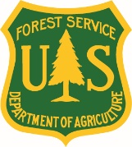
Forest Service
U.S. Department of Agriculture
ALASKA REGION, TONGASS NATIONAL FOREST
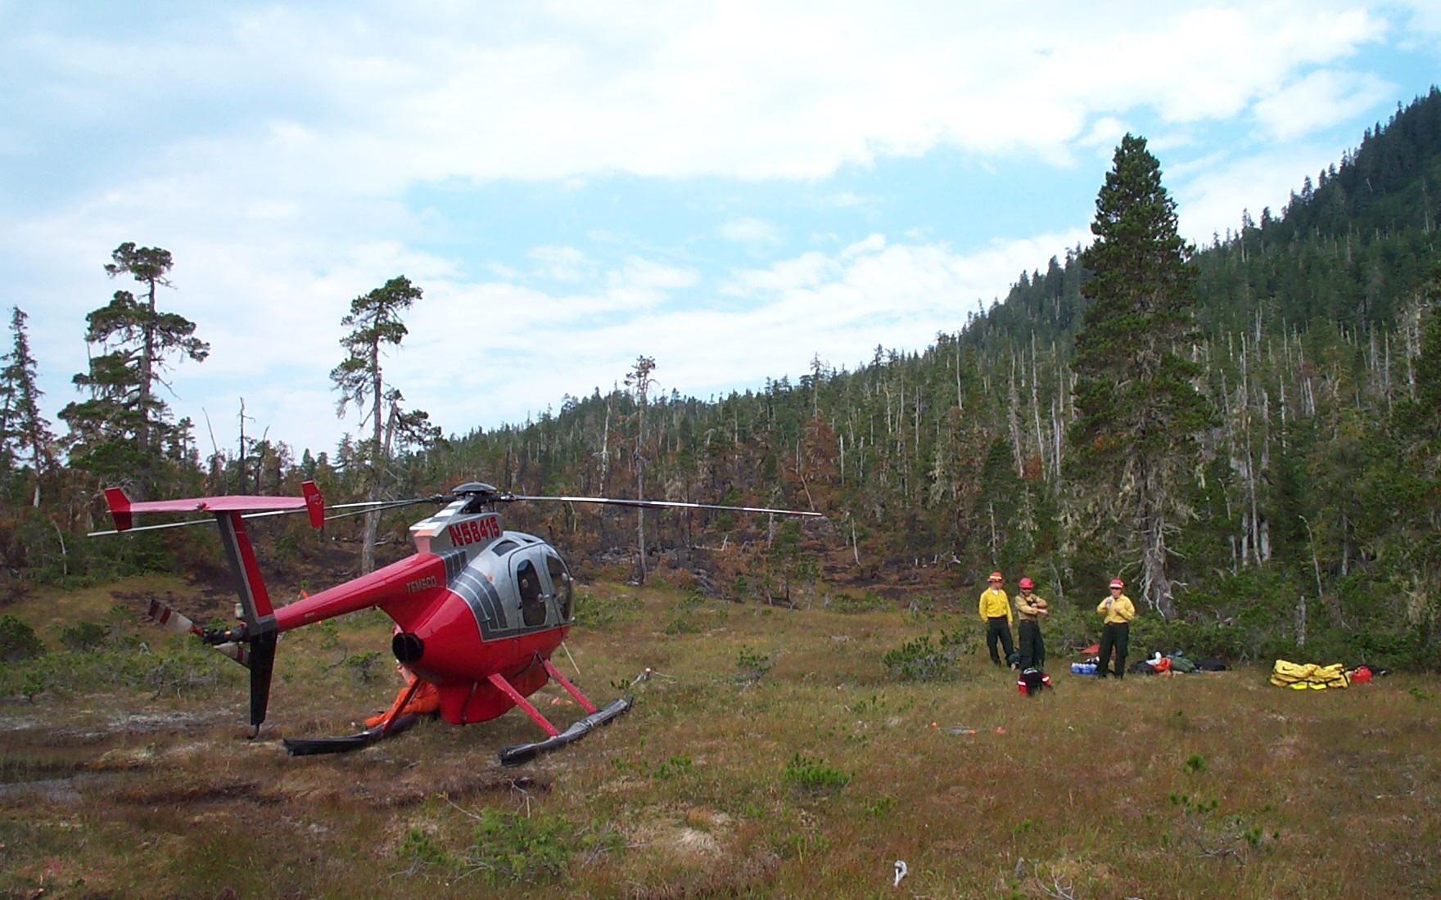

USDA FOREST SERVICE
Alaska R10
TONGASS NATIONAL FOREST, JUNEAU RANGER DISTRICT, JUNEAU AK/WRANGELL RANGER DISTRICT, WRANGELL AK/THORNE BAY RANGER DISTRICT, THORNE BAY AK
The Tongass National Forest is currently seeking qualified candidates interested in filling 3 permanent full-time Supervisory Forestry Technicians.

GS-0462-7/8 PFT HANDCREW CAPTAIN/WRANGELL, AK

GS-0462-7/8 PFT ENGINE CAPTAIN/JUNEAU, AK

GS-0462-7/8 PFT ENGINE CAPTAIN/THORNE BAY, AK

Duties: Major duties include but are not limited to:

The successful applicants will safely and effectively lead, supervise, and mentor individuals on their hand crew or engine. At each unit, the modules currently have five (5) personnel assigned. The selected individuals may also have opportunities to further their development by working on their desired career path, task books, training, and/or other opportunities.

When not involved in fire suppression duties, the modules perform a variety of tasks such as: prescribed fire implementation and preparation work, fuels work, ongoing training, prevention patrol, assisting other resource areas on the District.
Expectations are high, and will be clearly conveyed upon hire, with an emphasis on professionalism, safety, job training, a high fitness level, and project production.

Off-season duties will be tailored to the individual’s qualifications and developmental needs, to include single resource assignments, prescribed burn details, and other opportunities as they arise and as budget allows.

Major Duties:

- This is a primary firefighter position under the provisions of 5 U.S.C. 8336 (c) and 5 U.S.C. 8412 (d). A basic qualification requirement is ninety (90) days of experience as a primary/rigorous firefighter or equivalent experience outside federal employment. This position was approved for primary firefighter retirement coverage by USDA under FERS.

- Some responsibilities of the position related to fuels are the planning, preparing, and implementing prescribed fire plans, fire effects monitoring plans, manual and mechanical hazardous fuels treatments, brush disposal plan and stewardship treatment plans, and smoke management and wildland fire interaction monitoring plans. These skills are part of the position and the development of these skills will allow for upward mobility but the program is pretty limited on the fuels side and these duties would require opportunities outside of the Forest while helping to support the National effort.

- This position supports and participates in wildland fire safety training including proper safety techniques, methods of fire suppression, safe and efficient operation/use of tools, equipment, and vehicles used in fire suppression activities, with emphasis on those used for the particular function assigned.

- The Supervisory Captain also participates in preparedness reviews, proficiency checks and drills, safety sessions, and after-action reviews. Ensures own and other's welfare and safety in all aspects of fuels management and fire suppression duties.

- This position will be expected to participate in wildland firefighting activities. Based on the type of work performed, TAKING and PASSING the work capacity test at the ARDUOUS level is a condition of employment. The arduous, moderate, or light is dependent on the incumbent’s NWCG (National Wildfire Coordinating Group) incident management qualifications required for their IFPM or FS-FPM position.

ABOUT THE TONGASS NATIONAL FOREST

Bordered by the Pacific Ocean on the west and the Coast Mountains and Canadian border on the east, the lush greenery of the Tongass National Forest spans 500 miles of Southeast Alaska. Comprising the largest intact temperate rainforest in the world, the Tongass is a place filled with islands and salmon streams, where towering mountains sweep down into thick old-growth forest and granite cliffs drop into deep fjords. At roughly the size of West Virginia, the Tongass National Forest is also the largest national forest in the U.S. and home to approximately 70,000 people living in 32 communities, including the state capital, Juneau.

Location:

Wrangell-Although there are many small villages located across the Forest, the Wrangell Fire Module’s primary initial attack zone is on the road system within Wrangell and Petersburg. The Wrangell Fire Module’s office is located on the 1st floor of the Wrangell Ranger District on Bennett Street.

At 1,200 to 1,500 hundred people, Wrangell is a typical small remote town in the state of Alaska. Wrangell in a small Island close to the mainland and is directly in front of the Stikine River, where it is bordered by Zimovia Straight to the west and The Stikine River to the North.

Numerous glaciers spill out of the icefield and down the Coast Range into the largest temperate rainforest in North America. The forest here is comprised mainly of Sitka Spruce, Western Hemlock and Red/Yellow Cedar. On average Wrangell receives about 87” of rainfall and 76” of snowfall a year. The majority of fires on the Forest are human caused and situated near the beaches; however, during extremely rare circumstances there have been lightening caused fires.

The Wrangell Fire Module is staffed with 1slip-on pump unit, 2 Landing craft boats, 2 jetboats and 8 other ocean-going vessels. Wrangell also has a ¾ ton truck (#1591). Other boats are available upon demand.

Juneau-is the Inside Passage’s largest city and Alaska’s state capital! Juneau was built on a relatively narrow shelf between Mt. Juneau and the deep waters of Gastineau Channel. The Mendenhall Glacier is just 13 miles from downtown Juneau. Visitors can get close-up views of its mighty face measuring 200 feet tall and 1.5 miles wide. Glacier Bay National Park is located approximately 65 air miles northwest of Juneau. Another popular attraction is the Juneau Icefield. It is a spectacular expanse of mountains and glaciation and serves as the source of all the glaciers in the area, including Mendenhall, Taku, Eagle, Herbert and thirty-eight other glaciers within a 1,500-square-mile radius.
The Juneau area offers snow at high elevations for excellent downhill and cross-country skiing, with views of Mendenhall Glacier, Juneau Icefield, Lynn Canal and Stephens Passage. The population in Juneau is roughly 30,000. There is daily jet service to and from Seattle, Anchorage and Fairbanks and some of the smaller communities in Southeast Alaska. Also available is ferry and scheduled air and water taxi service to other southeastern communities.
Thorne Bay-The duty station office is in Thorne Bay, Alaska on Prince of Wales (POW) Island, about 40 air miles from the Supervisor’s Office in Ketchikan. Roughly one million acres each, the Craig and Thorne Bay Districts are larger than many forests in the lower 48. The Thorne Bay Ranger District is a challenging and interesting place to work. POW is a busy place with many customers coming to the office or contacting us by phone. Most fieldwork is done during the long light-filled days of summer. However, employees are busy throughout the year with a variety of work. The Districts and the Tongass National Forest are moving toward an organization for the future as they transition to changing needs over time. Most Prince of Wales program areas and employees are zoned with employees who work cooperatively on two Districts, Craig and Thorne Bay. The zone encompasses over two million acres and supports a variety of programs including recreation, mining, tribal government relations, state and native land selections, fish and wildlife, subsistence, watershed restoration, special forest products, silviculture, and timber.
IF INTERESTED
Please indicate your interest in this position through the https://www.usajobs.gov/
You may also contact:

Eric Morgan
Forest Assistant Fire Management Officer (Detailer)
U.S. Forest Service
Tongass National Forest, Juneau Ranger District
p: 208-217-7125
c: 208-290-6020
eric.morgan@usda.gov

The U.S. Department of Agriculture (USDA) prohibits discrimination on all its programs and activities on the basis of race, color, national origin, gender, religion, age, disability, political beliefs, sexual orientation, and marital or family status. (Not all prohibited bases apply to all programs.) Persons with disabilities who require alternative means for communication of program information (Braille, large print, audiotape, etc.) should contact USDA's TARGET Center at (202) 720-2600 (voice and TDD). To file a complaint of discrimination, write USDA, Director, Office of Civil Rights, Room 326-W, Whitten Building, 14th and Independence Avenue, SW, Washington, DC 20250-9410 or call (202) 720-5964 (voice and TDD). USDA is an equal opportunity provider and employer.

