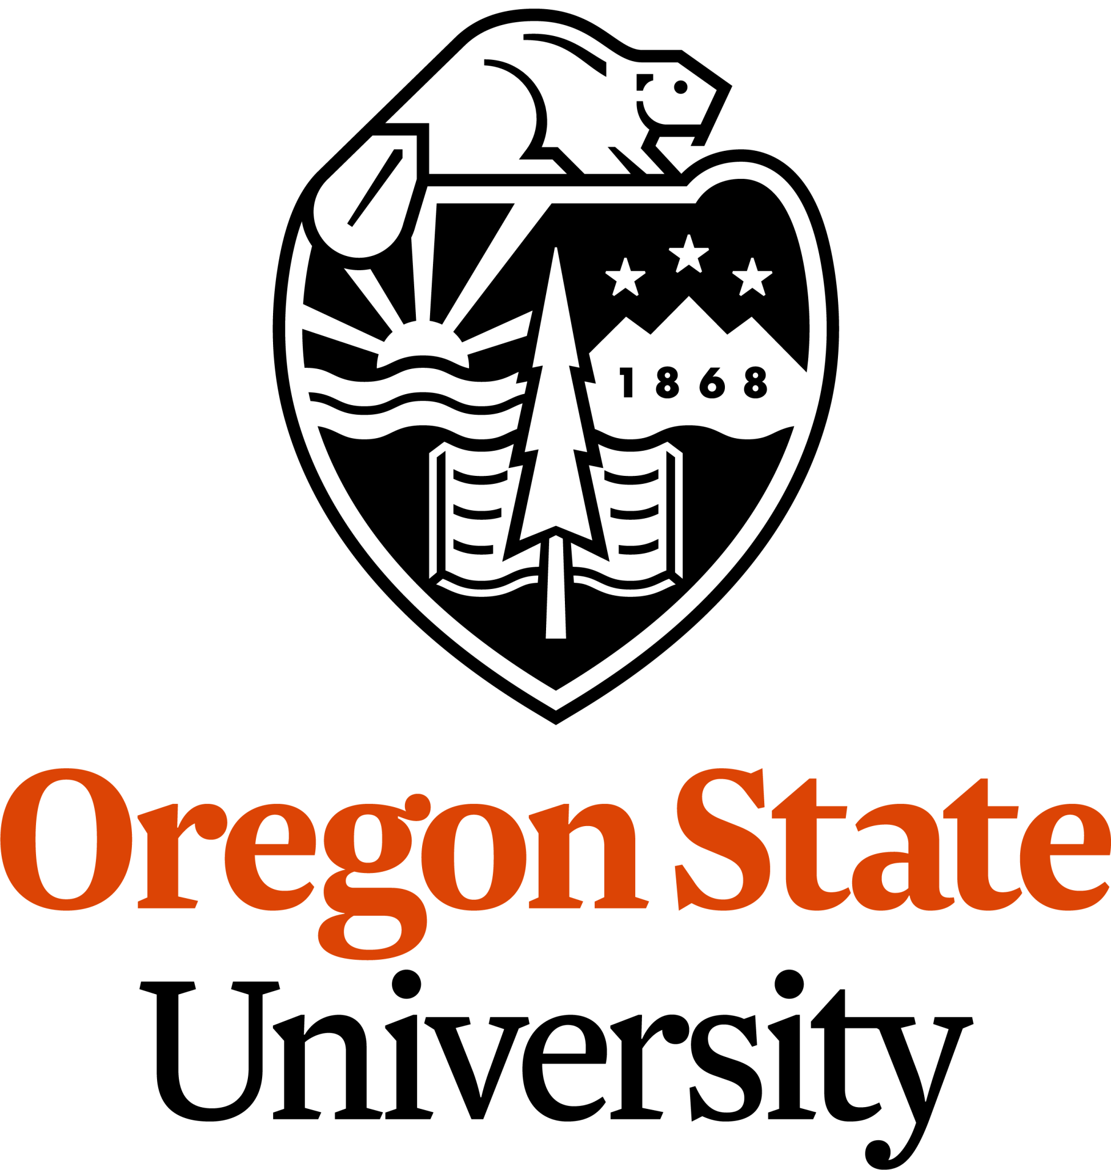
Apply for a paid summer 2026 fellowship
Department of Fisheries, Wildlife, and Conservation Sciences
with OSU researchers
in fisheries, wildlife, and conservation!

Invitation for students to participate in the
FWCS Vanguarding an Inclusive Ecological Workforce
(VIEW) Fellowship

Due Tuesday, February 17, 2026

The Department of Fisheries, Wildlife, and Conservation Sciences (FWCS) at Oregon State University is soliciting undergraduate student applications for our Vanguarding an Inclusive Ecological Workforce (VIEW) Fellowship. VIEW is a summer research program that supports the professional development of future ecologists from communities that historically have been excluded or are currently underrepresented in our field. VIEW aims to support students without previous experience in this field. We are looking for students who are eager to dive into this intensive summer opportunity, to engage in long-term mentorship and to make VIEW a launchpad for their careers with the natural world!
Benefits to VIEW Fellows: Six VIEW Fellows will receive 10 weeks of full-time, paid ($16.50/hour), and mentored summer work as research assistants with a FWCS research group, based out of Corvallis or Hatfield Marine Science Center in Newport, OR. Housing is provided for in-person positions in Oregon; cost of travel to Oregon is not provided. Program dates vary but center around June 22 - August 28, 2026. Please review the projects (page 2) and rank your preference in your application (pages 3-4).
Fellows will also participate in professional development activities such as field trips and skills training, with their cohort throughout the summer, and deliver a presentation at the end of the program. After the VIEW summer ends, Fellows will have the opportunity to develop a research poster and present it at the Oregon chapter conference of The Wildlife Society or the American Fisheries Society. Student Fellows will gain marketable experience to make you competitive for graduate school and future jobs and build your network of professional references, mentors, colleagues, and prospective graduate advisors. We encourage you to join us!
Eligibility: To be eligible to apply, you should be an undergraduate student aspiring to a career in wildlife, fisheries, or conservation sciences AND:

- Identify as a member of a community that has historically been excluded or is currently underrepresented in the fisheries, wildlife, and conservation sciences field. These might include but are not limited to students from communities that have been minoritized based on their racial, ethnic, or gender identity or sexual orientation, and/or students who have significant family obligations, who are the first generation to attend college, who manage health conditions, or who are eligible to participate in TRIO, ROOTS/LSAMP/CAMP, or similarly intentioned programs.
- Currently be enrolled at least half time in a 2- or 4-year college seeking a degree in a natural resources/biological sciences discipline. Students must be enrolled in spring and fall term. Students who graduate in June or September 2026 are unfortunately ineligible. Note that Fellows should not plan to take summer classes while doing VIEW.
How to apply: Complete the Application Form included on pages 3-5 and email your Application Form to the FWCS Internship Coordinator, Shalynn Pack, at FW.internship@oregonstate.edu by the deadline of Tuesday, February 17 at midnight. We will notify applicants of their status in early March.

VIEW 2026 RESEARCH PROJECTS

Project | Main research topics & duties | General location & schedule
A | Field surveys of amphibians & streams across forest types, with independent research project encouraged, with Garcia Lab | Corvallis with intensive fieldwork (hiking off-trail) at forest sites near Mary’s Peak; work will be July 6 - Sept. 11
B | Field & lab research on sculpin fish, including methods for surveys, genetics, physiology, photogrammetry & museum collections, with Burns Fin & Forms Lab & Oregon State Ichthyological Collection | Corvallis & multiple OR field sites:  ~4wks of field work, mostly in June.  *work will be June 15 - early Sept.
C | Lab experimental research on hatchery fish ecology (salmon & suckers), opportunities for independent research, with Fish Behaviorscapes Lab | Corvallis at Aquatic Animal Health Lab (10 min drive east of downtown)
D | Lab research on aquatic macroinvertebrates (identification & analysis of specimens from predator stomachs), & sporadic field surveys for stream sampling, with Arismendi Freshwater Ecology Lab | Corvallis & ~2wks of field work in HJ Andrews Experimental Forest. Work ends Sept. 5
E | Lab experimental research, husbandry, & genetics of oysters, with a collaborative research team, with Gurr Lab | HMSC Aquaculture Lab
F | Marine Mammal Stranding Network support, with field response, public outreach, data mgmt, & necropsies | HMSC with sporadic field work involving being near dead/ decomposing marine mammals

*HMSC = Hatfield Marine Science Center, an OSU research center in Newport, OR
*All projects run full-time June 22-August 28, unless noted otherwise. Projects often have some flexibility, pending advance notice and planning, to accommodate minor time-off needs.

See next page for VIEW 2026 Student Application Form.

VIEW 2026 STUDENT APPLICATION FORM
______________________________________________________________

Directions: Submit by Tuesday, February 17, 2026 at midnight PST. To apply, please type your responses in-line to each of the 14 questions below, save the document as a .docx or a .pdf titled “Last name, First” and attach it with your resume in an email to Shalynn Pack at FW.internship@oregonstate.edu with the subject line “VIEW application - Your name” by the deadline of February 17. You are welcome to email Ms. Pack with any questions. Thank you for your interest!

  - Are you currently enrolled at least half-time in a 2- or 4-year college seeking a degree in a natural resources/biological sciences discipline? (Yes/No)

  - Please enter your information after each colon:
Your full name:
Phone number:
Email:
Student ID (if an OSU student):
Your preferred gender pronouns:
College/university where you are currently enrolled:
If at OSU, are you enrolled as an Ecampus or Corvallis student?
Your college major:
Your college minor:
Your expected graduation date:
Will you be registered for at least half-time during the spring AND fall terms? (Yes/No)

  - Please note any racial or ethnic identities with which you identify, such as Latino/a/x, Hispanic, Black or African American, any Indigenous or First Nations group, Asian, Middle Eastern, North African, Pacific Islander, or White. (Please note that this list is not inclusive nor exhaustive; nor is this used to determine eligibility.)

  - Project dates will vary but most start around June 22, and end by August 28, 2026. Some projects may extend into September. Are you generally available to work full time during those dates? (Yes/No). If no or unsure, please explain your summer availability.

  - For Fellows based at Hatfield Marine Science Center, FWCS will always provide on-site shared dorm housing. For Fellows based in other locations, FWCS will provide shared dorm housing at the Corvallis campus if needed by the student. Should you be selected for a project based in Corvallis, do you anticipate that you would need dorm housing provided to you during the Fellowship? Please briefly explain. For example, you might say ‘no’ because you already have Corvallis housing this summer. Or, you might say ‘yes’ if you live outside of Corvallis and would need a home base for the summer. (Please note that your response will not affect the likelihood of acceptance to VIEW)

  - Our projects have varying levels of physical activity, and they all provide safety training. Please mark an X next to all the types of physical activity that you would be comfortable with for VIEW 2026:
___ Working long days outside in natural elements such as heat, rain, or cold
___ Hiking off-trail in forested areas
___ Wading through streams
___ Hiking in rocky coastal terrain
___ Waking up for pre-dawn, early morning field work
___ Living at a remote field site with a team
___ Handling dead, smelly animal tissue and carcasses
___ None of the above
___ Working fulltime in an office or lab

  - Please rank your interest level for each project, using the following ranking system:
1 = highest interest, 2 = moderate interest, 3 = lowest interest, 4 = no interest.
___ PROJECT A - Field surveys of amphibians & streams in forests (Corvallis)
___ PROJECT B - Lab & Field surveys of sculpin fish & collections (Corvallis)
___ PROJECT C - Lab experimental research on hatchery fish ecology (Corvallis)
___ PROJECT D - Lab & Field research of aquatic macroinvertebrates (Corvallis)
___ PROJECT E - Lab research on oyster aquaculture (HMSC)
___ PROJECT F - Marine Mammal Stranding Network support & necropsies (HMSC)

  - Please explain what is most appealing to you about the projects that you ranked highly above. What interests you about the project/s’ methods and topic/s? (100-300 words)

  - Ultimately, what do you see your role to be in fisheries, wildlife, or conservation sciences? Do you have any dream jobs in mind? (100-300 words)

  - What are you hoping to gain from working on this project with the VIEW Fellowship? How would it help advance you towards your career goals? (100-300 words)

  - This program is dedicated to providing opportunities that increase participation, equity, and inclusive success among people from communities that have been historically excluded or are currently underrepresented in natural science professions. If willing, please describe the challenges you navigate and/or victories you’ve experienced in the pursuit of your interests in fisheries, wildlife, and conservation sciences. (200-400 words)

  - Please note the name, email/phone, and relationship to you for one professional reference (or, a personal reference who is familiar with your work habits) whom we may contact.

  - Include your current resume, either at the bottom of this document or as a separate pdf. This should include any knowledge, skills, and experiences - including those gained in your personal life, such as hiking, club participation, or leadership - that will support your success in a VIEW position this season. We suggest you consult the FWCS Resume Guide for guidance.

  - Lastly, how did you hear about VIEW? (This is not considered in your application; we are just curious🙂)

