OUTREACH NOTICE

Idaho Panhandle National Forests

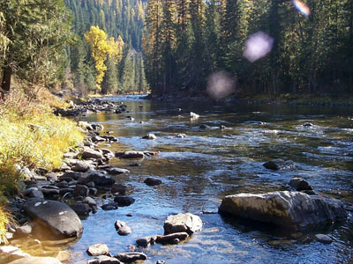

Title, GS-Series-Grade: | Forest Transportation assistant GS-2102-5/6/7
District/Unit: | Coeur d Alene, Idaho; Sandpoint, Idaho; St. Maries, Idaho
Number of vacancies | 1
Date of Notice: | August 23, 2023

The Idaho Panhandle National Forests is seeking individuals interested in a detail, temporary promotion and/or permanent placement into a forest transportation assistant position. This position will be challenged with managing a host of duties in direct support of the forest fleet program forest-wide.

The official advertisement of the permanent positions is expected in FY23, however, candidates meeting the requirements of special noncompetitive hiring authorities may receive early consideration if qualified. The following links may help you determine if you qualify for special hiring authorities.

- VRA (Veterans Recruitment authority? Check link for eligibility https://federaljobs.net/blog/veterans-hiring-authorities/
- Schedule A hiring authority? https://askearn.org/page/schedule-a

How much will I be paid? https://www.opm.gov/policy-data-oversight/pay-leave/salaries-wages/salary-tables/pdf/2023/GS.pdf

Interested applicants, or those desiring further information, should contact the supervisor listed below:

Point of contact | James Gebhardt
D U E D A T E T O R E S P O N D: | September 3, 2023
Phone Number: | 208-819-6195
e-mail address: | James.gebhardt@usda.gov
Mailing address: | Idaho Panhandle National Forests  3232 west nursery road  Coeur d’Alene, ID 83815

Please complete the response form located at bottom of the outreach notice and attach a resume. Return these forms to James Gebhardt by the closing date.

Why consider the Idaho Panhandle as your next destination…..

Aside from offering an amazing quality of life, North Idaho is home to an abundance of opportunities. Whether its escaping to the mountains for that quiet secluded experience, recreating in one of the numerous lakes and rivers or just immersing yourself in the local culture of Idaho, we have it all!

****NEW FOR 2024**** WE ARE EXPECTING A LOCALITY ADJUSTMENT FOR PARTS OF NORTH IDAHO THAT COULD PUT US IN LINE WITH SEATTLE, WASHINGTON. THIS COULD RESULT IN A LOCALITY ADJUSTMENT OF 29%. CHECK THIS OUT!

https://www.federalregister.gov/documents/2023/06/28/2023-13621/general-schedule-locality-pay-areas

A little bit about these positions…………

This position functions as a Transportation Assistant to a Forest Service unit’s Fleet Management Program. This position provides administrative support to Fleet Management Operations whose mission is to ensure optimum availability of Government-owned or leased passenger cars, trucks, or special purpose vehicles or equipment for the Forest Service unit.

MAJOR DUTIES

This position assists with managing, planning, directing, and overseeing the operation, maintenance, repair and replacement of a fleet of motor vehicles and trailers, ranging from sedans to heavy trucks and a variety of special-purpose vehicles or equipment (e.g., trailers (all sizes) forklifts, construction equipment, boats or off-road vehicles) through accomplishment of the following assignments:

Perform full range of Fleet Management support duties using specific guidelines, such as performing acceptance inspection of vehicles and equipment using established checklists and completing appropriate documentation. Assists the fleet manager in evaluating the overall fleet management program for the unit/zone. Investigates user complaints and inquiries of moderate complexity from the field and outside contacts. Collects data and reviews a variety of reports relating to vehicle use, expenses, and income, to identify problems or trends for further review. Makes recommendations on rental rates for vehicles to ensure recovery of costs. Assists the fleet manager in auditing vehicle files, procurement actions, license plates and credit card registers, motor vehicle accident reports, etc.

Prepares, processes, and maintains fleet documentation; reviews documents for accuracy; maintains files; prepares recurring reports, including expenditure reports, credit card monitoring reports for the current fleet card system, and GSA Fleet. Prepares documentation to obligate funds for repairs, licensing, and registration fees. Researches and obtains storage for surplus vehicles and supplies. Creates and maintains vehicle log books for assigned and pool vehicles; creates and/or order specific utilization forms and documents for use in vehicle log books. Collects monthly fuel, maintenance, and other Fleet Card receipts from operators and from pool vehicles as appropriate. Contacts drivers or their supervisors when questionable credit card purchases are made (e.g. premium fuel or unapproved repairs).

Responsible for various reports such as utilization, GSA vehicle accounting system, credit card usage, etc. Insures that transportation related data, such as USE and FOR, are compiled and input correctly into various automated data systems, such as the Fleet Equipment Database (FED) and GSA Fleet. Provides technical guidance and training for these data collections systems. Monitors computerized data for trends, indicating potential fleet management problems, and keeps the fleet manager informed. Conducts studies and surveys to insure proper vehicle use. Reviews fleet credit card purchases for validity, and notifies fleet manager of issues or problems. Compiles bills for obligation of funds and prepares appropriate documentation for review and approval by the Fleet Manager.

As required, works directly with the fleet manager to revise work procedures and programs. Implements changes that may be warranted by new or revised policies and procedures. Interprets regulations and directives and recommends procedures for local implementation. Develops plans and schedules to assure timely accomplishment of work, establishment and maintenance of necessary fleet files and records, and conformance with regulatory rules and deadlines.

Serves as liaison between the unit(s) and the Unit/Zone fleet manager, GSA, and Regional Office, attempting to resolve any administrative problems or discrepancies that arise. Receives bills from GSA, which they determine to be other than usual wear and tear and notifies projects of those changes. Consults the unit/zone fleet manager when large repairs are requested and authorizes the credit card charges for the work before it is performed. Cross checks bills for accuracy, and researches and corrects any discrepancies noted. Prepares recurring reports.

Performs other duties as assigned.

p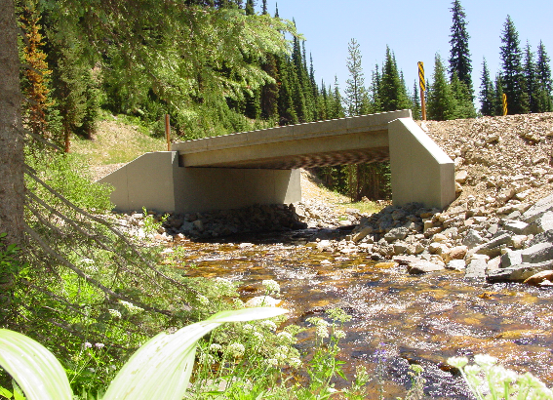

LOCATION/COMMUNITY INFORMATION:

The Idaho Panhandle National Forests comprise about 2.5 million acres of public lands, which lie within "the panhandle" of northern Idaho and extend into eastern Washington and western Montana. Northern Idaho is about 20 percent farmland and 80 percent forested. The IPNF administers approximately half of the total forested acres. Small woodland owners own One-fourth of the forested land; the remainder is owned by industries or other government entities.
The Idaho Panhandle National Forests are an aggregation of the Coeur d'Alene and portions of the Kaniksu and St. Joe National Forests. Local points of contact include the Supervisor's Office, five district offices and the Coeur d'Alene Tree Nursery. The Forest is within nine counties in three states: Boundary, Bonner, Benewah, Kootenai, Shoshone, Latah, and Clearwater Counties in Idaho; Lincoln County in Montana; and Pend Oreille County in Washington.

Check the Forest web site at: http://www.fs.fed.us/ipnf for more information.

A BIT ABOUT THE COEUR D’ALENE COMMUNITY

The Idaho Panhandle National Forests’ Supervisors Office is located in Coeur d'Alene, Idaho, a full-service community of over 40,000 people. Approximately 130,000 people live in Kootenai County. Located on the northern shore of Lake Coeur d'Alene, the city is 100 miles south of the Canadian border, 33 miles east of Spokane, Washington, and an hour’s drive from the Montana state line. There are four distinct seasons, with summer average highs and lows of 82 degrees and 51 degrees; and average winter temperatures from 38 degrees and 26 degrees, with consistent amounts of snowfall.

Higher education opportunities are available. North Idaho College (NIC) is located in Coeur d'Alene, Idaho, and 30 miles to the west of Coeur d'Alene, in Spokane, Washington, several colleges provide higher education opportunities. Moscow, Idaho is 80 miles south of Coeur d'Alene, and is the home of the University of Idaho. Washington State University is located just eight miles west of Moscow in Pullman, Washington, and Gonzaga University is located 33 miles away in Spokane. NIC, U of I, and other universities offer adult education classes in Coeur d’Alene and Post Falls.

Health care services include a full service hospital, physicians, dentist, chiropractors, optometrists, physical therapist, and mental health services at the Kootenai Medical Center. There is both an active professional and volunteer EMT program within the Coeur d'Alene communities. There are nursing homes and retirement centers within the community.

There is a modern library with excellent reference and checkout books, and access to other libraries for patron-requested books. A local museum and historical society chronicle the area's history.

There are several high schools within 5 miles of the office. There are many grade schools, middle schools and opportunities for private schooling exist in the area as well as in Spokane. Community day care and caregivers in private homes are readily available.

Numerous banks as well as credit unions provide financial services to area residents. Professional and volunteer fire departments provide emergency services to the local communities.

A county-owned airstrip for private, charter planes, and emergency medical transportation are located ten miles north of Coeur d'Alene in Hayden, Idaho. Spokane International Airport is located just 40 miles west of Coeur d'Alene.

Many professional, service, and special interest organizations offer area residents opportunities for personal growth and community service.

Numerous churches of many denominations serve the community.

Sandpoint, Idaho information: https://www.sandpointidaho.gov/

St. Maries, Idaho information: https://stmarieschamber.org/
Interagency Natural Resource Center

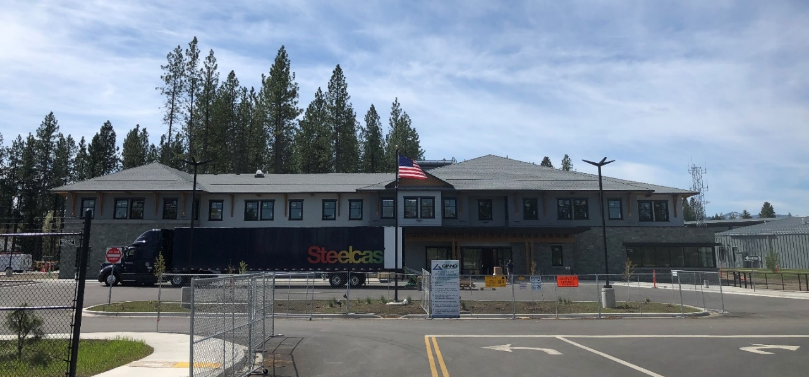
RECREATION

This area is often called "lake country" and Lake Coeur d'Alene is a center for recreation, as are the readily available National Forest lands. Recreational opportunities are numerous, including summer activities of camping, hiking, horseback riding, whitewater rafting, motorcycle riding, golfing, boating and water skiing, and fishing. During the winter months, hunting, cross-country skiing, and snowmobiling are popular. There are four winter ski resorts within easy drive of Coeur d'Alene, Mt. Spokane, Schweitzer, Silver Mountain, and Lookout Pass. The area contains several hundred miles of fishable streams and numerous lakes.

The city provides opportunities for organized youth sports such as Little League baseball and softball programs, soccer club, AAU basketball as well as City run recreational sports programs. A paved biking, jogging and walking trail runs along Coeur d'Alene Lake and extends 23 miles to Spokane, Washington. There are numerous theaters, bowling alleys, playhouses, and community sponsored events.

HOUSING: The standard cost of living in the Coeur d'Alene area is moderate. The median sale price of a home in 2020 was $386,000. Rentals average around $1200 per month according to Zillow.

OUTREACH NOTICE RESPONSE FORM
Idaho Panhandle National Forests

Position Title/Series/Grade: | Forest transportation assistant, GS-2102-5/6/7
Location: | Forest wide: Coeur d alene, St. Maries, Sandpoint

Personal Information

Name: |  |  | Date:
Address:

Internet E-Mail Address:

Phone: | Office
 | Cell:

Current Title/Series/Grade:

Highest Position Held:
Title/Series/Grade:
Location:

Are you currently a Federal Employee? | Yes: |  |  | No:

Current Agency and location:

Type of appointment you are interested in: _______detail/temporary promotion
_______Permanent appointment
_______Virtual assignment (detail/temporary promotion)

Location you are interested in: ______Coeur d alene, Idaho
______Sandpoint
______St. Maries

Are you interested in the permanent position? _______

Are you eligible for special noncompetitive hiring authorities? __y/n?_____

- VRA (Veterans Recruitment authority? Check link for eligibility https://federaljobs.net/blog/veterans-hiring-authorities/
- Schedule A hiring authority? https://askearn.org/page/schedule-a

