OSU/ODFW Volunteer
Internship Position 2023

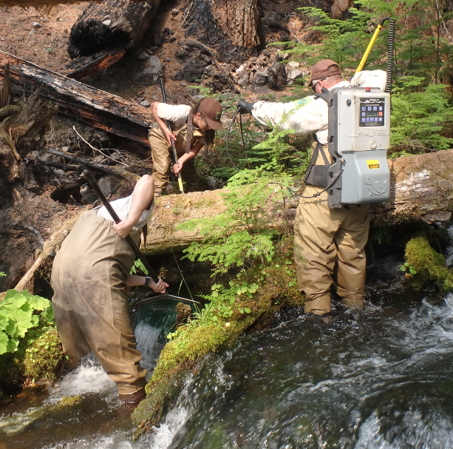
Interested in getting out in the field to do some hands-on fish work? The ODFW Corvallis District Office is looking for a volunteer (unpaid) student intern to assist fish management staff with a variety of field and office tasks. This internship offers the opportunity to participate in fish management and talk with fisheries professionals about career paths and choices.

The Corvallis district spans the mid-Willamette Valley, from Salem to Eugene, and includes the North Santiam, South Santiam and Calapooia Rivers to the east, and Rickreall Creek, and the Luckiamute, Marys, and Long Tom Rivers to the west.
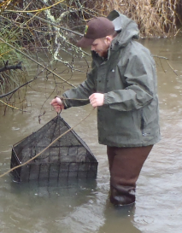
Responsibilities: Potential internship activities include spawning ground surveys, capturing and surveying fish using different methods (traps, nets, electrofishing, etc.), assisting with office tasks and data management, site visits for projects, assisting with management of angling ponds on ODFW properties, and maintenance and repair of sampling gear and equipment, among other duties.

The intern will also participate in Salmon Trout Enhancement Program (STEP) activities include fish dissections, youth angling events, fish salvage activities, and other educational outreach.

Anticipated workload and location: Our offices are in Adair village, a 15-minute drive from the OSU campus. The internship requires a commitment of one full day per week at our office (8 a.m. to 5 p.m. on Tuesday, Wednesday, Thursday, or Friday). The day of week worked can be adjusted to fit the intern’s schedule. Only applicants willing/able to commit at least one full day per week from March into mid-June should apply. Applicant must have a clean driving record. If interested, please email your resume to Reed Fischer, District STEP Biologist, at reed.b.fischer@odfw.oregon.gov cc elise.x.kelley@odfw.oregon.gov by Monday February 27th Midnight, 2023.

