-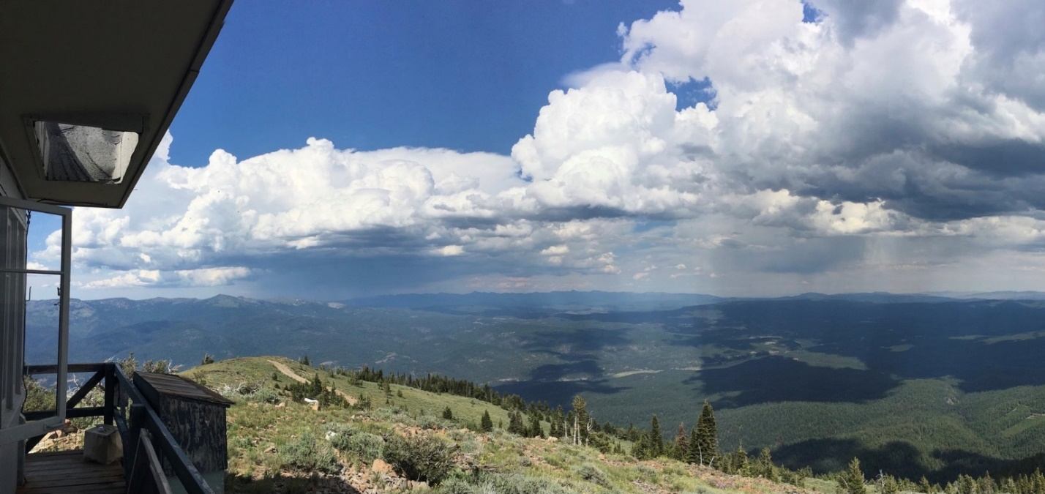

### GS-0462-8–PFT Fuels Technician

**MALHEUR NATIONAL FOREST**

**Blue Mountain Ranger District**

**John Day, Oregon**

The Malheur National Forest is at the center of a nationally recognized effort that has doubled the scale of restoration in Eastern Oregon. If you are looking for an opportunity to do groundbreaking nationally recognized work, we are certain you will find a refreshing approach to leadership in natural resource management.

This Outreach Notice is open to current Forest Service employees The vacancy announcement number will be posted in the outreach database as soon as it is created.

#### The Job

**Series/Grade:** GS-0462-8

**Title:** Forestry Technician (Fire)

**Duty Station:** John Day, OR

**Tour of Duty:** Permanent Fulltime

**Housing:** Government quarters are not available

##### The Position

This is a standard wildland fire management position description intended for use in the USDA Forest Service. The incumbent serves in a key fire management position in a field fire management organization as a Prescribed Fire/Fuels Technician.   
  
Primary responsibilities of the position are preparing and implementing prescribed fire plans, fire effects monitoring plans, manual and mechanical hazardous fuels treatments, and smoke and wildland fire use monitoring plans. The incumbent integrates prescribed fire/fuels management, smoke management, fuels modification principles and procedures, fire effects knowledge, and knowledge of scientific data collection and analysis principles into a comprehensive prescribed fire/fuels management program for a unit(s).

This is a secondary firefighter position under 5 USC 8336(c) (CSRS) and 8412(d) (FERS). Ninety (90) days of experience as a primary/rigorous wildland firefighter or equivalent experience outside federal employment as a basic qualification requirement for this position. Approved by USDA 5/17/21, A3.

##### Summary of Duties and Responsibilities

Assists in planning and coordinating routine aspects of the prescribed fire and fuels management program. Aids in program direction, short and long-range planning; budgeting; and, managing the wildland fire use, fuels management, and prescribed fire programs. Monitors a variety of limited operational projects to address a broad range of technical fire management problems.    
  
Assists in researching the effects and behavior of prescribed fire to assist in the development of short-term fire management objectives and strategies. Assists in evaluating prescription treatments, monitoring methods and new technologies and making refinements as appropriate to improve the organization's effectiveness.   
  
Reviews and comments as necessary on routine sections of the Fire Management Plan pertaining to prescribed fire and fuels treatments.

Assists in developing and recommending plans and schedules for the prescribed fire, wildland fire use, and fuels treatment projects. Solves, in collaboration with others, technical problems requiring the use of specialized, complicated techniques. Uses input from the interdisciplinary team, annual objectives, and management direction to develop and recommend schedule of treatment.   
  
Conducts surveys and evaluates data to develop prescriptions for prescribed fire and wildland fire use.   
  
Reviews project plans and makes recommendations on appropriate levels of monitoring. Assists in establishing study plots to assess fire and fire suppression impacts on the ecosystem. Develops and refines plot characteristics, frequency of visits, subjects to be measured, and data storage and analysis techniques.   
  
Conducts routine project assessments which determine the presence or absence of hazardous wildland fuels. Information on fuel conditions and predictions of fire behavior are collected through a variety of methods, including field surveys, computer modeling, and specific literature searches. Results are used in the determination and prioritization of prescribed fire and mechanical treatment projects.   
  
Reviews alternatives and prepares a wide variety of prescribed fire/fuels management plans following the interagency template.   
  
Creates, updates, and uses a database to model and analyze fire behavior and fire effects observation data. Ensures data quality. Ensures proper data storage and archival procedures are followed.

Implements routine aspects of the prescribed fire/fuels plan, ensuring that preparation, ignition, holding, mop-up, and rehabilitation are completed to the standards specified and in accordance with regulations, policies, and guidelines. Monitors fire behavior, evaluates fire effects, identifies potential problems, and makes recommendations. Solves, in collaboration with others, nonstandard technical problems requiring the use of specialized, complicated techniques in fire safety.   
  
Participates in conducting fuels management surveys to document presence, amount, and types of hazardous fuels. Utilizes this information to assist in prioritizing prescribed fire and fuels management projects.    
  
Conducts routine field reconnaissance of prescribed fire/fuels treatment units, summarizes field findings, and makes recommendations on appropriate prescriptive criteria for meeting program objectives. Responsible for record keeping associated with burn planning, fire occurrence reporting, and weather.

We are looking for an individual who:

* Has strong interpersonal and organizational skills
* Is a team player who enjoys working with a diverse group to accomplish a common goal
* Is a self-starter, enjoys a challenge and has excellent problem-solving skills
* Has the ability to cope well with changing direction, multiple priorities, and a fast-paced work environment

This Outreach Notice is open to current employees.. The purpose of this Outreach Notice is to determine the potential applicant pool for this position and to establish the appropriate recruitment method and area of consideration for the vacancy announcement. Responses received from this outreach notice will be used to make this determination. Your response by 3/18/2022 would be greatly appreciated.

Anyone interested in further information may contact Ed Clark, Fire Management Specialist at 541-575-3473 or [**edward.clark@usda.gov**](mailto:edward.clark@usda.gov)

More About the Area

##### John Day within Grant County Oregon

The cities of John Day and Canyon City constitute the primary population center (est. population 2,500) of Grant County (est. population 8,000). Despite its remote setting, the city of John Day is working to attract sustained growth through a variety of [community projects](https://www.cityofjohnday.com/planning/page/community-projects). The city has recently built a greenhouse to provide local produce to restaurants, residents, and schools; a new playground and splash pad; and new park expansions and trail systems. The Malheur Lumber Company mill in John Day recently added [torrefaction plant expansions](https://www.bendbulletin.com/business/john-day-biomass-plant-preparing-for-production/article_2178e32a-e7e4-57cf-8605-dee4665a2856.html) to process biomass from our thinning projects into fuel pellets. The forest attracts seasonal hunting (elk, deer, upland birds), huckleberry picking, mushroom hunting, and a wide array of outdoor recreation opportunities, further boosting area commerce.

John Day and Canyon City feature a hospital and clinic, dental offices, an airport and helibase, public transit, a public library, and public and private schools. There are several restaurants, Chester’s grocery, a natural food shop, local artisans, furniture and antique shops, two gyms, an art center, clubs, interest groups, volunteer originations, 4H opportunities, youth sports, taekwondo, tumbling, several museums, and an interpretive center.

Other communities within Grant County include Prairie City, Mount Vernon, Seneca, Dayville, Granite, Long Creek, and Monument. The closest urban centers include Baker City, Oregon (1 ½ hours northeast); La Grande, Oregon (2 ½ hours northeast); Bend, Oregon (3 hours west); Boise, Idaho (3 hours east); and Pendleton, Oregon (3 hours north)*.* National Airports are located in Redmond, Oregon and Boise, Idaho.

##### Malheur National Forest

The Malheur National Forest encompasses approximately a million and a half acres of wilderness, rangeland, and general forest in the majestic Blue Mountains of eastern Oregon. It sustains a diversity of vegetation ranging from juniper-sagebrush woodlands and bunchgrass grasslands to high elevation alpine forests of subalpine fir and whitebark pine. Extensive tracts of ponderosa pine, western larch, Douglas-fir, grand fir and lodgepole forests occur between the juniper/grassland foothills and alpine peaks. Elevations range from 4000 feet to 9038 feet atop beautiful Strawberry Mountain. Watersheds in the area include the John Day River, the longest undammed river in Oregon. Our forest’s rich and diverse history of mining and logging is still evident with historic railroad grades, mill sites, gold mining, use of the area by American Indian communities, and more.

The Malheur National Forest is a leader for aquatic restoration and working as an interdisciplinary workforce to integrate large vegetative projects with aquatic and wildlife habitat restoration internally and with multiple partners. Stream reaches and floodplains have greatly improved through a range of aquatic restoration activities from mimicking beaver-dams, tipping trees and moving large woody material into streams, and constructing new aquatic organism passages. The aquatic restoration work completed on the Blue Mountain Ranger District ranks within the top five the Pacific Northwest Region for miles and acres of streams restored, with over a million dollars of restoration work completed within the last 2 years alone.

##### The Forest has three ranger districts: Blue Mountain Ranger District and Prairie City Ranger District in the north, and the Emigrant Creek Ranger District to the south.

##### Blue Mountain Ranger District

The Blue Mountain Ranger District is the largest district on the Malheur National Forest. There are many active grazing allotments, wilderness areas, natural research areas, inventoried roadless areas, a wild horse joint management area, visual corridors, unique geology, and more.

Our district is regionally-recognized for active partnerships with State, Tribal, and non-profit originations. The success of our partnership with the Blue Mountain Forest Partners collaborative group has helped us maintain an accelerated pace and scale of project planning. This collaborative group has taken an active role in shaping our projects and helping the Forest engage with our public and stakeholders on monthly field trips and meetings. With the Collaborative Forest Landscape Restoration designation, the Malheur has received steady funding to ensure implementation of a range of fuels reduction and habitat restoration projects for fisheries and wildlife. Our district’s setting and unique features attracts research by Pacific Northwest Research Station, Dr. James Johnson of Oregon State University, and the Southern Oregon University Laboratory of Anthropology (SOULA) and Oregon Chinese Diaspora Project, just to name a few.

District recreation attractions include historic lookout towers (some available as overnight rentals), Magone Lake campground and trails, hiking and dispersed camping opportunities, and scenic rivers with abundant wildlife and fish species that attract many big game hunters and anglers.

# OUTREACH RESPONSE FORM

### GS-0462-8

**MALHEUR NATIONAL FOREST**

**Blue Mountain Ranger District**

**John Day, Oregon**

**Posted XXXX**

**Please send outreach response form to Robert Foxworth (**[**edward.clark@usda.gov**](mailto:edward.clark@usda.gov)**)**

**by 3/18/2022 for detail/temporary promotion**

Name:Provide First and Last names

E-Mail Address: Enter a valid email address where we can contact you

Mailing Address:Enter your mailing address

Telephone #:Enter telephone number

Cell #:Enter cell phone number

Agency Currently Employed With:Enter agency, as applicable

Type of Appointment: Enter type of appointment

If Current USFS Employee, Provide Unit Information (Region, Forest, District):Enter type of appointment

Current Series and Grade: Enter type of appointment

Current Position Title: Enter type of appointment

How did you find out about this outreach notice? Describe method

|  |  |  |  |
| --- | --- | --- | --- |
| Confirm That Educational Requirements Have Been Met: | Yes | No | Do Not Know |
| Fire Positions Only: IFPM/FSFPM Qualifications Have Been Met: | Yes | No | Do Not Know |

If not a current permanent (career or career conditional) employee are you eligible to be hired under any of the following special authorities?

Schedule A (Persons with Disabilities)

Veterans Readjustment (VRA)

Disabled Veterans W/30% Compensable Disability

Veterans Employment Opportunities Act Of 1998

Former Peace Corps Volunteer

Pathways Program (Students and Recent Graduates)

Public Land Corps

Land Management Workforce Act (Long-Term Temporary Employee)

If a veteran, please identify preference eligible group:

CPS - Disability Rating Of 30% or More (10 Points)

CP - Disability Rating Of At Least 10% but Less Than 30% (10 Points)

XP - Disability Rating Less Than 10% (10 Points)

TP - Preference Eligible with No Disability Rating (5 Points)

SSP – Sole Survivorship Preference (0 Points)