OUTREACH NOTICE

Idaho Panhandle National Forests

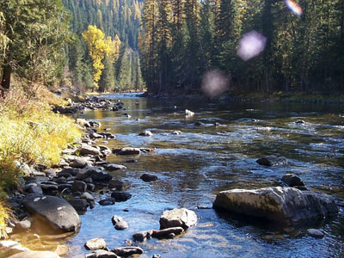

Title, GS-Series-Grade: | Facilities Operations Specialist, Gs-1640-11
District/Unit: | Coeur d Alene, Idaho; Sandpoint, Idaho; St. Maries, Idaho
Number of vacancies | 1
Date of Notice: | September 18, 2023

The Idaho Panhandle National Forests is seeking individuals interested in a detail, temporary promotion and/or permanent placement into a Facility Operations specialist position. This position will be challenged with the development and administration of numerous facilities projects forest-wide as well as maintenance and operations at the Interagency Natural Resource Center.

The official advertisement of the permanent positions is expected in fy24, however, candidates meeting the requirements of special noncompetitive hiring authorities may receive early consideration if qualified. The following links may help you determine if you qualify for special hiring authorities.

- VRA (Veterans Recruitment authority? Check link for eligibility https://federaljobs.net/blog/veterans-hiring-authorities/
- Schedule A hiring authority? https://askearn.org/page/schedule-a

How much will I be paid? https://www.opm.gov/policy-data-oversight/pay-leave/salaries-wages/salary-tables/pdf/2023/GS.pdf

Interested applicants, or those desiring further information, should contact the supervisor listed below:

Point of contact | James Gebhardt
D U E D A T E T O R E S P O N D: | September 25, 2023
Phone Number: | 208-819-6195
e-mail address: | James.gebhardt@usda.gov
Mailing address: | Idaho Panhandle National Forests  3232 west nursery road  Coeur d’Alene, ID 83815

Please complete the response form located at bottom of the outreach notice and attach a resume. Return these forms to James Gebhardt by the closing date.

A little bit about these positions…………

This position serves as Facility Operations Specialist. The position is responsible for the Facilities Management Program for the Supervisor’s Office and the ranger districts. The program includes preventative maintenance, restoration, renovation and replacement of building, electrical, and mechanical equipment.

MAJOR DUTIES
Plans, coordinates and manages all phases of the buildings and facilities maintenance program, including installation, maintenance, and repair of mechanical, electrical, refrigeration, and pumping systems associated with specialized operations.

Plans, manages, schedules, and accomplishes daily, weekly, and monthly inspection as well as annual, 3-year, 5-year, and long range planning for buildings, utilities, grounds, sanitation and other facilities to promote the administration of occupant safety and health, protection and maintenance of buildings and grounds for continuous productive operation. Develops the cost estimates and works with the Facility Program Manager to help formulate the budget for assigned facilities. Maintains close contact with the Program Manager throughout the year to adjust expenditures as directed by unforeseen events. In emergency situations, assists in preparing estimates of cost for supplemental budget requests for funding to cover unforeseen major maintenance needs.

Conducts research and analysis of buildings and grounds to locate and solve potential or unusual problems, such as inspecting and analyzing aging facilities and systems or changes in facilities or equipment use. For example, analyzes use and maintenance needs for aging elevators, fire alarms, sprinkler systems, primary and secondary electrical distribution systems, refrigeration units, and acoustical barriers.

Studies and evaluates equipment and work procedures to achieve goals of greater economy and efficiency. Determines when to coordinate with other organizations to change plans, methods, and procedures to prevent problems. Balances cost factors between preventive maintenance and major maintenance, and considers operational and installation costs versus improved service.

Matches space to functional requirements. Uses knowledge in space utilization in following through to coordinate the work of shops under his/her jurisdiction to meet demands made upon available space.

Develops and maintains the work order system responsive to customer and facility needs. Ensures that work orders are prepared and priorities to determine tracking progress through project completion. Develops and maintains historical records, which documents costs and classifies work accomplished.

Oversees major repetitive tasks such as repair and replacement of components of buildings, septic and water systems, electrical systems, heating and refrigeration systems, grounds maintenance, snow removal from walk ways, paths, compound road system, parking lots and roofs, as necessary. Schedules maintenance as required. Evaluates and monitors equipment costs and use and makes recommendations regarding efficiencies. Monitors the repairs or replacements program through the use of an automated facility management program. Develops alternatives for repair and/or replacement of existing systems and arrives at a solution which is compatible with budgetary constraints. Recommends engineering studies be done when analysis shows this to be appropriate.

Conducts condition surveys on existing buildings to identify deficiencies including structural integrity, adequacy of electrical systems, refrigeration, heating and cooling systems, and water and sanitation systems to identify deficiencies such as: damages or inadequacies, systems showing signs of failure. Makes arrangements for new construction. Prepares work packages that include drawings of the existing areas involved, changes required, and detailed descriptions of the work and equipment involved.

Ensures that installations are completed in strict adherence with approved drawings. Arranges for and meets with stakeholders in order to successfully resolve issues, problems, and complexities of the installations.

Reviews contractor's progress charts, conducts field surveys, and verifies the fulfillment of obligations on projects of moderate complexity. Provides technical assistance to contractors, independently determining approaches and solutions to solve complex issues or problems, such as determining facilities deficiencies and preparing packages for unusual or new construction and repair. Inspects and directs construction and maintenance projects keeping safety considerations in mind.

Reviews project plans and specifications prior to contract advertisement. Confers with contractor's representatives about improvement or adoption of construction practices and procedures. Works closely with the Contracting Officer's Technical Representative (COTR).to help resolve construction problems as they relate to project drawings and specifications. Reviews submittals, shop drawings, samples, warranties, or other data for the purpose of advising the COTR. Assists the COTR in conducting final inspections of construction projects.

Serves as Level 1/2/3 Contracting Officer Representative for maintenance and service contracts for the facilities. Compiles contracts for advertisement to bid quotes. Monitors construction projects as they proceed and informs the Contracting Officer and/or Program Manager of any problems. Position also serve as inspector or COR on facilities construction projects.

p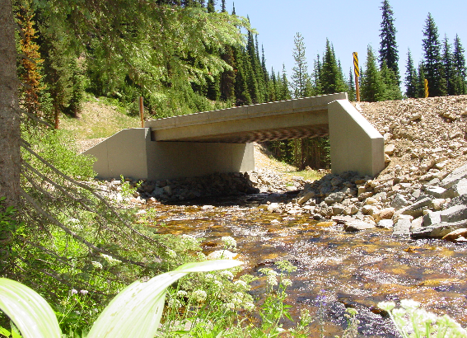

LOCATION/COMMUNITY INFORMATION:

The Idaho Panhandle National Forests comprise about 2.5 million acres of public lands, which lie within "the panhandle" of northern Idaho and extend into eastern Washington and western Montana. Northern Idaho is about 20 percent farmland and 80 percent forested. The IPNF administers approximately half of the total forested acres. Small woodland owners own One-fourth of the forested land; the remainder is owned by industries or other government entities.
The Idaho Panhandle National Forests are an aggregation of the Coeur d'Alene and portions of the Kaniksu and St. Joe National Forests. Local points of contact include the Supervisor's Office, five district offices and the Coeur d'Alene Tree Nursery. The Forest is within nine counties in three states: Boundary, Bonner, Benewah, Kootenai, Shoshone, Latah, and Clearwater Counties in Idaho; Lincoln County in Montana; and Pend Oreille County in Washington.

Check the Forest web site at: http://www.fs.fed.us/ipnf for more information.

A BIT ABOUT THE COEUR D’ALENE COMMUNITY

The Idaho Panhandle National Forests’ Supervisors Office is located in Coeur d'Alene, Idaho, a full-service community of over 40,000 people. Approximately 130,000 people live in Kootenai County. Located on the northern shore of Lake Coeur d'Alene, the city is 100 miles south of the Canadian border, 33 miles east of Spokane, Washington, and an hour’s drive from the Montana state line. There are four distinct seasons, with summer average highs and lows of 82 degrees and 51 degrees; and average winter temperatures from 38 degrees and 26 degrees, with consistent amounts of snowfall.

Higher education opportunities are available. North Idaho College (NIC) is located in Coeur d'Alene, Idaho, and 30 miles to the west of Coeur d'Alene, in Spokane, Washington, several colleges provide higher education opportunities. Moscow, Idaho is 80 miles south of Coeur d'Alene, and is the home of the University of Idaho. Washington State University is located just eight miles west of Moscow in Pullman, Washington, and Gonzaga University is located 33 miles away in Spokane. NIC, U of I, and other universities offer adult education classes in Coeur d’Alene and Post Falls.

Health care services include a full service hospital, physicians, dentist, chiropractors, optometrists, physical therapist, and mental health services at the Kootenai Medical Center. There is both an active professional and volunteer EMT program within the Coeur d'Alene communities. There are nursing homes and retirement centers within the community.

There is a modern library with excellent reference and checkout books, and access to other libraries for patron-requested books. A local museum and historical society chronicle the area's history.

There are several high schools within 5 miles of the office. There are many grade schools, middle schools and opportunities for private schooling exist in the area as well as in Spokane. Community day care and caregivers in private homes are readily available.

Numerous banks as well as credit unions provide financial services to area residents. Professional and volunteer fire departments provide emergency services to the local communities.

A county-owned airstrip for private, charter planes, and emergency medical transportation are located ten miles north of Coeur d'Alene in Hayden, Idaho. Spokane International Airport is located just 40 miles west of Coeur d'Alene.

Many professional, service, and special interest organizations offer area residents opportunities for personal growth and community service.

Numerous churches of many denominations serve the community.

Sandpoint, Idaho information: https://www.sandpointidaho.gov/

St. Maries, Idaho information: https://stmarieschamber.org/

Interagency Natural Resource Center

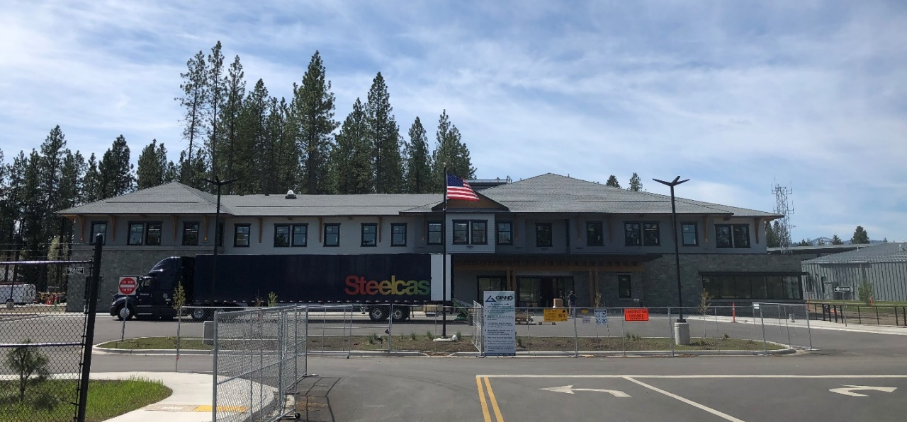
RECREATION

This area is often called "lake country" and Lake Coeur d'Alene is a center for recreation, as are the readily available National Forest lands. Recreational opportunities are numerous, including summer activities of camping, hiking, horseback riding, whitewater rafting, motorcycle riding, golfing, boating and water skiing, and fishing. During the winter months, hunting, cross-country skiing, and snowmobiling are popular. There are four winter ski resorts within easy drive of Coeur d'Alene, Mt. Spokane, Schweitzer, Silver Mountain, and Lookout Pass. The area contains several hundred miles of fishable streams and numerous lakes.

The city provides opportunities for organized youth sports such as Little League baseball and softball programs, soccer club, AAU basketball as well as City run recreational sports programs. A paved biking, jogging and walking trail runs along Coeur d'Alene Lake and extends 23 miles to Spokane, Washington. There are numerous theaters, bowling alleys, playhouses, and community sponsored events.

HOUSING: The standard cost of living in the Coeur d'Alene area is moderate. The median sale price of a home in 2020 was $386,000. Rentals average around $1200 per month according to Zillow.

OUTREACH NOTICE RESPONSE FORM
Idaho Panhandle National Forests

Position Title/Series/Grade: | Facilities Operations Specialist gs-1640-11
Location: | Forest wide: Coeur d alene, St. Maries, Sandpoint

Personal Information

Name: |  |  | Date:
Address:

Internet E-Mail Address:

Phone: | Office
 | Cell:

Current Title/Series/Grade:

Highest Position Held:
Title/Series/Grade:
Location:

Are you currently a Federal Employee? | Yes: |  |  | No:

Current Agency and location:

Type of appointment you are interested in: _______detail/temporary promotion
_______Permanent appointment
_______Virtual assignment (detail/temporary promotion)

Location you are interested in: ______Coeur d alene, Idaho
______Sandpoint
______St. Maries

Are you interested in the permanent position? _______

Are you eligible for special noncompetitive hiring authorities? _______

- VRA (Veterans Recruitment authority? Check link for eligibility https://federaljobs.net/blog/veterans-hiring-authorities/
- Schedule A hiring authority? https://askearn.org/page/schedule-a

******please clearly show your current COR certifications and experience in your resume***

