
 BEAVERHEAD-DEERLODGE
NATIONAL FOREST

_______________________________
Outreach Notice:
-Permanent Appointment, Two Positions.
-Facilities Operations Specialist GS-1640-07/09
-Wisdom or Wise River, MT
-Supervisors Office Dillon, MT-Location, TBD
___________________________________
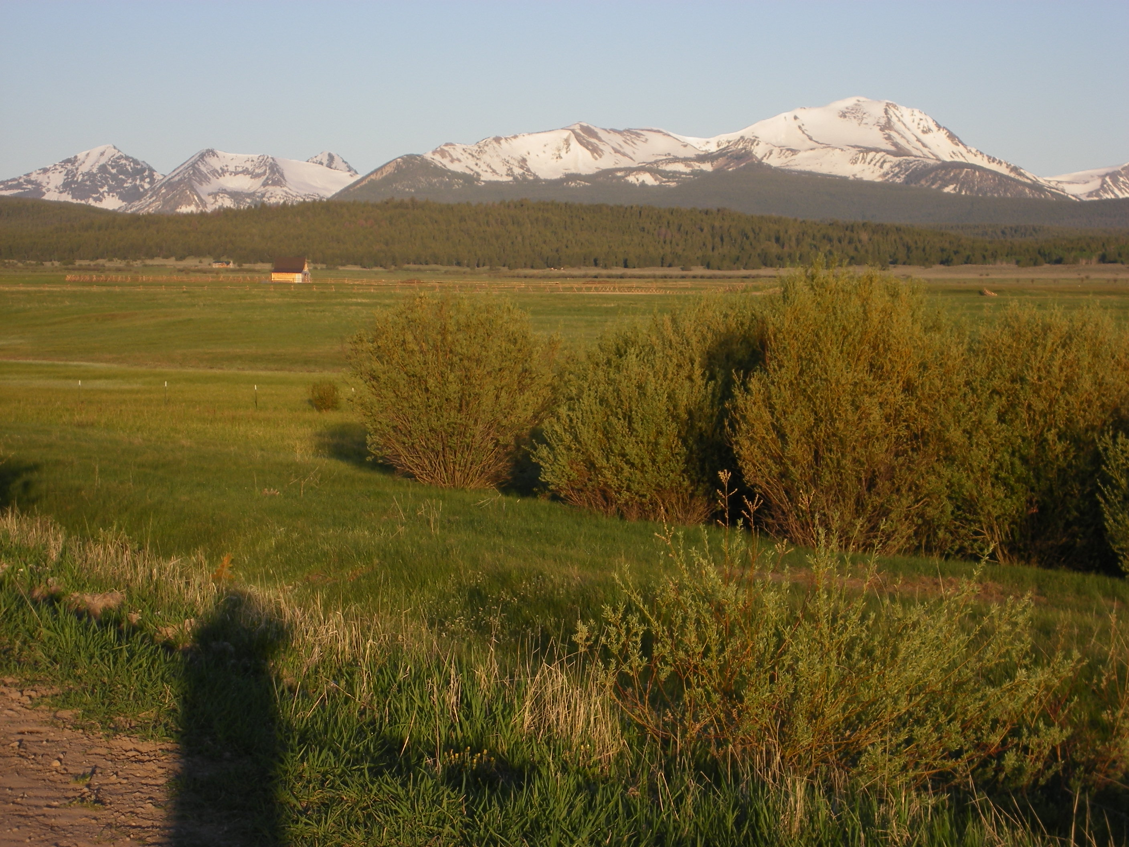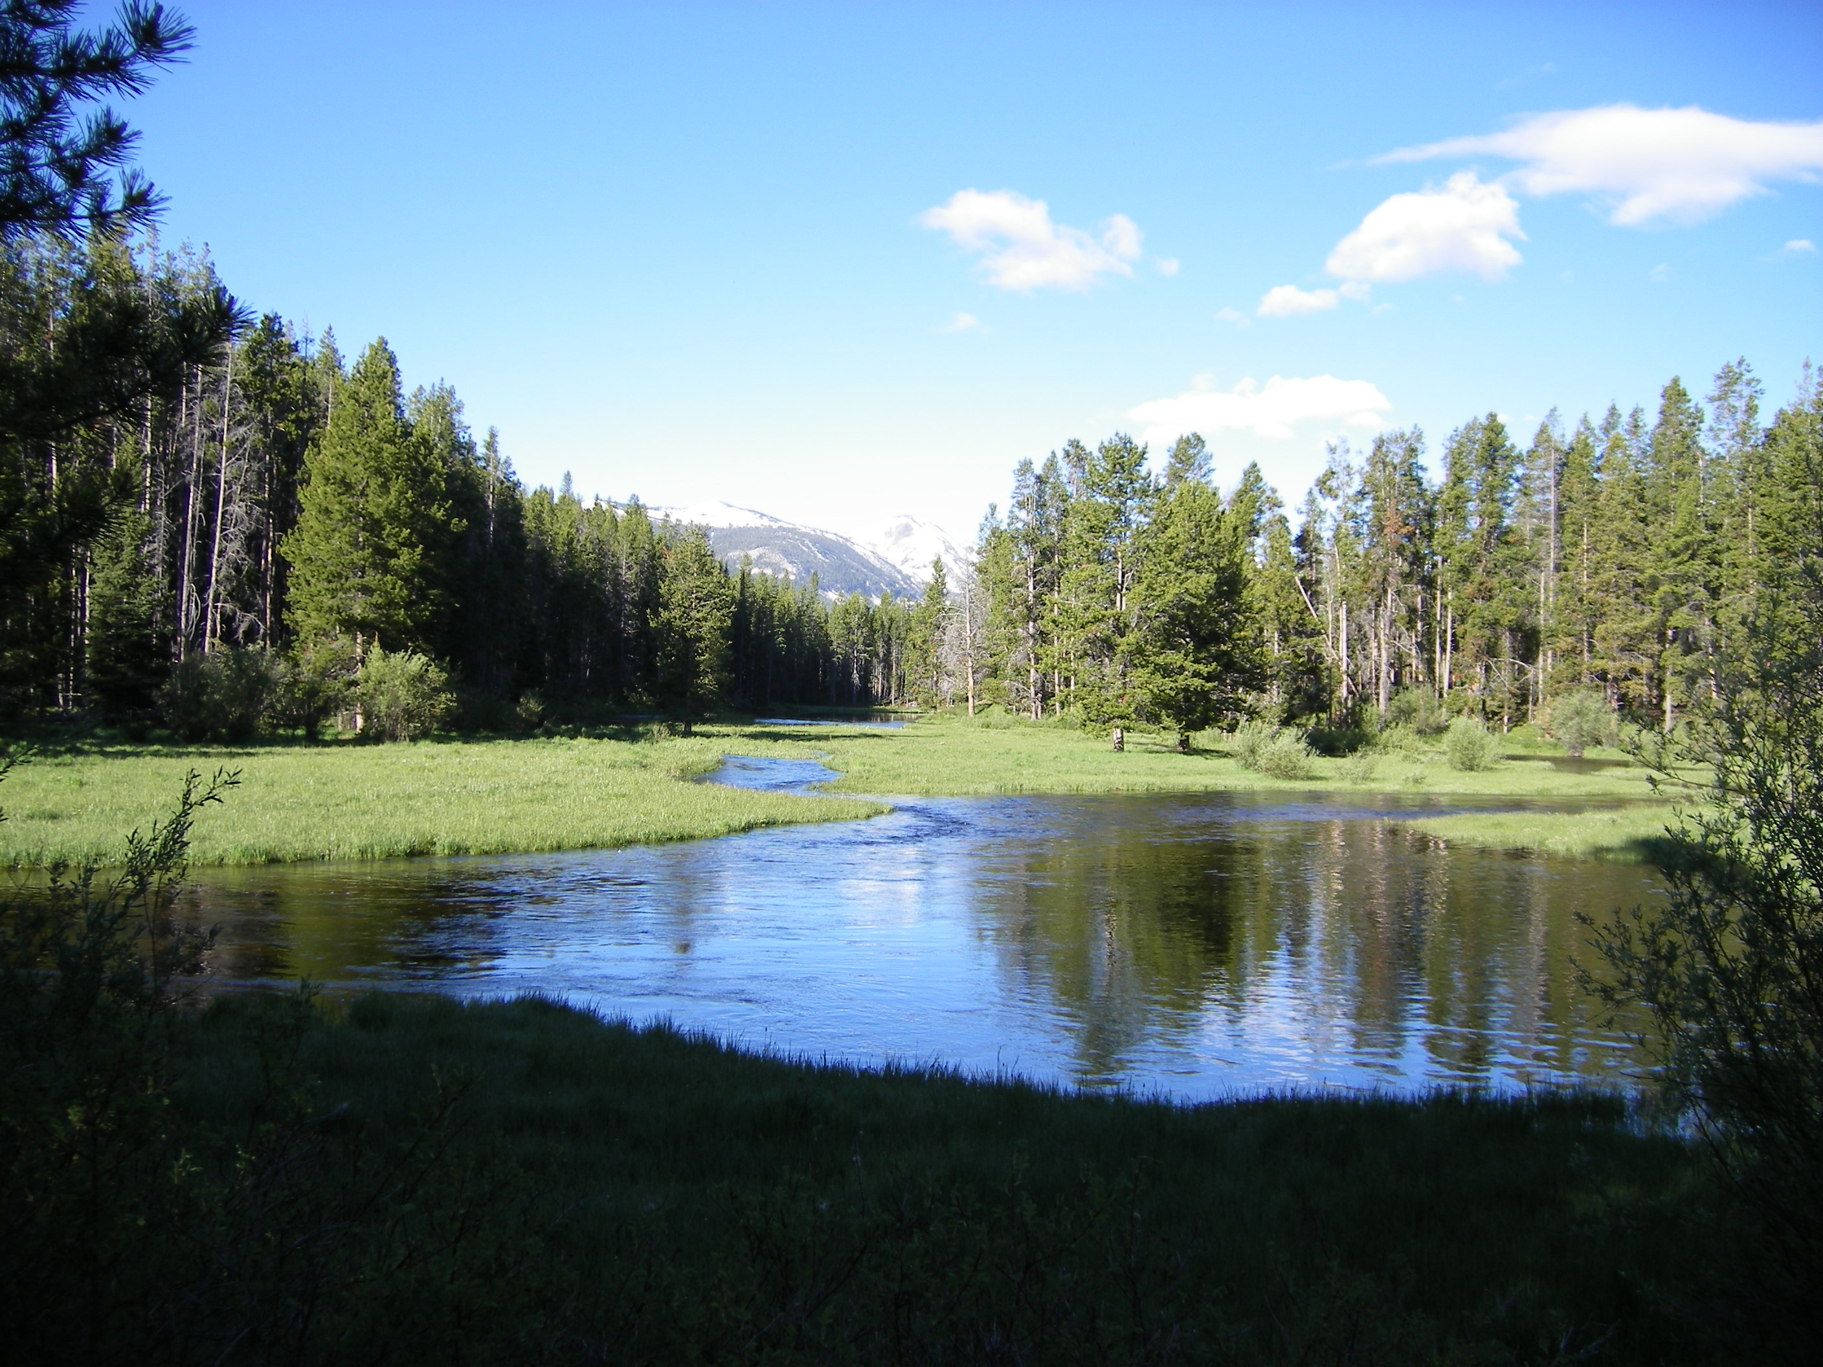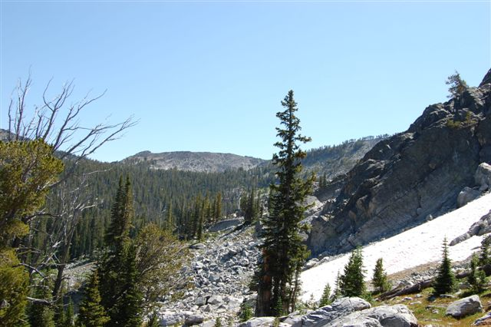

POSITION: Facilities Operations Specialist, GS-1640, 07/09 FS3704/FS3705

LOCATION: -Beaverhead-Deerlodge National Forest, Wisdom Ranger District.
-One Supervisor Office Position-Duty Location TBD

TOUR: Permanent Full Time, Start Date: TBD

DUTY STATION: Wisdom or Wise River, Montana
Supervisors Office, Station TBD

REPLY DUE BY: COB 2/22/2022 – Interest form and resume must be submitted for consideration.

To reply to this outreach: contact Eric Riener, Wisdom FMO at 406-396-0724, or by e-mail eric.riener@usda.gov for interest in the Wisdom Ranger District position.

Or contact Mark Libby, Forest Engineer at 406-683-3971, or by e-mail mark.libby@usda.gov for the BDNF-Supervisor office position.

Please respond with the attached outreach form, resume and interest in which specific position/location.

POSITION DESCRIPTION AND MAJOR DUTIES:

Manages all phases of the buildings and facilities maintenance program, including installation, maintenance, and repair of mechanical, electrical, refrigeration, and pumping systems associated with specialized operations.

Oversees major repetitive tasks such as repair and replacement of components of buildings, septic and water systems, electrical systems, heating and refrigeration systems, grounds maintenance, lawn care, and snow removal.

Monitors equipment costs and makes recommendations regarding efficiencies for facilities/quarters funding obligation. Schedules maintenance as required for quarters and facilities. Conducts facility safety and health compliance inspections and monitors compliance with safety and health regulations.

Compiles contracts for advertisement to bid within the scope of building, septic systems, refrigeration and facilities maintenance. Writes specifications for construction projects to be contracted or outsources for quotes. Monitors construction projects as they proceed and informs the Contracting Officer and/or Engineering Project Manager of any problems. Acts as COR or inspector on contracts within the scope of the facilities maintenance program, and qualifications. Coordinates all facilities maintenance, and upgrades.

Conducts condition surveys on existing buildings to identify deficiencies including structural integrity, adequacy of electrical systems, refrigeration, heating and cooling systems. Also including water and sanitation systems to identify deficiencies.

Prioritizes repairs or replacements; develops alternatives for repair and/or replacement of existing systems and arrives at a solution which is compatible with budgetary constraints, county requirements. Recommends engineering, modifications and capacity studies be conducted when appropriate.

Plans, schedules, and accomplishes daily, weekly, and monthly inspection as well as annual, 3-year, 5- year, and long-range planning for buildings, utilities, grounds, sanitation and other facilities to promote the administration of occupant safety and health, protection and maintenance of buildings and grounds for continuous productive operations.

Manages facility and Quarters budgets and makes cost estimates for facilities repairs. Procures materials needed to accomplish scheduled projects. Maintains close contact with the Facilities Engineer throughout the year to adjust expenditures and contracts.

In emergency situations, assists in preparing estimates of costs for supplemental budget requests for funding to cover unforeseen major maintenance needs.

For more information, for the Wisdom Ranger District Vacancy please contact Eric Riener, Wisdom RD FMO at 406-396-0724. For the Supervisor Office Position Vacancy please contact Mark Libby, Forest Engineer at 406-683-3971. If you are interested in the position, please complete the attached Position Outreach Interest Response Form, along with a brief resume, and email to eric.riener@usda.gov or mark.libby@usda.gov by COB 02/22/2022.

OUTREACH RESPONSE FORM
Facilities Operation Specialist
GS – 1640 – 7/9
Wisdom RD
BDNF-Supervisors Office

NAME:
E-MAIL ADDRESS:
MAILING ADDRESS:
TELEPHONE NUMBER:
 | USFS |  | {BLM |  | {OTHER
AGENCY EMPLOYED WITH:

TYPE OF APPOINTMENT:
 | {PERMANENT |  | {TEMPORARY |  | {TERM

 | {VRA |  | {PWD |  | {OTHER
 | {REGION |  | {FOREST
CURRENT:
{DISTRICT

 | {SERIES |  | {GRADE
CURRENT:
{POSITION TITLE
CURRENT:

HOW DID YOU FIND OUT ABOUT THIS OUTREACH NOTICE?

IF NOT A CURRENT PERMANENT (CAREER OR CAREER CONDITIONAL) EMPLOYEE
ARE YOU ELIGIBLE TO BE HIRED UNDER ANY OF THE FOLLOWING SPECIAL AUTHORITIES?

PERSON WITH DISABILITIES

VETERANS RECRUITMENT ACT

DISABLED VETERANS W/30% COMPENSABLE DISABILITY

VETERANS EMPLOYMENT OPPORTUNITIES ACT OF 1998

FORMER PEACE CORPS VOLUNTEER

PATHWAYS PROGRAM

