OUTREACH NOTICE

Region One, Supervisory Operations Engineer

Idaho Panhandle National Forests

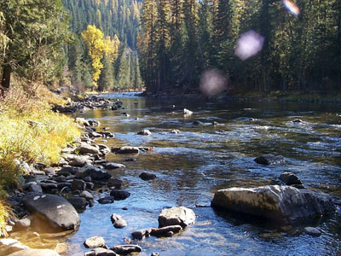

Title, GS-Series-Grade: | Supervisory Operations Engineer, GS 0810-12
District/Unit: | Supervisors Office, Coeur d’ Alene, Idaho
Date of Notice: | September 20, 2023

The Idaho Panhandle National Forests is seeking an individual interested in a detail, temporary promotion and/or permanent placement into a supervisory Gs-12 operations engineering position. This position will be located in the supervisors office and will operate as the forest facility engineer as well as supervise fleet, Infra and facilities operations.

The official advertisement of the permanent position will be in January or February of 2023. However, candidates meeting the requirements of special non competitive hiring authorities may receive early consideration if qualified.
- VRA (Veterans Recruitment authority? Check link for eligibility https://federaljobs.net/blog/veterans-hiring-authorities/
- Schedule A hiring authority? https://askearn.org/page/schedule-a

How much will I be paid? https://www.opm.gov/policy-data-oversight/pay-leave/salaries-wages/salary-tables/pdf/2023/GS.pdf

Interested applicants, or those desiring further information, should contact the supervisor listed below:

Name of Supervisor: | James Gebhardt
D U E D A T E T O R E S P O N D: | September 30, 2023
Phone Number: | 208-819-6195
e-mail address: | James.gebhardt@usda.gov
Mailing address: | Idaho Panhandle National Forests  3232 west nursery road  Coeur d’Alene, ID 83815

Please complete the response form located at bottom of the outreach notice and attach a resume. Return these forms to James Gebhardt by the closing date.

A little bit about the position…………

Participates with the Forest Leadership Team to provide necessary information pertaining to facility design projects. Reviews and provides input into new, proposed, or revised forest and regional policy direction concerning facility engineering. Assists in the development and distribution of standards and guidelines for implementation and compliance by the forest or districts.
Provides technical advice on all aspects of complex or unusual facility maintenance projects. Projects are located throughout the forest and/or on neighboring forests within the region. Projects include transportation improvement plans for a Forest Service area, buildings, barracks, bridges, parking facilities, drainage structures, water and waste water systems, retaining walls, equipment shops and yards, residences, recreational sites/facilities, and, other site facilities. Coordinates all aspects of the engineering and administrative work between the unit and the Regional Office.
Assists in the evaluation of facility plans and design objectives including conducting surveys and investigations to establish the necessary data to initiate facility designs. Initiates and performs complex technical calculations, and identifies the most economical and efficient procedures for facility projects. Incorporates critical factors into design considerations and solutions. Prepares completed and detailed designs, drawings, and specifications for projects such as roads, trails, bridges, or other miscellaneous facilities and structures. Performs reviews to determine the probability of terms for complex or expensive facility projects.
Is responsible for giving advice and guidance in the preparation and issuance of construction contracts, and for resolving controversial issues/problems before and during construction. Provides direction to others in the principles of planning, designing, operation, maintenance, monitoring, and inspection of engineering facilities. Evaluates design plans and layouts prepared by others prior to start of construction. Serves as Engineering Representative (ER) or as Contracting Officer’s Representative (COR), providing professional engineering expertise, technical advice, recommendations, and suitable alternatives to the Contracting Officer and Forest officials. Confers with contractors' representatives about improvement or adoption of construction practices and procedures necessary to produce a satisfactory finished project.
Performs or oversees inspections; interprets plans and specifications and confers with contractor representative to resolve differences of opinion. Investigates need for contract change orders, considering conditions at work site, field measurements and computations, and local prices, and negotiates cost for changes required. Authorizes changes that do not modify the designer's intent and do not result in contract time or cost changes.
Responsible for training other engineers and technicians in all aspects of facility engineering, e.g., design, operation, maintenance, monitoring etc.
Conducts safety inspections and condition surveys of structures and facilities such as buildings, water and wastewater systems, recreation site facilities, and utilities according to agency requirements; and evaluates and recommends corrective action as needed to ensure the safety of all users. Conducts periodic inspections of facilities to ensure they are maintained to the original standard of construction and to ensure the safety of the public. Inspects and directs construction and maintenance projects keeping safety considerations in mind.

Provides daily oversight and supervision to the forest fleet program as well as Intra and facilities operations personnel.
Supervision less than 20% - Provides technical and administrative supervision to subordinate employees. Plans work, sets and adjusts short-terms priorities and prepares schedules for completion of work. Assigns work, based on priorities, selective consideration of the difficulty and requirements of assignments, and the capabilities of employees. Evaluates work performance. Gives advice, counsel, or instruction to employees on both work and administrative matters. Hears and resolves minor complaints from employees. Refers group grievances and more serious unresolved complaints to a higher-level supervisor or manager. Interviews candidates for employment; recommends or selects for temporary positions. Finds way to improve production or increase the quality of work directed.

LOCATION/COMMUNITY INFORMATION:

The Idaho Panhandle National Forests comprise about 2.5 million acres of public lands, which lie within "the panhandle" of northern Idaho and extend into eastern Washington and western Montana. Northern Idaho is about 20 percent farmland and 80 percent forested. The IPNF administers approximately half of the total forested acres. Small woodland owners own One-fourth of the forested land; the remainder is owned by industries or other government entities.
The Idaho Panhandle National Forests are an aggregation of the Coeur d'Alene and portions of the Kaniksu and St. Joe National Forests. Local points of contact include the Supervisor's Office, five district offices and the Coeur d'Alene Tree Nursery. The Forest is within nine counties in three states: Boundary, Bonner, Benewah, Kootenai, Shoshone, Latah, and Clearwater Counties in Idaho; Lincoln County in Montana; and Pend Oreille County in Washington.

Check the Forest web site at: http://www.fs.fed.us/ipnf for more information.

A BIT ABOUT THE COEUR D’ALENE COMMUNITY

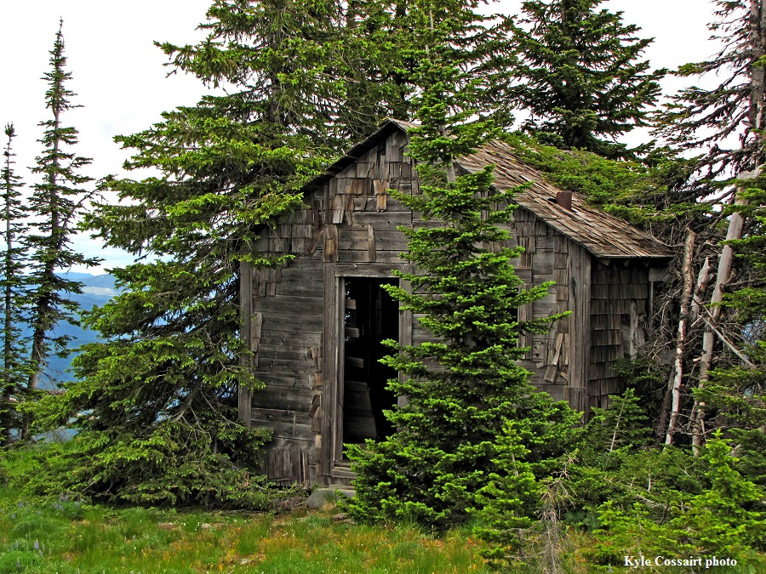
The Idaho Panhandle National Forests’ Supervisors Office is located in Coeur d'Alene, Idaho, a full-service community of over 40,000 people. Approximately 130,000 people live in Kootenai County. Located on the northern shore of Lake Coeur d'Alene, the city is 100 miles south of the Canadian border, 33 miles east of Spokane, Washington, and an hour’s drive from the Montana state line. There are four distinct seasons, with summer average highs and lows of 82 degrees and 51 degrees; and average winter temperatures from 38 degrees and 26 degrees, with consistent amounts of snowfall.

Higher education opportunities are available. North Idaho College (NIC) is located in Coeur d'Alene, Idaho, and 30 miles to the west of Coeur d'Alene, in Spokane, Washington, several colleges provide higher education opportunities. Moscow, Idaho is 80 miles south of Coeur d'Alene, and is the home of the University of Idaho. Washington State University is located just eight miles west of Moscow in Pullman, Washington, and Gonzaga University is located 33 miles away in Spokane. NIC, U of I, and other universities offer adult education classes in Coeur d’Alene and Post Falls.

Health care services include a full service hospital, physicians, dentist, chiropractors, optometrists, physical therapist, and mental health services at the Kootenai Medical Center. There is both an active professional and volunteer EMT program within the Coeur d'Alene communities. There are nursing homes and retirement centers within the community.

There is a modern library with excellent reference and checkout books, and access to other libraries for patron-requested books. A local museum and historical society chronicle the area's history.

There are several high schools within 5 miles of the office. There are many grade schools, middle schools and opportunities for private schooling exist in the area as well as in Spokane. Community day care and caregivers in private homes are readily available.

Numerous banks as well as credit unions provide financial services to area residents. Professional and volunteer fire departments provide emergency services to the local communities.

A county-owned airstrip for private, charter planes, and emergency medical transportation are located ten miles north of Coeur d'Alene in Hayden, Idaho. Spokane International Airport is located just 40 miles west of Coeur d'Alene.

Many professional, service, and special interest organizations offer area residents opportunities for personal growth and community service.

Numerous churches of many denominations serve the community.

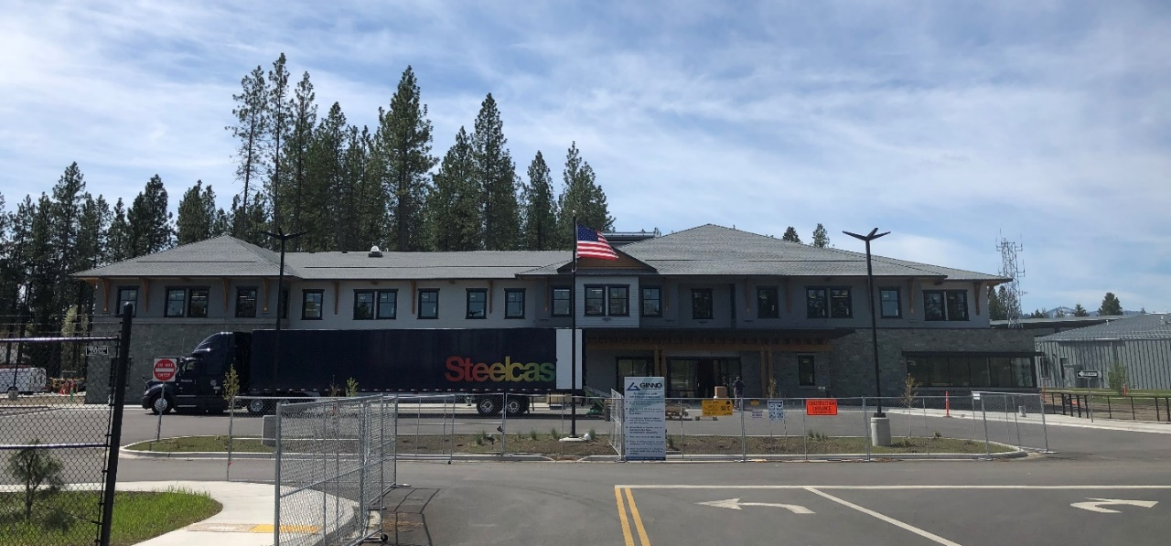

RECREATION

This area is often called "lake country" and Lake Coeur d'Alene is a center for recreation, as are the readily available National Forest lands. Recreational opportunities are numerous, including summer activities of camping, hiking, horseback riding, whitewater rafting, motorcycle riding, golfing, boating and water skiing, and fishing. During the winter months, hunting, cross-country skiing, and snowmobiling are popular. There are four winter ski resorts within easy drive of Coeur d'Alene, Mt. Spokane, Schweitzer, Silver Mountain, and Lookout Pass. The area contains several hundred miles of fishable streams and numerous lakes.

The city provides opportunities for organized youth sports such as Little League baseball and softball programs, soccer club, AAU basketball as well as City run recreational sports programs. A paved biking, jogging and walking trail runs along Coeur d'Alene Lake and extends 23 miles to Spokane, Washington. There are numerous theaters, bowling alleys, playhouses, and community sponsored events.

HOUSING: The standard cost of living in the Coeur d'Alene area is moderate. The median sale price of a home in 2020 was $386,000. Rentals average around $1655 per month according to Zillow.

OUTREACH NOTICE RESPONSE FORM
Idaho Panhandle National Forests

Position Title/Series/Grade: | Supervisory operations engineer, GS-0810-12
Location: | Forest Supervisor’s Office - Coeur d’Alene, Idaho

Personal Information

Name: |  |  | Date:
Address:

Internet E-Mail Address:

Phone: | Office
 | Cell:

Current Title/Series/Grade:

Highest Position Held:
Title/Series/Grade:
Location:

Are you currently a Federal Employee? | Yes: |  |  | No:

IF YES:
Type of Appoint you are currently under:
(e.g., Career, Career-Conditional, Excepted)
Current Agency and location:
IF NO:
Are you currently a temporary employee? | Yes: |  |  | No:

Type of appointment you are interested in: _______detail/temporary promotion
_______Permanent appointment
_______Virtual assignment (detail/temporary promotion)

Are you interested in the permanent position? _______
Are you eligible for special noncompetitive hiring authorities to include:
- VRA (Veterans Recruitment authority? Check link for eligibility https://federaljobs.net/blog/veterans-hiring-authorities/
- Schedule A hiring authority? https://askearn.org/page/schedule-a

