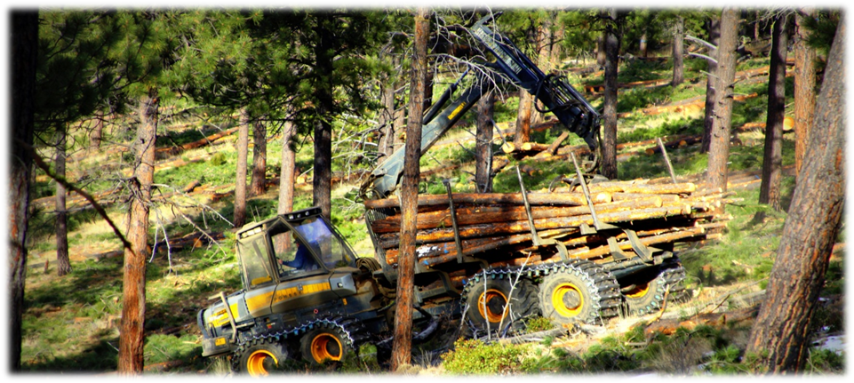
OUTREACH NOTICE

DESCHUTES NATIONAL FOREST

BEND/FORT ROCK RANGER DISTRICT

BEND, OREGON

Lead Forestry Technician (Presale)

GS-0462-06/07
Announcment #

The Deschutes National Forest will soon be advertising one GS-0462-06/07 Lead Forestry Technician position. The position is permanent full time appointments, and will be located at the Bend/Fort Rock Ranger District in Bend, Oregon.
The purpose of this Outreach Notice is to determine the potential applicant pool for this position and to establish the appropriate recruitment method and area of consideration for the advertisement. Responses received from this outreach will be relied upon to make this determination.
Reply by December 21, 2018
Please complete the outreach response form within the outreach database to indicate your interest in the position. https://fsoutreach.gdcii.com/Outreach

THE POSITION
This position serves as the Timber Sale Prep Crew Lead, performing a variety of timber sale prep duties that include but are not limited to: organizing daily crew assignments, leading crew(s) in the field, timber sale layout, map making, cruise design, timber marking, and timber cruising.

As a Lead Forestry Tech, applicants must have strong leadership skills and experience. The position leads 2-3 five person crews and is responsible for the quality of work, crew safety, and general field operations. The applicant must be a Certified Timber Cruiser to assist in the implementation of cruise plans and design, as well as educate and train new employees. The applicant must be able to interpret complex silvicultural prescriptions and marking guides to carry out Forest restoration goals on the landscape and ensure quality of work is met. Applicant can also expect to train and mentor personnel on up to three timber crews consisting of both permanent and temporary employees performing work up to the GS- 6 level;. The number of employees supervised each year varies depending on workload. On average, the district produces 40 MMBF across 6,000 to 8,000 acres annually.

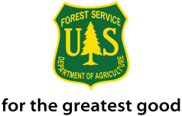
Good communication skills, a positive attitude and strong work ethic are highly desirable along with knowledge of forest measurement tools and techniques including the use of Spiegel Relaskop, clinometer, laser measurement tools, Trimble GPS, map and compass and prism. Full performance of this position includes certification as a Region 6 Certified Advanced Cruiser. Applicants who possess or are working on this certification should highlight that in their resume and as part of the outreach response. Some of the work occurs in the winter and requires off-road winter travel, often on snowmobiles.

ABOUT THE AREA
The City of Bend (http://www.bend.or.us) is a rapidly-growing metropolitan area located in the central portion of the state, on the east side of the Cascade Mountains. This “High Desert” community is a full-service community that serves as a hub for medical, educational, recreation and entertainment needs for a large geographic area in Central Oregon. Tourism plays an important role in the local economy and regional economy.
COMMUNITY INFORMATION
Elevation: 3,623 feet
Population: City – ~80,000
County: Deschutes
Location: East side of the Cascade Mountains in Central Oregon
20 miles southeast of Sisters, Oregon
15 miles south of Redmond, Oregon
Average Summer Temperatures: 85º/day 44º/night
Average Winter Temperatures: 41º/day 21º/night
Average Annual Precipitation: 12” (mostly in the form of winter snow)
Closest Commercial Airport: Redmond, Oregon (an easy 15-mile drive to the north);
serviced by United, Delta, and Alaska Airlines
SCHOOLS
Bend is served by public and private schools from pre-school through high school. Public schools are administered by the Bend-LaPine School District (http://www.bend.k12.or.us) . College level community education courses and two year degree programs are offered locally in Bend, and at satellite campuses, through Central Oregon Community College (COCC) (http://www.cocc.edu). Additionally, OSU Cascades offers four-year degrees through Oregon State University and the University of Oregon (http://www.osucascades.edu).
HEALTH CARE
Bend is the primary center for high quality health care in Central Oregon with one major hospital (http://www.stcharleshealthcare.org), numerous clinics, and the associated full array of medical support and services. Redmond, located approximately 15 miles north of Bend, also has a community hospital and associated high quality medical support and services.
HOUSING
Bend is a rapidly growing city and region, and the real estate market can be tight. The median sales price for a residential three bedroom home is around $390,000 and 3 bedroom rentals average ~$1,800 per month (property listings and rental rates vary significantly for different parts of town and for the greater Bend area). Prices in Redmond are typically lower ($270,000 and $1,500 respectively).
ANNUAL EVENTS
The local area is well known for its many annual events, including: Winterfest (February), Bend Summer (July) and Fall Festivals (October), Arts in the High Desert (August, ranked in the top 15 nationally for fine arts shows), Bend Film Festival (October). Classical music is performed by the Central Oregon Symphony in Bend during the winter months.
Annual athletic and recreational events also take place on forest lands under special use permit.
The Pole, Pedal, Paddle race (May) is a well recognized event in Oregon and surrounding states.
The Cascade Cycling Classic (July) a week of professional and amateur races, Mt. Bachelor ski area(http://www.mtbachelor.com) 25 miles, and Hoodoo Ski Area (http://www.hoodoo.com) 40 miles, provide excellent skiing opportunities. Mountain bike trails are abundant, with the Phil’s
trail system very highly regarded.

A diversity of other events and concerts are regularly held at the refurbished downtown Tower Theatre (http://www.towertheater.org), as well as outdoor concerts at the Les Schwab Amphitheater (http://www.bendconcerts.com) and Athletic Club of Bend (http://www.athleticclubofbend.com). The nearby communities also offer many festivities, including the Sisters Rodeo and Parade (June), Outdoor Quilt Show (July), Sisters Folk and Jazz Festivals (September), Sunriver Music Festival (August), and free music venues throughout the summer in both Bend and Redmond. The County Fairgrounds in nearby Redmond hosts numerous events, as well as major entertainment on a regular basis.

For additional details on the position, you may call Jeff Finley, Supervisory Forest Technician at (d)(541) 383-4780 or (c)(541) 408-7398.

Vacancies will be advertised on USAJobs at https://www.usajobs.gov.

The U.S. Department of Agriculture (USDA) prohibits discrimination in all its programs and activities on the basis of race, color, national origin, age, disability, and where applicable, sex, marital status, familial status, parental status, religion, sexual orientation, genetic information, political beliefs, reprisal, or because all or part of an individual’s income is derived from any public assistance program. (Not all prohibited bases apply to all programs.) Persons with disabilities who require alternative means for communication of program information (Braille, large print, audiotape, etc.) should contact USDA’s TARGET Center at (202)720-2600 (voice and TDD). To file a complaint of discrimination, write to USDA, Director, Office of Civil Rights, 1400 Independence Avenue, S.W., Washington, DC 20250-9410, or call (800) 795-3272 (voice) or (202) 720-6382 (TDD). USDA is an equal opportunity provider and employer

Forest Technician (TIMB SALE PREP)GS-0462-6/7

OUTREACH RESPONSE FORM

If you are interested in this position, please complete your response on the Outreach Database. If you experience problems with the database fill out the information below and return it to:
E-mail: jeffreyrfinley@fs.fed.us
or
Mail: Bend-Fort Rock Ranger District
ATTN: Jeff Finley
60395 Deschutes Market Road
Bend, OR 97701

For additional details on the position, you may call Jeff Finley, Supervisory Forest Technician at (541) 383-4780

Vacancies will be advertised on USAJobs at https://www.usajobs.gov.

PERSONAL INFORMATION:
Name |  | Date
Address
City |  | State
Zip |  | E-Mail
Phone number(s)
Are you currently a federal employee
If Yes, current agency and location
current title/series/grade
Type of Appointment |  |  | Permanent |  |  | Term | Temporary
Type of Schedule |  |  | Full-time |  |  | Part-time | Intermittent
If you are not a current permanent (career or career conditional) employee, are you eligible for appointment under any of the following special authorities (check the appropriate box):
 | Person with Disabilities
 | Veteran’s Recruitment Act
 | Former Peace Corps Volunteer
 | Disabled Veteran with 30% Compensable Disability
 | Student Intern Program
 | Veterans Employment Opportunities Act 0f 1998
 | Other (LMWFA), please describe:

