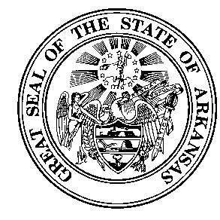
ARKANSAS AGRICULTURE DEPARTMENT

#1 Natural Resources Drive
Little Rock, AR 72205

AN EQUAL OPPORTUNITY EMPLOYER

JOB OPPORTUNITY
November 2, 2018

TITLE  LOCATION | ANNUAL SALARY  POSITION # | APPLICATION MUST BE RECEIVED BY:
Administrative Specialist II  Agency: Arkansas State Plant Board  Division: Pesticide  Location: Little Rock, AR Office  Hiring Authority:  Arkansas State Plant Board  PO Box 1069  Little Rock, AR 72203  Phone: 501/219-6330  susie.nichols@agriculture.arkansas.gov  Standard State of Arkansas employment application required.  Apply on line:  http://www.arstatejobs.com  Under Arkansas Agriculture Department | Entry Level Salary: $26,034  Grade GS03  Position #: 22087925 | November 16, 2018

STATE’S MINIMUM QUALIFICATIONS:
Education/experience requirements:
- The formal education equivalent of a high school diploma; plus three years of experience in a specialized or related area applicable to work performed.

Knowledge of:
- Record keeping procedures.
- The principles and practices of mathematics and statistics.
- Work-related subject area.
- Computers and software applications

Ability to:
- Conduct research and compile data into report form.
- Establish and maintain filing systems.
- Operate standard office equipment.
- Analyze documents to determine compliance with rules, regulations, and procedures.
- Communicate both orally and in writing.

